# AndroidStudio项目结构（版本一：视图角度）

## （1） 版本一

参考：

（1） <https://blog.csdn.net/eastmoon502136/article/details/50596806>

（2） 主：<https://www.cnblogs.com/lcchuguo/p/5272831.html>

以最简单的Hello工程为例。

以下Android Studio以AS简称。

AS共有三种视图，

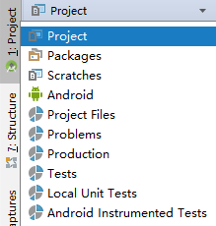

### Project视图

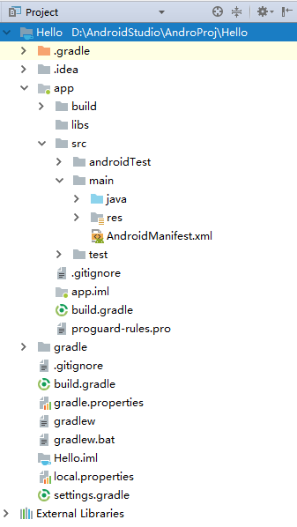

#### Hello文件夹（路径）

项目/项目空间名称（项目/项目空间路径）

1. **.gradle文件夹**
2. **.idea文件夹**

系统自动生成的关于AS的环境配置目录，包括版权，jar包信息，项目名称，编译信息等等。

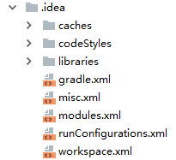

1. **app文件夹**（模块列表：多个模块有多个文件夹）

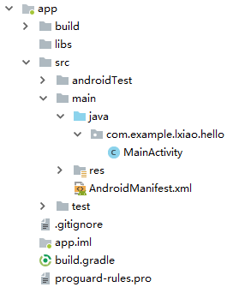

1. **build文件夹**

系统自动生成的，当前module的编译目录。

1. **libs文件夹**
2. **src文件夹**

源码，资源目录。

1. **androidTest文件夹**

系统自动生成用于测试的目录。

1. **main文件夹**

主目录（存放java文件，资源，Manifest）

1. **java文件夹**

java文件目录。

1. **res文件夹**

资源文件目录。

1. **AndroidManifest.xml**

Manifest文件

1. **test文件夹**
2. **.gitignore**

当前Module在上传到git的时候的忽略文件。具体见：

<http://www.html-js.com/article/2030>

1. **app.iml**

当前Module的配置文件。

1. **build.gradle**

当前module的Gradle编译文件。

1. **proguard-rules.pro**

当前Module的混淆文件

1. **gradle文件夹**

Gradle目录

1. **其余文件**

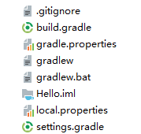

1. **.gitignore**

项目空间的同步忽略文件。

1. **build.gradle**

项目空间的Gradle编译文件。

1. **gradle.properties**

Gradle属性文件

1. **gradlew**

Gradle信息文件

1. **gradlew.bat**

Gradle执行文件

1. Hello.iml

项目空间的配置文件

1. **local.properties**

本地属性文件，里面存放了SDK和NDK的路径，两者的路径配置可通过File->Project Structure来设置。

1. **settings.gradle**

Gradle设置文件，包含当前项目的Module。

#### 《2》 PART2. External Libraries

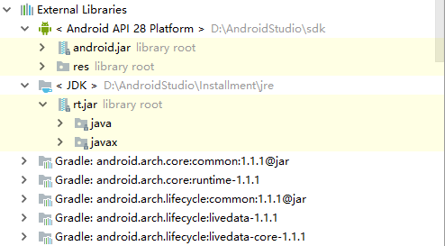

1. **<Android API 28 Platform>+PATH 文件夹**

SDK版本和路径（可通过）

1. **<JDK>+PATH 文件夹**JDK路径
2. **其他**

依赖库文件

### Package视图

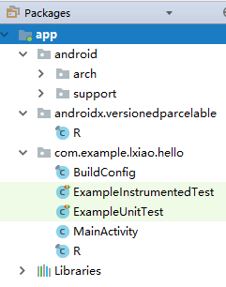

#### 概述

该视图下和Project最大的差别就是隐藏了配置文件，属性文件和系统自身的文件夹。仅仅显示了当前的Module列表（多个Module）和Module内部的文件夹，文件。

### Android视图

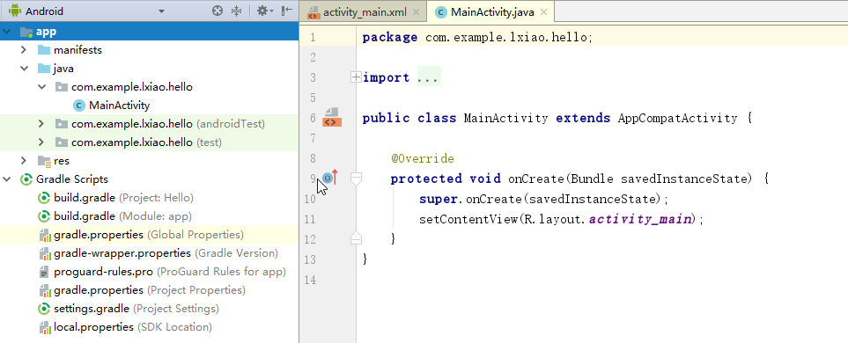

#### 1.1.2.1 概述

可以看到该视图下的一级文件夹分为两个区域，一个是Module列表区域，一个是Gradle Scripts区域。

#### 1.1.2.2 组成详解

##### （1） Module区域

该文件夹下分三个子文件夹，分别是manifests文件，java源代码，res资源文件夹。

在java源码文件夹中，有多个文件夹和文件名称相同，但后面带有不同的标识。

事实上，Project视图的全部内容都是真实的文件夹，而在Android视图下，

##### （2） Gradle Scripts文件夹

这里有多个Gradle文件和属性文件。

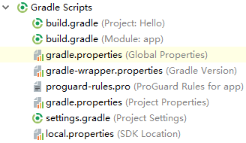

从上到下依次为

1. build.gradle（Project：Hello）：项目空间的gradle配置文件
2. build.gradle（Module：app）：module的配置文件（可有多个module）
3. gradle.properties（Global Properties）：gradle属性文件

其他具体见Project视图说明。

#### 1.1.2.3 总结

Android视图最大的优点就是去掉了一些我们本身不关心的文件和文件夹（配置，属性文件等），而且把一些资源文件，源文件非常清晰地合并在一起，隐藏了一些AS自主生成的文件和文件夹（比如R文件等），能够让我们更方便地管理整个项目的module。

## （2） 版本二

参考：

<https://developer.android.google.cn/studio/projects#ProjectFiles>

### Android视图

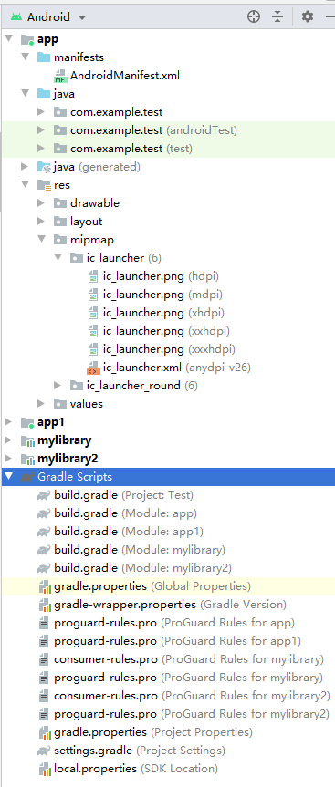

默认情况下，Android Studio 会在 **Android** 视图中显示您的项目文件。此视图并不能反映磁盘上的实际文件层次结构，而是按模块和文件类型进行整理，以简化项目的关键源文件之间的导航方式，并隐藏某些不常用的文件或目录。与磁盘上的结构相比，一些结构变化包括以下方面：

* 在top-level **Gradle Script**  group中显示all the project's build-related configuration files；
* Shows all manifest files for each module in a module-level group (when you have different manifest files for different product flavors and build types)；
* Shows all alternative resource files in a single group, instead of in separate folders per resource qualifier. For example, all density versions of your launcher icon are visible side-by-side.

Within each Android app module, files are shown in the following groups:

1. **manifests**

Contains the [AndroidManifest.xml](https://developer.android.google.cn/guide/topics/manifest/manifest-intro) file.

1. **java**

Contains the Java source code files, separated by package names, including JUnit test code.

1. **res**

Contains all non-code resources, such as XML layouts, UI strings, and bitmap images, divided into corresponding sub-directories. For more information about all possible resource types, see [Providing Resources](https://developer.android.google.cn/guide/topics/resources/providing-resources).

### Project视图

为了看到project的actual file structure（包括所有在Android view中隐藏的文件），选择Project视图。

When you select **Project** view, you can see a lot more files and directories. The most important of which are the following:

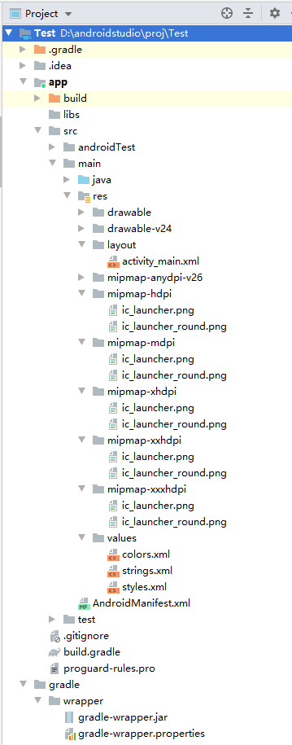

**module-name**/

build/

Contains build outputs.

libs/

Contains private libraries.

src/

Contains all code and resource files for the module in the following subdirectories:

androidTest/

Contains code for instrumentation tests that run on an Android device. For more information, see the [Android Test documentation](https://developer.android.google.cn/tools/testing).

main/

Contains the "main" sourceset files: the Android code and resources shared by all build variants (files for other build variants reside in sibling directories, such as src/debug/ for the debug build type).

AndroidManifest.xml

Describes the nature of the application and each of its components. For more information, see the [AndroidManifest.xml](https://developer.android.google.cn/guide/topics/manifest/manifest-intro) documentation.

java/

Contains Java code sources.

jni/

Contains native code using the Java Native Interface (JNI). For more information, see the [Android NDK documentation](https://developer.android.google.cn/ndk).

gen/

Contains the Java files generated by Android Studio, such as your R.java file and interfaces created from AIDL files.

res/

Contains application resources, such as drawable files, layout files, and UI string. See [Application Resources](https://developer.android.google.cn/guide/topics/resources) for more information.

assets/

包含应该按原样被编译进一个.apk file的文件。你能通过和使用URIs来访问一个typical file system相同的方式来navigate this directory，同时用 read files as a stream of bytes using the [AssetManager](https://developer.android.google.cn/reference/android/content/res/AssetManager)。比如，这里是放置textures和game data的好地方。

test/

Contains code for local tests that run on your host JVM.

build.gradle**(module)**

This defines the module-specific build configurations.

build.gradle**(project)**

This defines your build configuration that apply to all modules. 该文件和project是一体的，因此你应该在revision control中与所有其他源代码一起维护。For information about other build files, see [Configure Your Build](https://developer.android.google.cn/studio/build).

# AndroidStudio项目结构（版本二：project files分析）

参考：

<https://developer.android.google.cn/studio/projects#ApplicationModules>

## build.gradle详解

参考：

1. gradle官方文档：

<https://docs.gradle.org/current/userguide/userguide.html>

1. 史上最全Android build.gradle配置详解

<https://www.jianshu.com/p/c11862136abf>

### 1.2.1 概述

Gradle是一个致力于flexibility以及performance的开源自动化构建工具。Gradle构建脚本使用Groovy或Kotlin DSL编写。

AS是采用gradle来构建项目的。当创建一个Android项目时会包含多个build.gradle配置文件，包括一个项目的，一个或多个模块的。如下：

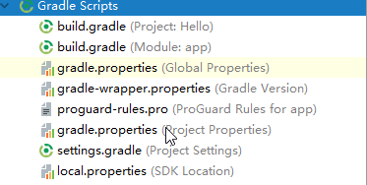

### 1.2.2 Project和Module的build.gradle详解

#### 1.2.2.1 Project的build.gradle文件

对应的build.gradle代码如下：

|  |
| --- |
| *// Top-level build file where you can add configuration options common to all sub-projects/modules.* buildscript { //这里是gradle脚本执行所需依赖，分别对应的maven库和插件    repositories {  google() //从AS3.0后新增了google()配置，可以引用google上的开源项目  jcenter() //是一个类似于github的代码托管仓库，声明了jcenter（）配置，可以轻松引用jcenter上的开源项目  }  dependencies {  classpath **'com.android.tools.build:gradle:3.1.3' //**此处是android的插件gradle，gradle是一个强大的项目构建工具，后面数字和AS版本号一样 *// NOTE: Do not place your application dependencies here; they belong  // in the individual module build.gradle files* } }  allprojects { //这里是项目本身需要的依赖，比如项目所需的maven库  repositories {  google()  jcenter()  } }  //运行gradle clean时，执行此处定义的task任务  //该任务继承自Delete，删除根目录中的build目录  //相当于执行Delete.delete（rootProject.buildDir）  //gradle使用groovy语言，调用method时可以不加（）。 task clean(**type**: Delete) {  delete rootProject.buildDir } |

##### repositories{}闭包：配置远程仓库

该闭包中声明了jcenter（）和google（）配置，其中jcenter是一个代码托管仓库，上面托管了很多Android开源项目，在这里配置了jcenter后我们可以在项目中方便引用jcenter上的开源项目，从AS3.0后新增了google（）配置，可以引用google上的开源项目。

##### dependencies{}闭包：配置构建工具

该闭包使用classpath声明了一个Gradle插件，由于Gradle并不只是用来构建Android项目，因此此处引入相关插件来构建Android项目，其中3.1.3为该插件的版本号，可以根据最新的版本号来调整。

#### 1.2.2.2 Module的build.gradle文件

从文件内容可以看出，主要分为三大部分，如图：

|  |
| --- |
| apply **plugin**: **'com.android.application'** android {  compileSdkVersion 28  defaultConfig {  applicationId **"com.example.lxiao.hello"** minSdkVersion 15  targetSdkVersion 28  versionCode 1  versionName **"1.0"** testInstrumentationRunner **"android.support.test.runner.AndroidJUnitRunner"** }  buildTypes {  release {  minifyEnabled **false** proguardFiles getDefaultProguardFile(**'proguard-android.txt'**), **'proguard-rules.pro'** }  } }  dependencies {  implementation fileTree(dir: **'libs'**, include: [**'\*.jar'**])  implementation **'com.android.support:appcompat-v7:28.0.0'** implementation **'com.android.support.constraint:constraint-layout:1.1.3'** testImplementation **'junit:junit:4.12'** androidTestImplementation **'com.android.support.test:runner:1.0.2'** androidTestImplementation **'com.android.support.test.espresso:espresso-core:3.0.2'** } |

##### apply plugin

|  |
| --- |
| //声明时Android程序  //com.android.application表示这是一个应用程序模块  //com.android.library表示这是一个库模块  //二者区别：前者可以直接运行，后者是依附别的应用程序运行  apply **plugin**: **'com.android.application'** |

apply plugin表示应用了一个插件，该插件一般有两种值可选：

1. ‘com.android.application’：表示该模块是应用程序模块，可以直接运行，打包得到的是.apk文件。
2. ‘com.android.library’：表示该模块为库模块，只能作为代码库依附于别的应用程序模块来运行，打包得到的是.aar文件。

##### android{}闭包

这个闭包主要为了配置项目构建的各种属性

###### 添加signingConfigs{}闭包

|  |
| --- |
| signingConfigs {// 自动化打包配置  release {// 线上环境  keyAlias 'test'  keyPassword '123456'  storeFile file('test.keystore')  storePassword '123456'  }  debug {// 开发环境  keyAlias 'test'  keyPassword '123456'  storeFile file('test.keystore')  storePassword '123456'  }  } |

可以手动添加签名配置，也可以通过Project Structure选中app，点击signing添加，具体如下

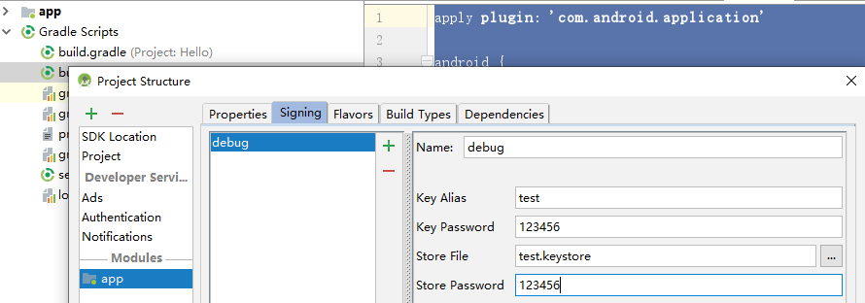

签名配置完成后可以方便带签名打包，在module的Build Variants有两个Type，分别是debug和release，

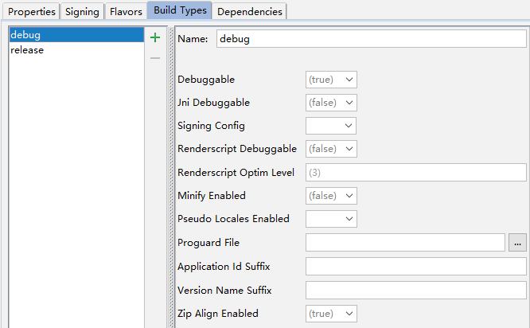

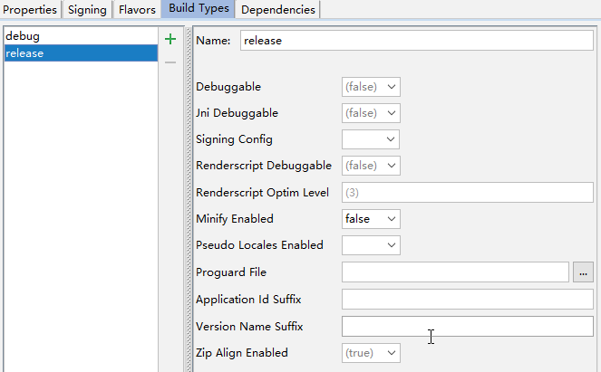

可以选择任意一个类型进行打包，并且他们会利用各自配置的Key进行打包。

打包有两种方法：

1. 执行Run app或Build->Build apk就会自动在module\_name/app/build/output/apk路径下生成apk文件，

这里我使用上面对debug的配置进行打包，因为没有生成keystore所以报错，

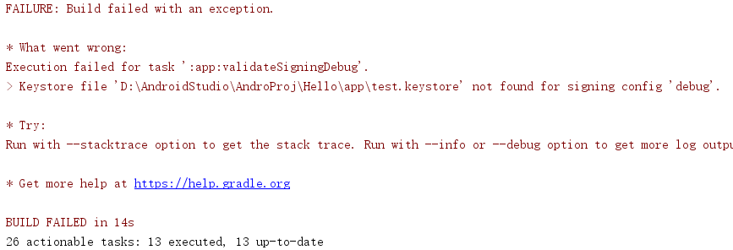

1. Build->Generate Signed APK填写签名信息生成Apk

###### compileSdkVersion

设置编译时用的Sdk版本

###### buildToolsVersion

设置编译时使用的构建工具的版本，AS3.0后取出此项

###### defaultConfig{}闭包

|  |
| --- |
| defaultConfig {  applicationId **"com.example.lxiao.hello"** minSdkVersion 15  targetSdkVersion 28  versionCode 1  versionName **"1.0"** testInstrumentationRunner **"android.support.test.runner.AndroidJUnitRunner"** } |

1. **applicationId**

指定了项目的包名。

1. **minSdkVersion**

指定项目最低兼容的版本，如果设备小于这个版本或者大于maxSdkVersion（一般不用）将无法安装这个应用，这里指定为15，表示最低兼容到Android4.0系统。

1. **targetSdkVersion**

指定项目的目标sdk版本，表示在该目标版本上已经做过充分测试，系统会为该应用启动一些对应该目标系统的最新功能特性以及Android系统平台的行为变更，只有targetSdkVersion的属性值被设置为大于或等于该系统平台的API版本时，才会生效。例如，若指定targetSdkVersion值为22，则表示该程序最高只在Android5.1版本上做过充分测试，在Android6.0系统上（对应targetSdkVersion为23）拥有的新特性如系统运行时权限等功能就不会被启用。

1. **versionCode**

表示版本号，一般每次打包上线时该值只能增加，打包后看不见。

1. **versionName**

表示版本名称，展示在应用市场上。

1. **testInstrumentationRunner**

“android.support.test.AndroidJUnitRunner”表明要使用AndroidJUnitRunner进行单元测试。

##### buildTypes闭包

这个闭包主要指定生成安装文件的主要配置，一般包含两个子闭包。

一个是debug闭包，用于指定生成测试版安装文件的配置，可以忽略不写。

另一个是release闭包，用于指定生成正式版安装文件的配置。

两者能配置的参数相同，最大的区别是默认属性配置不同，两种模式支持的属性配置如下：

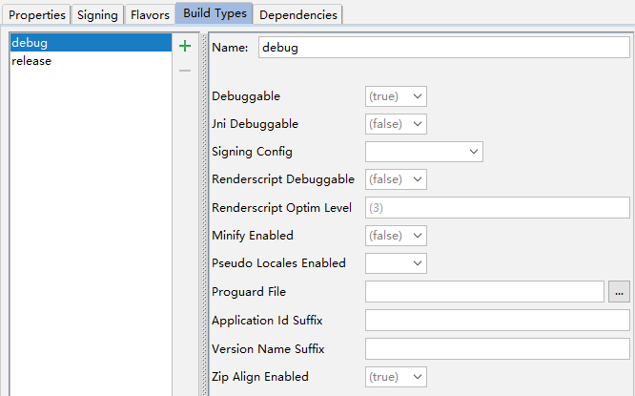

|  |
| --- |
| buildTypes {//生产/测试环境配置  release {//生产环境  buildConfigField("boolean", "LOG\_DEBUG", "false")//配置Log日志  buildConfigField("String", "URL\_PERFIX", "\"https://release.cn/\"")// 配置URL前缀  minifyEnabled false//是否对代码进行混淆  proguardFiles getDefaultProguardFile('proguard-android.txt'), 'proguard-rules.pro'//指定混淆的规则文件  signingConfig signingConfigs.release//设置签名信息  pseudoLocalesEnabled false//是否在APK中生成伪语言环境，帮助国家化的东西，一般用的不多  zipAlignEnabled true//是否对APK包执行ZIP对齐优化，减小zip体积，增加运行效率  applicationIdSuffix 'test'//在applicationId中添加了一个后缀，一般使用的不多  versionNameSuffix 'test'//在versionName中添加了一个后缀  }  debug {// 测试环境  buildConfigField("boolean", "LOG\_DEBUG", "true")//配置Log日志  buildConfigField("String", "URL\_PERFIX", "\"https://test.com/\"")// 配置URL前缀  minifyEnabled false//是否对代码进行混淆  proguardFiles getDefaultProguardFile('proguard-android.txt'), 'proguard-rules.pro'//指定混淆的规则文件  signingConfig signingConfigs.debug//设置签名信息  debuggable false//是否支持断点调试  jniDebuggable false//是否可以调试NDK代码  renderscriptDebuggable false//是否开启渲染脚本就是一些c写的渲染方法  zipAlignEnabled true//是否对APK包执行ZIP对齐优化，减小zip体积，增加运行效率  pseudoLocalesEnabled false//是否在APK中生成伪语言环境，帮助国际化的东西，一般使用的不多  applicationIdSuffix 'test'//在applicationId 中添加了一个后缀，一般使用的不多  versionNameSuffix 'test'//在versionName 中添加了一个后缀，一般使用的不多  }  } |

**release{}闭包和debug{}闭包两者能配置的参数相同，最大的区别是默认属性配置不同。**

1. **minifyEnabled**

表明是否对代码混淆，true表混淆，false表不进行混淆，默认是false。

1. **proguardFiles**

指定混淆的规则文件，这里指定了proguard-android.txt文件，proguard-android.txt为默认的混淆文件，里面定义了一些通用的混淆规则。proguard-rules.pro文件位于当前项目的根目录下，可以在该文件中定义一些项目特有的混淆规则。

1. **buildConfigField**

用于解决Beta版本服务和Release版本服务地址不同或者一些Log打印需求控制的。例如，配置buildConfigField（“boolean”，“LOG\_DEBUG”，“true”），这个方法接收三个非空的参数，第一个：确定值的类型，第二个：指定key的名字，第三个：传值，调用的时候BuildConfig.LOG\_DEBUG即可调用。

1. **debuggable**

表示是否支持断点调试，release默认为false，debug默认为true。

1. **jniDebuggable**

表示是否可以调试NDK代码，使用lldb进行C和C++代码调试，release默认为false。

1. **signingConfig**

设置签名信息，通过signingConfigs.release或者signingConfigs.debug，配置相应的签名，但是添加此配置前必须先添加signingConfigs闭包，添加相应的签名信息。

1. **renderscriptDebuggable**

表示是否开启渲染脚本，即一种c写的渲染方法，默认为false。

1. **renderscriptOptimLevel**

表示渲染等级，默认是3。

1. **pseudoLocalesEnabled**

是否在APK中生成伪语言环境。

1. **applicationIdSuffix**

和defaultConfig中配置是一样的，这里是在applicationId中添加一个后缀，一般使用不多。

1. **versionNameSuffix**

表示添加版本名称的后缀，一般使用的不多。

1. **zipAlignEnabled**

表示是否对APK包执行ZIP对齐优化，减小zip体积，增加运行效率，release和debug默认都是true。

##### sourceSets{}闭包：配置目录指向

|  |
| --- |
| sourceSets {//目录指向配置  main {  jniLibs.srcDirs = ['libs']//指定lib库目录  }  } |

配置jniLibs.srcDirs=[‘libs’]，可以在AS的Android视图下生成jniLibs文件夹，可以方便我们存放jar包和库文件，其中Android视图下的jniLibs和project视图下的libs指向同一文件夹（app->libs），如下图所示：

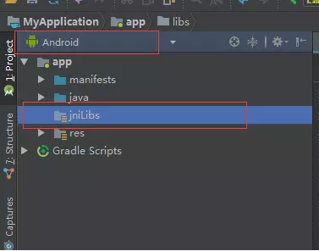

（不知道怎么生成）

##### packagingOptions{}闭包：打包时的相关配置

当项目中依赖的第三方库越来越多时，有可能会出现两个依赖库中存在同一个（名称）文件。如果这样，Gradle在打包时就会提示错误（警告）。那么就可以根据提示，然后使用以下方法将重复的文件剔除，比较常用的是通过exclude去除重复的文件，例如：

|  |
| --- |
| packagingOptions{  //pickFirsts作用是：当有重复文件时，打包会报错，这样配置会使用第一个匹配的文件打包进入apk  //表示当apk中META-INF目录下有重复的LICENSE文件时，只用第一个，这样打包就不会报错。  pickFirsts = ['META-INF/LICENSE']    //merges表示当出现重复文件时，合并重复的文件，然后打包入apk  //这个是有默认值的 merges=[]这样会把默认值去掉，所以我们用下面这种方式，在默认值后添加  merge 'META-INF/LICENSE'    //这个是在同时使用butterknife，dagger2做的一个处理。同理，遇到类似的问题，只要根据gradle的提示，做类似处理即可。  exclude 'META-INF/services/javax.annotation.processing.Processor'  } |

##### productFlavors{}闭包：多个渠道配置

这个配置是经常会使用的，通常在适配多个渠道的时候，需要为特定的渠道做部分特殊的处理，比如设置不同的包名，应用名等。场景：当我们使用友盟统计时，通常需要设置一个渠道ID，那么我们就可以利用productFlavors来生成对应渠道信息的包，如：

|  |
| --- |
| android {  productFlavors{  wandoujia{  *//豌豆荚渠道包配置* manifestPlaceholders=[**UMENG\_CHANNEL\_VALUE**:**"wandoujia"**]  *//manifestPlaceholders的使用在后续章节（AndroidManifest里的占位符）中介绍* }  xiaomi{  manifestPlaceholders=[**UMENG\_CHANNEL\_VALUE**:**"xiaomi"**]  applicationId **"com.wiky.gradle.xiaomi"** *//配置包名* }  \_360{  manifestPlaceholders=[**UMENT\_CHANNEL\_VALUE**:**"\_360"**]  }  *//...* } } |

也可以用更简洁的方式：

|  |
| --- |
| android {productFlavors{  wandoujia{}  xiaomi{}  \_360{}  *//...* }   productFlavors.all{  *//批量修改，类似一个循环遍历* flavor -> flavor.manifestPlaceholders=[**UMENG\_CHANNEL\_VALUE**: name]  } } |

配置完之后，在命令行窗口中（Terminal）中输入gradlew assembleRelease（windows）即可开始打包，在Mac系统中对应指令应该是./gradlew assembleRelease。当然，如果想要debug版本的包，将指令中assembleRelease改为assembleDebug即可。最后生成的包还是在app/build/outputs/apk中，默认命名格式如app-wandoujia-release-unisigned.apk，在module的Build Variants中可以选择相应的渠道。

注：AS3.0需在主app的build.gradle里面进行如下设置

|  |
| --- |
| defaultConfig { targetSdkVersion：\*\*\* minSdkVersion ：\*\*\* versionCode：\*\*\* versionName ：\*\*\*  //版本名后面添加一句话，意思就是flavor dimension它的维度就是该版本号，这样维度就都是统一的了  flavorDimensions “versionCode”  } |

##### lintOptions{}闭包：代码扫描分析

Lint是AS提供的代码扫描分析工具，它可以帮助我们发现代码结构/质量问题，同时提供一些解决方案，而且这个过程不需要我们手写测试用例。

Lint发现的每个问题都有描述信息和等级（和测试发现bug很相似），我们可以很方便地定位问题，同时按照严重程度进行解决。

|  |
| --- |
| *//程序在编译的时候会检查lint，有任何错误提示会停止build，我们可以关闭这个开关* lintOptions{  abortOnError **false** *//即使报错也不会停止打包* checkReleaseBuilds **false** *//打包release版本的时候进行检测* } |

##### dependencies{}闭包

该闭包定义了项目的依赖关系，一般项目都有三种依赖方式：本地依赖，库依赖和远程依赖。

1. 本地依赖可以对本地的jar包或目录添加依赖关系。
2. 库依赖可以对项目中的库模块添加依赖关系。
3. 远程依赖可以对jcenter库上的开源项目添加依赖关系。

从AS3.0后compile语法不再使用，而是通过API和implement代替，api完全等同于以前的compile，用api引入的库整个项目都可以用，用implementation引入的库只有对应的Module能使用，其他Module不能使用。

由于之前的项目统一用compile语法，导致的情况就是模块的耦合性太高，不利于项目拆解，使用implementation之后虽然使用起来复杂了但是做到降低耦合性提高安全性。

|  |
| --- |
| dependencies { //项目依赖关系  //本地jar包依赖  implementation fileTree(**include**: [**'\*.jar'**], **dir**: **'libs'**)   //远程依赖  implementation **'com.android.support:appcompat-v7:28.0.0'** //远程依赖  implementation **'com.android.support.constraint:constraint-layout:1.1.3'**  //声明测试用例库  testImplementation **'junit:junit:4.12'** androidTestImplementation **'com.android.support.test:runner:1.0.2'** androidTestImplementation **'com.android.support.test.espresso:espresso-core:3.0.2'** } |

1. **implementation fileTree(include: ['\*.jar'], dir: 'libs')**

implementation fileTree是一个本地依赖声明，表示将libs目录下所有.jar后缀的文件都添加到项目的构建路径当中。

1. **implementation 'com.android.support:appcompat-v7:28.0.0'**

该语句为远程依赖声明，‘**com.android.support:appcompat-v7:28.0.0**’ 为一个标准的远程依赖库格式，其中com.android.support为域名部分，用于区分不同公司的库；appcompat-v7为组件名称，用于区分同一个公司的不同库；28.0.0为版本号，用于区分同一个库的不同版本。加上这句声明后，Gradle在构建项目时会先检查一下本地是否已经缓存过该库，若没有缓存则自动联网下载，下载后自动添加到项目的构建路径中去。

1. **testImplementation和androidTestImplementation**

用于声明测试用例库。

# AndroidStudio的Project和Module

参考：

1. 官方文档：<https://developer.android.google.cn/studio/projects>
2. 概念补充：<https://www.jianshu.com/p/e861b759bf18>
3. 在app module引用library module：

<https://blog.csdn.net/qq_21358401/article/details/79042434>

## 是什么

### 3.1.1 Project

AS中的project包含everything that defines your workspace for an app，包括源码，assets，test codes，build configurations等。当开启一个新的project，AS会为你的所有文件创建必要的结构，同时使它们在Project Window可见。

### 3.2.2 Modules

#### （1） 概述

一个module是一个collection（包含source files和build settings），

它能将你的project分割为不同functionality的离散units。你的project

能有一个或多个modules，同时一个module能将另一个module作为

dependency。每个module能被独立地built，tested以及debugged。

额外的modules通常是有用的，这个体现在当你在自己的project中创

建code libraries或当你想为不同的device types（比如phones和

wearables）创建不同的sets of code以及resources，但同时又想将所有

文件放在一个project中让它们共享部分代码。

可以通过以下方式在project中添加module：**File > New > New Module**.

#### （2） Module详解

AS提供了一些不同功能的module：

##### Android app module

这个module为你app的source code，resource files以及app level settings（如module-level build files以及Android Manifest文件）提供了一个container。当你创建一个新的project，默认module名为“app”。

在**Create New Module窗口，AS提供了如下类型的app modules：**

1. Phone & Tablet Module
2. Wear OS Module
3. Android TV Module
4. Glass Module

以上模块每个都提供了必要文件以及一些代码模板（适用于相关app或设备类型）。

添加module的详细指南可看官方文档：

<https://developer.android.google.cn/studio/projects/add-app-module.html>

##### Feature module

代表可以利用Play Feature Delivery 的你app的模块化特性。比如，如果用了feature modules，你能通过[Google Play Instant](https://developer.android.google.cn/topic/google-play-instant/overview)向用户提供应用程序按需的特定功能或即时体验。

具体看官方文档： [Add support for Play Feature Delivery](https://developer.android.google.cn/studio/projects/dynamic-delivery)

##### Library module

该模块为你可重用代码提供了一个container，你可以将它作为其他app modules的依赖库，或者在其他projects中import它。就结构而言，一个library module和app module相同，但当build时，它生成一个code archive file而不是apk，所以它无法被安装在设备上。

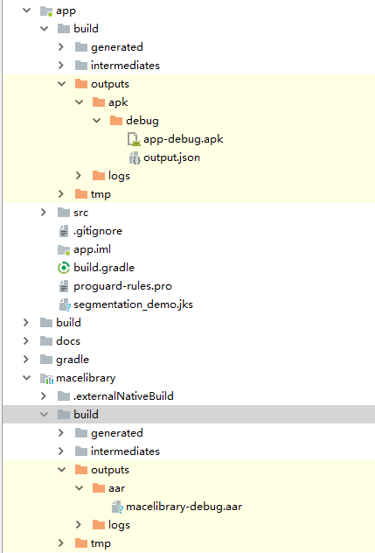

在**Create New Module窗口，AS提供了以下library modules：**

1. Android Library

这种类型的library包含Android project中支持的所有文件类型，包括source code，resources以及manifest files。build后得到Android Archive（AAR）文件，你可以为你的Android app modules添加该文件作为dependency。

1. Java Library

这种类型的library仅仅能包含Java source file。build后是Java Archive（JAR）file，你可以将它作为一个依赖add给你的Android app modules或其他Java projects。

关于Android library的详细见：[Android Library](#_Android_Library)

##### Google Cloud module

为你的Google Cloud backend code提供了一个container。该模块有Java App Engine backend所需的代码和依赖项，通过使用简易的HTTP，Cloud Endpoints以及Cloud Messaging来连接到你的app。你自己可以开发backend来为你的app提供定制的cloud services。

更多信息该模块信息，看官方文档：

<https://cloud.google.com/tools/android-studio/app_engine/run_test_deploy>

#### 使用

也有人将模块称为子项目，这没关系，因为 Gradle 也将模块称为项目。若你想将library module添加为Android app module的依赖，必须进行如下声明：

|  |
| --- |
| dependencies {   compile project(':my-library-module') } |

# AndroidStudio工具栏

参考：<https://developer.android.com/studio/run>

测试：AS4.0.1

安装应用后，您可以使用 [Apply Changes](https://developer.android.com/studio/run#apply-changes) 部署特定代码和资源更改，而无需构建新的 APK。

如需构建和运行您的应用，请按以下步骤操作：



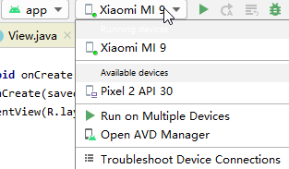

如果您未配置任何设备，则需要[通过 USB 连接设备](https://developer.android.com/studio/run/device" \l "connect)或[创建 AVD](https://developer.android.com/studio/run/managing-avds#createavd) 来使用 [Android 模拟器](https://developer.android.com/studio/run/emulator)。

**注意**：您也可以通过点击 **Debug** 图标 ，在调试模式下部署应用。在调试模式下运行应用可让您在代码中设置断点、在运行时检查变量和对表达式求值，以及运行调试工具。如需了解详情，请参阅[调试您的应用](https://developer.android.com/studio/debug)。

## 更改运行/调试配置

当您首次运行应用时，Android Studio 使用默认运行配置。运行配置用于指定要通过 APK 还是 [Android App Bundle](https://developer.android.com/guide/app-bundle) 部署您的应用、要运行的模块、要部署的包、要启动的 Activity、目标设备、emulator settings、logcat 选项等等。

默认的运行/调试配置 能构建 APK，启动默认的project Activity，并使用**Select Deployment Target**对话框选择目标设备。如果默认设置不适合您的项目或模块，您可以自定义运行/调试配置，也可以在Project、default和Module级别创建新配置。如要修改run/debug配置，请依次选择 **Run > Edit Configurations**。如需了解详情，请参阅 [Create and Edit Run/Debug Configurations](https://developer.android.com/studio/run/rundebugconfig)。

## 更改build variant

默认情况下，在您点击 **Run** 后，

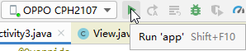

Android Studio会构建应用的debug版本，不过这仅供在开发期间使用。

如要更改 Android Studio 使用的build variant，请在菜单栏中依次选择 **Build** > **Select Build Variant**。

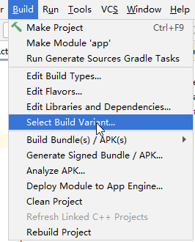

到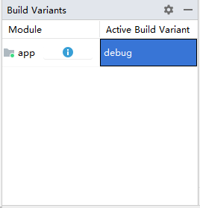。

对于不含native/C++代码的项目，**Build Variants**面板有两列：**Module** 和 **Active Build Variant**。模块的 **Active Build Variant** 值决定了IDE部署到你连接设备的和在editor中可见的是哪个build variant。

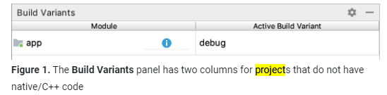

如需在variants之间切换，点模块的**Active Build Variant单元格，**然后从列表字段中选择所需的variants。

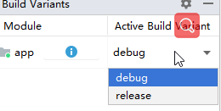

对于含有native/C++ 代码的项目，**Build Variants** 面板有三列：**Module**、**Active Build Variant** 和 **Active ABI**。模块的 **Active Build Variant** 值决定了 IDE 部署到设备并显示在editor中的构建变体。对于native模块，**Active ABI** 值决定了editor使用的 [ABI](https://developer.android.com/ndk/guides/abis)，但不会影响部署的内容。

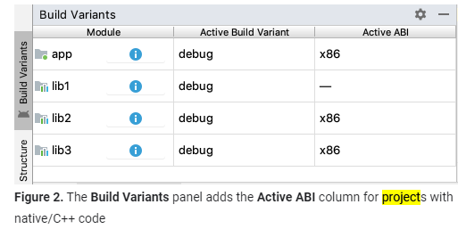

如要更改build variants或 ABI，请点击 **Active Build**

**Variant** 或 **Active ABI** 列的单元格，然后从列表中选择所需的variants或 ABI。您更改选择后，IDE 会自动同步您的项目。 更改app或library module的任一列都会将更改应用于所有相关行。

默认情况下，新Project设置有两个build variants：debug和release variants。您需要构建release variant，以便[为应用的公开发布做好准备](https://developer.android.com/studio/publish/preparing)。

如需构建应用的其他variations（每个变体具有不同的特点或设备限制），你能 [define additional build variants](https://developer.android.com/studio/build/build-variants)。

## 构建你的Project

**Run**  button用于build应用并将其deploy到设备。不过，要build应用以共享或上传到 Google Play，您需要使用**Build** 菜单中的某个选项来编译project的部分或全部代码。在选择表 1 中列出的任意build选项之前，请务必先[select the build variant](https://developer.android.com/studio/run#changing-variant)。

注：Android Studio 需要 AAPT2 来构建 app bundle，默认情况下，会为新projects启用该工具。不过，如需确保为现有projects启用该工具，请在 **gradle.properties**  文件中添加  **android.enableAapt2=true**，并通过从命令行运行 **./gradlew --stop** 来重启 Gradle 守护进程。

**表 1.** **Build** 菜单中的build选项。

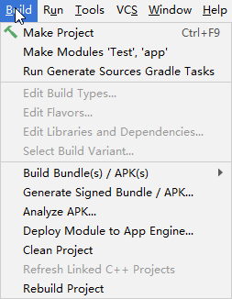

|  |  |
| --- | --- |
| 菜单项 | 说明 |
| Make Module | 编译自上次build以来已修改的所选模块中的所有源文件，以及所选模块以递归方式依赖的所有模块。编译包括dependent源文件和所有关联的build tasks。您可以通过在 Project 窗口中选择模块名称或模块的某个文件来选择要build的模块。此命令不会生成 APK。（3.1.3和4.0.1中都生成了APK）    和 |
| Make Project | make所有模块。 |
| Clean Project | 删除所有intermediate/cached的build文件。 |
| Rebuild Project | 针对所选build variant运行 Clean Project 并生成 一个APK。 |
| Build Bundle(s)/APK(s) > Build APK(s) | 为当前项目中每个模块根据其所选的variant来各自build一个 APK。build完成后，系统将显示确认通知，提供指向 APK 文件的链接以及用于在[APK Analyzer](https://developer.android.com/studio/build/apk-analyzer)中对其进行分析的链接。  如果您选择的build variant是debug build type，则使用a debug key为 APK 签名，然后就可以安装了。如果您选择了release variant，则默认情况下，APK 处于未签名状态，您必须手动 [sign the APK](https://developer.android.com/studio/publish/app-signing)。 或者，您也可以从菜单栏中依次选择 Build > Generate Signed Bundle/APK。  Android Studio 会将您build的 APK 保存在 **project-name**/**module-name**/build/outputs/apk/ 中。 |
| Build Bundle(s)/APK(s) > Build Bundle(s) | 为所选的variant，build当前项目中所有模块的 [Android App Bundle](https://developer.android.com/guide/app-bundle)。构建完成后，系统将显示确认通知，提供指向 app bundle 的链接以及用于在  [APK Analyzer](https://developer.android.com/studio/build/apk-analyzer)中对其进行分析的链接。  如果您选择的构建变体是debug build type，则系统会使用debug key为 app bundle 签名，您可以用[bundletool](https://developer.android.com/studio/command-line/bundletool) 通过 app bundle 将应用部署到连接的设备。如果您选择了release variant，则默认情况下，app bundle 处于未签名状态，您必须使用[jarsigner](https://docs.oracle.com/javase/8/docs/technotes/tools/windows/jarsigner.html)手动为其签名。 或者，您也可以从菜单栏中依次选择 Build > Generate Signed Bundle/APK。  Android Studio 会将您构建的 APK 保存在 **project-name**/**module-name**/build/outputs/bundle/ 中。 |
| Generate Signed Bundle/APK | 使用向导打开一个对话框以设置新的签名配置，并build已签名的 app bundle 或 APK。您需要先使用release key为您的应用签名，然后才能将其上传到 Play Console。如需详细了解应用签名，请参阅[Sign your app](https://developer.android.com/studio/publish/app-signing)。 |

注1： **Run**  button builds可以在设置了 **[testOnly="true"](https://developer.android.com/guide/topics/manifest/application-element" \l "testOnly)** 的情况下build APK，这意味着，只能通过 **[adb](https://developer.android.com/studio/command-line/adb)** （Android Studio使用）安装 APK。如果您想要无需 adb 即可安装的可调试 APK，请选择您的调试变体，然后依次点击 **Build Bundle(s)/APK(s) > Build APK(s)**。

如需详细了解 Gradle 针对每个command执行的task，请按照下一部分中的说明打开 **Build** 窗口。如需详细了解 Gradle 和build流程，请参阅 [Configure Your Build](https://developer.android.com/studio/build)或[本文](#_Configure_your_build)。

注2：因为经过实践make project和build apks都会生成apk，和文档中不同，目前两者经过测试区别是make project会build所有module（包括app和library）而build apks只会build所有app模块及其依赖的library模块，那这里就按如下规定：

1. 若要针对特定app module生成apk，就用make module；
2. 若要为所有app module生成apk，就用build apks；
3. 若要编译所有module（包括app和library），就用make project。

## 监控build过程

您可以通过依次点击 **View > Tool Windows > Build**（或点击工具窗口栏中的 **Build** 图标 ），查看有关build流程的详细信息。

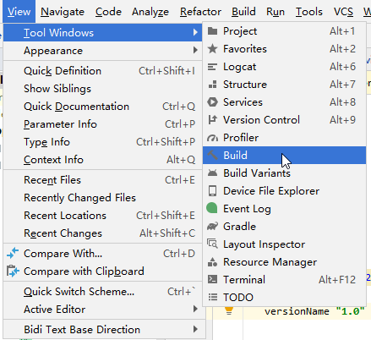

该窗口显示 Gradle 为build应用而执行的tasks，如图 3 所示。

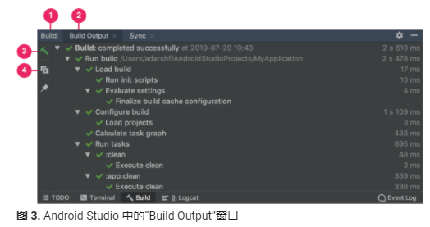

1. **“Build”标签页**：以树状显示 Gradle 执行的任务，

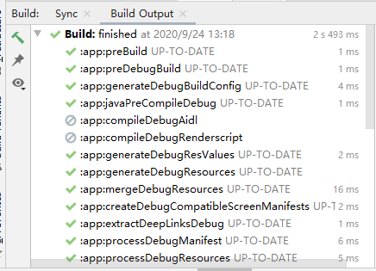

其中每个节点表示一个构建阶段或一组任务依赖项。如果您收到构建时错误或编译时错误，可以检查该树并选择一个元素来查看错误输出，如图 4 所示。

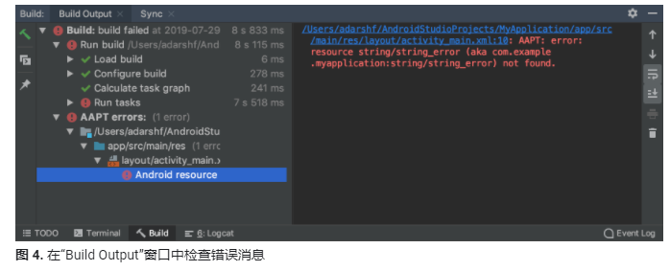

1. **“Sync”标签页**：显示 Gradle 为与project文件同步而执行的task。与 **Build** 标签页类似，如果您遇到同步错误，可以在树中选择元素来查找有关错误的更多信息。

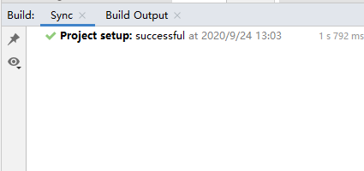

1. **Restart**：通过为project中的所有modules生成对应的intermediate build文件，执行和进行 **Build > Make Project** 相同的操作。

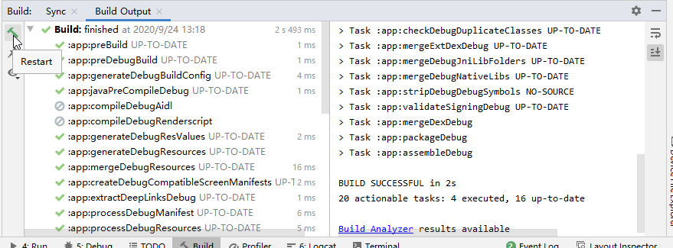

1. **Toggle view**：在以图形树形式显示任务执行情况与显示 Gradle 中更详细的文本输出（这与在 Android Studio 3.0 及更低版本上的 **Gradle Console**  窗口中显示的输出相同）之间切换。

注：在AS4.0.1中无

如果您的build variants使用product flavors，Gradle也会调用tasks来build那些product flavors。如需查看所有可用build tasks的列表，点 **View > Tool Windows > Gradle** （或点工具窗口栏中的**Gradle** 图标 ）。

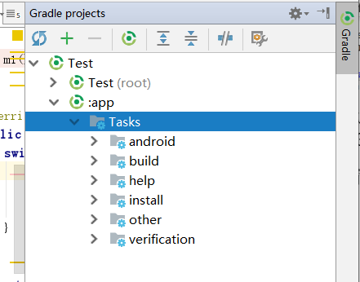

如果在build流程中出现错误，Gradle 可能会向您推荐一些命令行选项来帮助您解决问题，如--stacktrace or –debug。如需在build流程中使用命令行选项，请执行以下操作：

1. 打开 **Settings** 或 **Preferences** 对话框：
2. 在 Windows 或 Linux 上，从菜单栏中依次选择 **File** > **Settings**。
3. 在 Mac OSX 上，从菜单栏中依次选择 **Android Studio** > **Preferences**。
4. 依次转到 **Build, Execution, Deployment** > **Compiler**。
5. 在“Command-line Options”旁边的文本字段中，输入您的命令行选项。

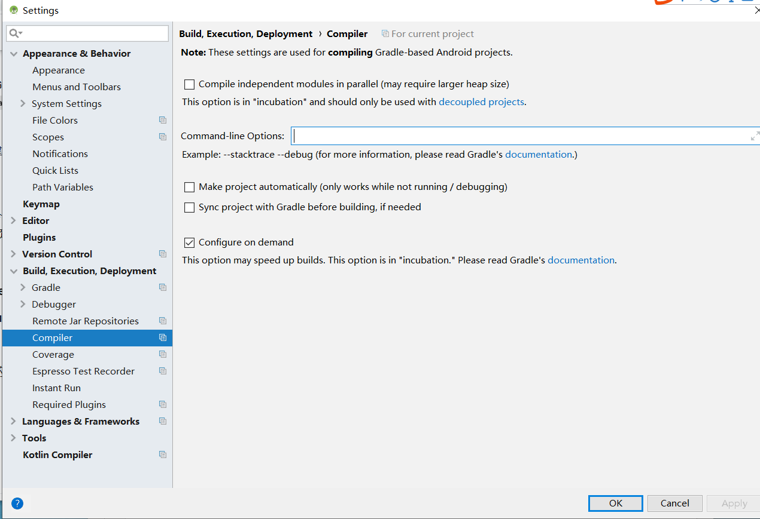

1. 点击 **OK** 保存，然后退出。

当您下次尝试build应用时，Gradle 会应用这些命令行选项。

## Apply Changes

在 Android Studio 3.5 及更高版本中，Apply Changes 可让您将代码和资源更改推送给正在运行的应用，而无需重启应用（在某些情况下，甚至无需重启当前的 Activity）。当您要部署和测试小范围的更改，同时保持设备的当前状态时，这种灵活性可帮助您控制应用的重启程度。Apply Changes使用搭载 Android 8.0（API 级别 26）或更高版本的设备上支持的[capabilities in the Android JVMTI implementation](https://docs.oracle.com/javase/8/docs/platform/jvmti/jvmti.html" \l "bci)。如需详细了解 Apply Changes 的工作原理，请参阅 [Android Studio Project Marble：Apply Changes](https://medium.com/androiddevelopers/android-studio-project-marble-apply-changes-e3048662e8cd)。

### 条件

Apply Changes 操作仅在满足以下条件时可用：

* 您使用debug build variant来构建应用的 APK。
* 您将应用部署到搭载 Android 8.0（API 级别 26）或更高版本的目标设备或模拟器上。

### 使用Apply Changes

如果要将更改部署到兼容设备，请使用以下选项：

#### Apply Changes and Restart Activity 图标



尝试通过重启 Activity 但不重启应用来进行资源和代码更改。通常，如果您修改了一个方法中的代码或修改了一个已有的资源，则可以使用此选项。

您也可以按 Ctrl+Alt+F10（或者，在 macOS 上，按 Control+Shift+Command+R）来执行此操作。

#### Apply Code Changes 图标

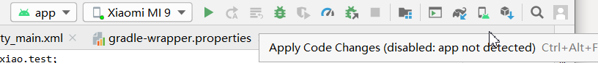

尝试仅应用代码更改而不重启任何内容。 通常，如果您修改了一个方法中的代码，但没有修改任何资源，则可以使用此选项。如果您既修改了代码，又修改了资源，则应改用 **Apply Changes and Restart Activity**。

您也可以按 Ctrl+F10（或者，在 macOS 上，按 Control+Command+R）来执行此操作。

#### Run 图标

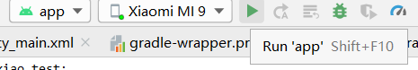

部署所有更改并重启应用。如果使用任一 Apply Changes 选项都无法应用您所做的更改，请使用此选项。如需详细了解哪些对project的改变需要重启应用，见[Limitations of Apply Changes](https://developer.android.com/studio/run#apply-changes-limitations)。

## 为 Apply Changes 启用 Run 回退机制

在您点击 **Apply Changes and Restart Activity** 或 **Apply Code Changes**, Android Studio 会构建新的APK 并决定是否可以应用更改。 若无法应用更改并且会导致 Apply Changes 失败，则 Android Studio 会提示您重新运行您的应用（通过点击“Run”图标 ）。不过，如果您不想在每次发生这种情况时都收到提示，则可以将 Android Studio 配置为在无法应用更改时自动重新运行您的应用。

如需启用此功能，请按以下步骤操作：

【1】 打开 **Settings** 或 **Preferences** 对话框：

* 在 Windows 或 Linux 上，从菜单栏中依次选择 **File > Settings**。
* 在 macOS 上，从菜单栏中依次选择 **Android Studio > Preferences**。

【2】 依次转到 **Build, Execution, Deployment > Deployment**。

【3】 选中复选框以针对任一 Apply Changes 操作启用自动 Run fallback。

【4】 点击**确定**。

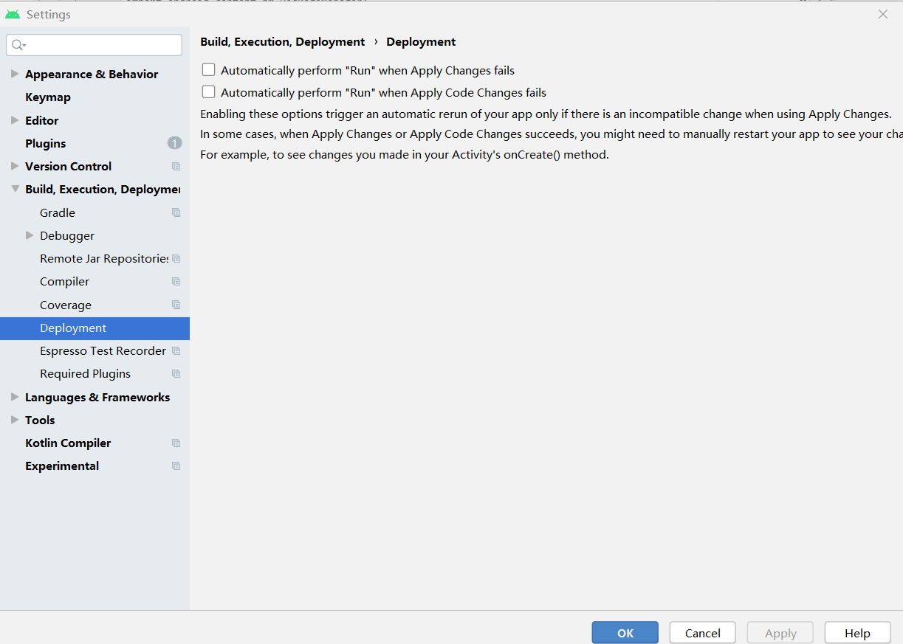

**注意**：某些类型的更改不会导致 Apply Changes 失败，但仍然要求您手动重启应用，然后才能看到这些更改。例如，如果您更改了某个 Activity 的 **[onCreate()](https://developer.android.com/reference/android/app/Activity" \l "onCreate(android.os.Bundle))** 方法，则只有在该 Activity 重新启动后，这些更改才会生效，因此您必须restart your app才能看到这些更改。

## Apply Changes的限制

Apply Changes 旨在加快应用部署流程。不过，它的使用时机存在一些限制。如果您在使用 Apply Changes 时遇到任何问题，请[提交错误](https://issuetracker.google.com/issues/new?component=550294&template=1207130)。

### 需要重启应用才能实现的代码更改

某些代码和资源更改必须在重启应用之后才能进行，其中包括以下更改：

* 添加或删除method或field
* 更改method signatures
* 更改方法或类的修饰符
* 更改类继承行为
* 更改枚举中的值
* 添加或移除资源
* 改变app manifest
* 更改native libraries（SO 文件）

### 库和插件

某些库和插件会自动更改应用的manifest files或manifest中引用的resources。这些自动更新可能会通过以下方式干扰 Apply Changes：

* 如果库或插件更改了应用的manifest，您不能使用 **Apply Code Changes** 或 **Apply Changes and Restart Activity** ，而必须重启应用，然后才能看到相应更改。
* 如果库或插件更改应用的resources files，您不能使用 **Apply Code Changes** ，而必须使用 **Apply Changes and Restart Activity** 来查看相应更改。

您可以通过为 debug build variants停用所有自动更新来避免这些限制。

For example, Crashlytics updates app resources with a unique build ID during every build, which prevents you from using **Apply Code Changes**  and requires you to restart your app's activity to see your changes. You can [disable this behavior](https://developer.android.com/studio/build/optimize-your-build#disable-crashlytics-build-id) so that you can use **Apply Code Changes** alongside Crashlytics with your debug builds.

### 直接引用已安装 APK 中的内容的代码

如果您的代码直接引用已在设备上安装的应用 APK 中的内容，在您点击 **Apply Code Changes** 图标后，该代码可能会导致崩溃或出现异常。发生此行为的原因是，当您点击 **Apply Code Changes** 时，设备上的已有 APK 会在安装过程中被替换。在这些情况下，您可以改为点击 **Apply Changes and Restart Activity** 图标 或 **Run** 图标 。

## （8） Gradle视窗

参考：<https://www.jetbrains.com/help/idea/jetgradle-tool-window.html>

注：这里以AS4.0.1为例（包含1个app module和2个library module）



The Gradle tool window is enabled automatically when you [create](https://www.jetbrains.com/help/idea/gradle.html#gradle_create_project) or [open](https://www.jetbrains.com/help/idea/gradle.html#gradle_import_project_start) your Gradle project. Click **Gradle** on the right sidebar to open the tool window. The tool window displays the Gradle linked projects, their tasks, dependencies, and all changes made to the underlying **build.gradle** file.

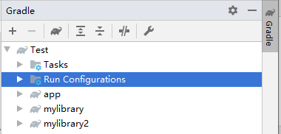

If you removed the Gradle tool window from the sidebar, select **View | Tool Windows | Gradle** from the main menu to reopen it.

### 【1】 Gradle视图操作

#### 《1》

Click this button to open the menu for configuring the current view and changing the tool window viewing modes. The menu items are options that you can turn on or off. An active item contains a check mark（√） on the left side of its name.

The available options in the menu are as follows:

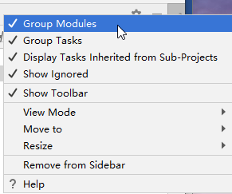

##### 1） Group Module

 select this option if you want to group modules in the project.

##### 2） Group Tasks

select this option if you want to group your tasks. For example, build tasks will be included into the **build** directory.

##### 3） Display Tasks Inherited from Sub-Projects

As官网说sub-project指modules

（https://developer.android.com/studio/projects）

##### 4） Show Ignored

select this option to display the [ignored projects](https://www.jetbrains.com/help/idea/work-with-gradle-projects.html#ignore_detach_gradle_project).

##### 5） Show Toorbar

select this option to show the toolbar for your Gradle projects.

就是有和没有。

##### 6） View Mode

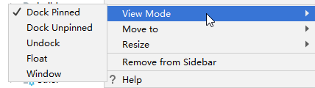

these options let you control general appearance and behavior of the tool window（就是Gradle这个窗口的显示方式）

参考：<https://www.jetbrains.com/help/idea/viewing-modes.html>

The following tool window view modes are available:

1》 Dock pinned

This is the default view mode when the tool window is attached to the tool window bar and is always visible along with the editor and other pinned tool windows.（即总是固定在tool window bar，能显示）

2》 Dock unpinned

The tool window is attached to the tool window bar but is visible only when it is active. It does not obstruct the editor or other tool windows.

3》 Undock

The tool window is attached to the tool window bar and covers a part of the editor or other tool windows when active. It is not visible when another tool window is active.（即若有其他tool window在使用，这个就不会显示）

4》 Float

The tool window is detached from the tool window bar, floating on top of the main window. It is visible only together with the main project window.（即是浮动的，可自由移动）

5》 Window

The tool window acts as a separate application window. You can view it independently from the main project window and even move it to a different monitor or desktop.

##### 7） Move to

select this option to move the Gradle tool window to either top, left or right.

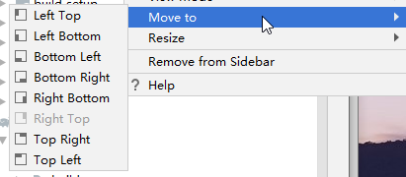

就是把这个tool window移到整个AS的可选位置。

##### 8） Resize

select this option to resize the Gradle tool window.

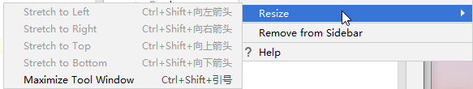

即重置该tool window的大小。

##### 9） Remove from Sidebar

将tool window移除。

#### 《2》

Hide the tool window

### 【2】 Gradle Tasks

#### 《1》 Tasks This area contains a list of all available tasks.

#### 《2》 Run Configurations

This area contains a list of the last executed tasks and command types under which these tasks were executed.

### 【3】 Toolbar



#### 《1》

Click this button to [link](https://www.jetbrains.com/help/idea/gradle.html#link_gradle_project) a Gradle project.

即可添加一个新的gradle project。

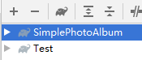

#### 《2》

Click this button to [detach](https://www.jetbrains.com/help/idea/work-with-gradle-projects.html#ignore_detach_gradle_project) an external Gradle project.

即可去掉一个gradle project

#### 《3》 Use this button to [execute a Gradle task](https://www.jetbrains.com/help/idea/work-with-gradle-tasks.html#gradle_tool_bar). When you click this icon, the Run Anything window opens. Enter a name of the task that you want to execute. To execute several tasks, enter task names using space to separate each new task.

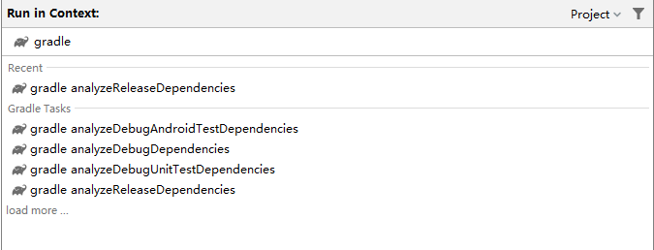

#### 《4》

展开或收拢所有节点。

#### 《5》 Click this button to work with Gradle projects in the [offline mode](https://www.jetbrains.com/help/idea/working-offline.html#gradle). In this case Gradle will use dependencies from the cache. Gradle will not attempt to access the network to perform dependency resolution. If the required dependencies are not present in the cache, build execution will fail. Also, if the offline mode is enabled, the opening and syncing of your project might fail.

即使用cache中的dependencies，而不是从网络中获取。

参考：<https://www.jetbrains.com/help/idea/working-offline.html#gradle>

By default, Gradle connects to remote repositories and checks for updates on every launch. Resolving Gradle dependencies can require downloading new artifacts. You can switch to offline mode if you want Gradle to use only those resources that are available locally.

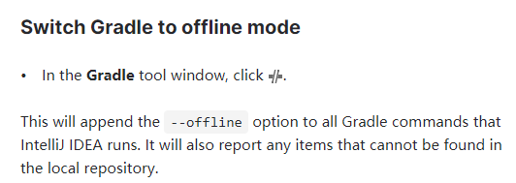

#### 《6》

Use this icon to access the **Gradle Settings**

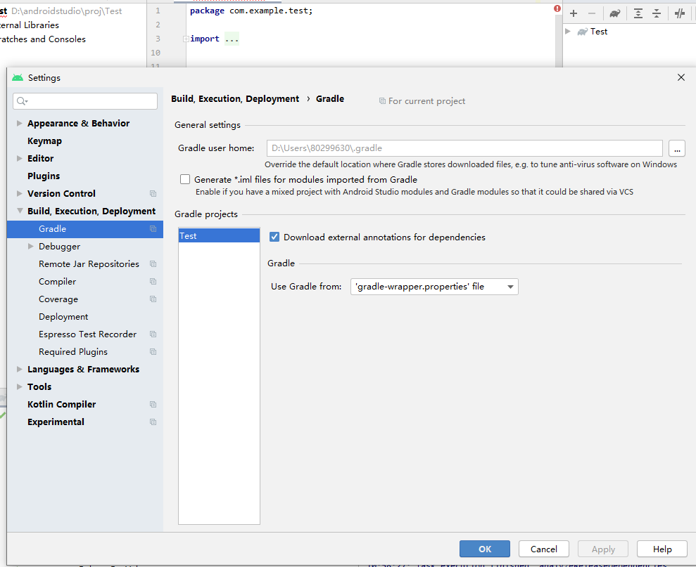

## （9） Git Navigation Bar（导航栏）



### 【1】 选项

《1》 Update Project 

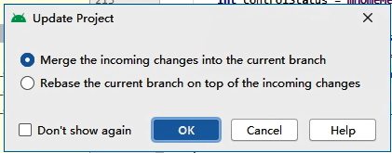

《2》 Commit Changes 

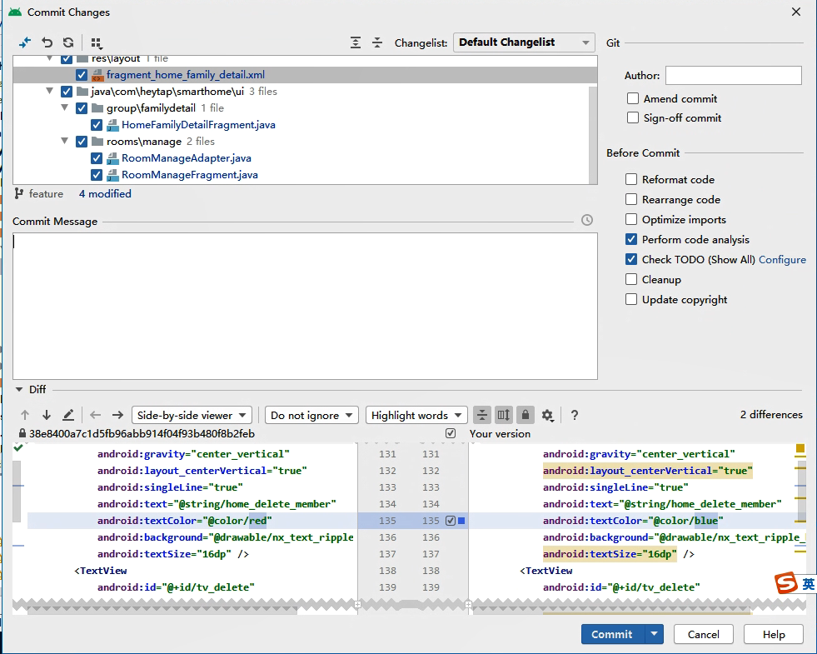

《3》 Show History 

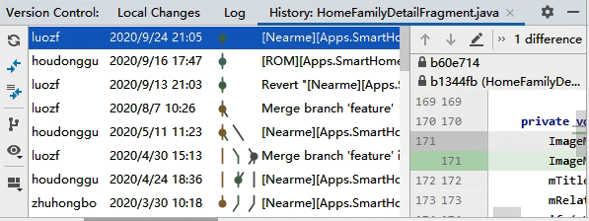

《4》 Rollback Changes

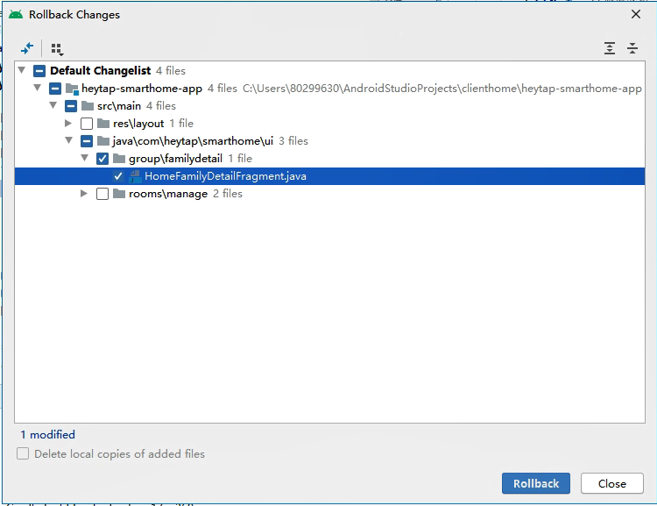

# Android Library

参考：<https://developer.android.com/studio/projects/android-library>

一个Android library和一个Android app module在结构上相同。它能包含用于build an app所需的一切，包含source code, resource files, and an Android manifest。但是，而不是编译为一个APK来在一个设备上运行，一个Android library编译为一个Android Archive（AAR）file（可被用作一个Android app module的依赖）。不像JAR files，AAR files为Android applications提供以下功能：

（1） AAR files能包含Android resources和a manifest file，其允许你除了Java classes和methods还能bundle in共享资源，如layouts和drawables

（2） AAR files能[contain C/C++ libraries](https://developer.android.com/studio/build/native-dependencies)，供app modules的C/C++ code使用。

一个library module在以下情况有用：

（1） 当你正build多个apps，它们使用一些相同的组分，如activities, services, or UI layouts.

（2） 当你正build一个app，其存在多个APK variations，如一个免费和付费版本，但两者都需要相同的核心组分。

在以上任一情况下，仅需要移动你想要重用的文件到一个library module中，然后为每个app module添加该library作为一个依赖。

该页教你如何做。

## （1） Create a library module

To create a new library module in your project, proceed as follows:

1. Click **File > New > New Module**.
2. In the **Create New Module** window that appears, click **Android Library**, then click **Next**.

还有一个选项是创建一个**Java Library**，其构建一个传统的JAR file。虽然一个JAR file对许多projects是有用的—特别是当你想和其他平台共享代码—它不允许你包含Android resources或manifest files（这两者在Android projects中对代码重用是很有用的）。因此该指南focuses on创建Android libraries。

1. Give your library a name and select a minimum SDK version for the code in the library, then click **Finish**.

一旦Gradle project sync完成，library module出现在左侧的**Project**面板中。若没看到新的module folder，确保当前在 [Android view](https://developer.android.com/studio/projects#ProjectFiles)中。

### Convert an app module to a library module

若你有一个已有的app module，其中有你要重用的所有代码，你能通过以下方法将其转为一个library module：

1. 打开module-level build.gradle file；
2. 删除有applicationId的行。只有一个Android app module能定义这个；
3. At the top of the file, you should see the following:

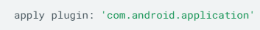

Change it to the following:

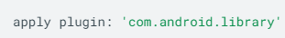

1. Save文件并点击**File > Sync Project with Gradle Files**.

Module的整个结构在转换前后还是相同的，但它现在按Android library来操作，同时build现在将创建一个AAR file而不是一个APK。

当你想build AAR file，在Project窗口选择library module，然后点**Build > Build APK。**

## （2） Choose resources to make public

为了在另一个app module中使用你的Android library的代码，进行如下：

* 1. 将library添加到你的project按以下任一方式（若你在相同的project中创建了library module，则它已经在那了，你能跳过该步骤）：

暂不看

* 1. 确保library被列在settings.gradle file的最上面，如下：

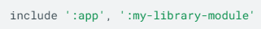

* 1. 打开app module的build.gradle file并将一个新行添加到dependencies块中，如下：

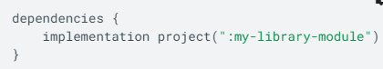

* 1. 点击**Sync Project with Gradle Files**

在上面例中，implementation语句添加了库名为my-library-module作为整个app module的a build dependency。若你只想将library用于一个特定[build variant](https://developer.android.com/studio/build/build-variants)，则应该用

**buildVariantName**Implementation 形式。如，若你想在你的“pro”product flavor中include the library，如下：

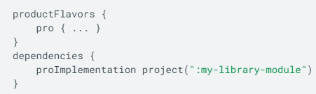

任何Android library中的code和resources现在对于你的app module都是可访问的，同时library AAR file在build时被bundled into你的APK。

但是，若你想共享你的AAR file，你能在

找到它，同时你能重新生成它通过点击。

**Note**: To learn more about dependency management, read [Use variant-aware dependency management](https://developer.android.com/studio/build/gradle-plugin-3-0-0-migration#variant_aware).

## Choose resources to make public

暂不看，是关于library resources的访问权限设置

## Development considerations for library modules

暂不看，是关于library modules的优先级

## Anatomy of an AAR file

AAR file的file extension是.aar，同时Maven artifact type也应为aar。文件本身是一个zip file。唯一的必有项是/AndroidManifest.xml。

此外，一个AAR file可能包含一个或多个以下可选项：

* /classes.jar
* /res/
* /R.txt
* /public.txt
* /assets/
* /libs/**name**.jar
* /jni/**abi\_name**/**name**.so (where **abi\_name** is one of the Android [supported ABIs](https://developer.android.com/ndk/guides/abis#sa))
* /proguard.txt
* /lint.jar
* /api.jar
* /prefab/ for [exporting native libraries](https://developer.android.com/studio/build/native-dependencies)

# Make project和build apk区别

## 博客

参考：

1. <https://stackoverflow.com/questions/35334319/difference-between-make-project-make-module-app-build-apk-and-generate-signed>
2. <https://stackoverflow.com/questions/20375863/difference-between-make-and-build-in-android-studio>

Most of the time you should use **Make Project**.  Sometimes, after adding libraries and making big changes to the project you should use **Rebuild Project**.

**Make Project**:表示你将创建一个real application，其会运行在一个device上，且有一个可执行文件如APK。

**Make Module**:表示你将为你的application创建一个library，其和那个project一起执行且没有可执行文件如APK，但有一个.aar file，其作为一个library运行。

**Build APK:当你正常地run你的application，一个APK file将在本地生成，其像一个ZIP file，且很容易解压，没有安全措施被实施，且你能从那个APK file得到code。它主要用于本地测试。**

**Signed APK:你能创建一个有密码和安全性的APK，不是很好解压，且用于成品。**

**但从实践来看，Make Project和Build APK看起来没区别。都会为每个module生成build文件夹。**

## ****参考Intellij IDEA****

**参考：**<https://www.jetbrains.com/help/idea/compiling-applications.html>

**Intellij版本：2019.3**

IntelliJ IDEA的compilation和building过程编译源文件并将外部库、属性文件和配置结合在一起，从而生成一个可运行的应用程序。IntelliJ IDEA使用了一个根据Java规范 运行的编译器。

你能compile a single file，对一个module或一个project使用incremental build，以及rebuild a project from scratch。

如果您有一个纯Java或Kotlin项目，我们建议您使用IntelliJ IDEA来构建您的项目，因为IntelliJ IDEA支持incremental build，这可以显著加快构建过程。

然而，若build script file使用自定义plugins或tasks，Intellij IDEA native builder可能不能正确build Gradle或Maven project。这种情况下， 对[Gradle](https://www.jetbrains.com/help/idea/work-with-gradle-projects.html" \l "delegate_build_actions) 或[Maven](https://www.jetbrains.com/help/idea/delegate-build-and-run-actions-to-maven.html" \l "delegate_to_maven) 的build delegation能帮你正确build your project。

### Compile

|  |
| --- |
| Compile a single file or class﻿ 有以下两种方法：   1. 点击需要编译的java文件，ctrl+shift+f9（或Build里面Recompile） 2. 右键点击java文件，Recompile   如果在编译过程中出现错误，IntelliJ IDEA将在[Review compilation and build output](https://www.jetbrains.com/help/idea/compiling-applications.html" \l "see-results)中显示它们以及warning messages。 |

### 【2】 Build

当你执行**Build**命令，

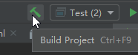

IntelliJ IDEA 编译在你build target中的所有的classes，并将它们放在output directory。

当你改变build target中的任何class，并执行build action，Intellij IDEA执行incremental build即仅仅编译改变的classes。Intellij IDEA也递归地build the classes‘ dependencies。

|  |
| --- |
| Build a module, or a project 选择你想编译的一个module或一个project，并点Build Module/Project（Ctrl+F9）    IntelliJ IDEA displays the compilation results in the [Review compilation and build output](https://www.jetbrains.com/help/idea/compiling-applications.html#see-results). |

依赖模块的编译，暂不看

### 【3】 Rebuild

当你执行一个rebuild command，Intellij IDEA清除整个output directory，删除build caches并重新build a project或a module。当classpath中的项已经改变时这可能有用。比如，project使用的SDKs或libraries增加，移除或被替换。

|  |
| --- |
| Rebuild a module, or a project﻿ 选择Rebuild Project或Rebuild ‘module name’来进行。  IntelliJ IDEA displays the build results in the [Review compilation and build output](https://www.jetbrains.com/help/idea/compiling-applications.html#see-results). |

注：When the **Rebuild Project** action is delegated to [Gradle](https://www.jetbrains.com/help/idea/work-with-gradle-projects.html#delegate_build_gradle) or [Maven](https://www.jetbrains.com/help/idea/delegate-build-and-run-actions-to-maven.html#delegate_to_maven), IntelliJ IDEA doesn't include the clean task/goal when rebuilding a project. If you need, you can execute the clean command before the rebuild using the **Execute Before Rebuild** option in the [Gradle](https://www.jetbrains.com/help/idea/jetgradle-tool-window.html) or [Maven](https://www.jetbrains.com/help/idea/maven-projects-tool-window.html) tool window.

# Configure your build

## （1） 概述

参考：<https://developer.android.com/studio/build>

注：以下Android Studio用AS简称

Android build system编译app resources和source code，并将它们打包成你能测试，部署，签名和分发的APKs。Android Studio使用 [Gradle](http://www.gradle.org/)—一个高级的build toolkit—来自动化并管理build process，同时允许你定义灵活的build configurations。每个build configuration能定义自己的一组code and resources，同时重用应用程序的所有版本的通用部分。Gradle的Android插件与build toolkit一起工作，来提供特定于building和testing Android applications的过程和可配置设置。

Gradle和Android plugin独立于Android Studio运行。这表明您可以从AS内部、您机器上的命令行或未安装Android Studio的机器（如continuous integration servers）来build your Android apps。若你不用AS，你可以学习如何通过命令行build并run your app。无论您是从命令行、在远程机器上还是使用Android Studio来build a project，build的输出都是相同的。

注：因为Gradle和Android插件独立于Android Studio运行，所以你需要分别更新build tools。阅读release notes来了解如何[update Gradle and the Android plugin](https://developer.android.com/studio/releases/gradle-plugin#updating-plugin).

Android build system的灵活性使您可以执行自定义的build configuration，而无需修改app的核心源文件。该部分帮你明确Android build system是如何工作的，以及它是如何帮你自定义和自动化多个build configurations。如果你只是想了解更多关于部署应用程序的知识，见 [Building and Running from Android Studio](https://developer.android.com/studio/run)。为了开始马上用AS创建自定义build configurations，见[Configuring Build Variants](https://developer.android.com/studio/build/build-variants)。

### 【1】 The build process

Build process包含许多工具和流程来将你的project转为一个Android Application Package（APK）。Build process十分灵活，因此明白底层发生的一些事情是有用的。

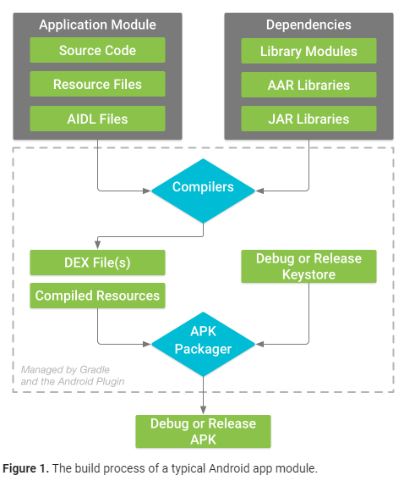

这里暂不看。

### 【2】 Custom build configurations

Gradle和Android plugin帮你配置你的build的下面方面：

#### 《1》 Build types

#### 《2》 Product flavors

#### 《3》 Build variants

#### 《4》 Manifest entries

#### 《5》 Dependencies

#### 《6》 Signing

#### 《7》 Code and resource shrinking

#### 《8》 Multiple APK support

### 【3】 Build configuration files

#### 《1》 概述

创建自定义build configurations需要你对一个或多个build configuration files，或build.gradle files做出改变。这些plain text files（纯文本文件）使用Domain Specific Language（DSL）来describe and manipulate the build logic（DSL由[Groovy](http://groovy-lang.org/)编写），Groovy是Java Virtual Machine（JVM）的动态语言。你不需要知道Groovy就能开始configure your build，因为Android plugin for Gradle引入了你需要的大部分DSL elements。为了解更多Android plugin DSL，参照[DSL reference documentation](https://google.github.io/android-gradle-dsl/current/index.html)。

当开始一个新的project，AS自动为你创建一些文件，如图2所示，并基于合理的默认值填充它们。

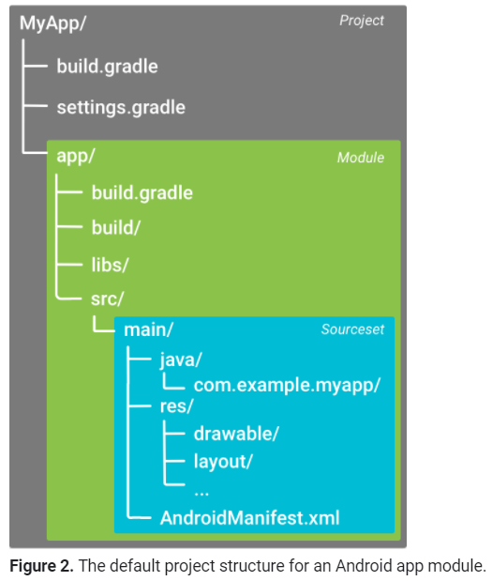

有一些Gradle build configuration files，它们是an Android app的standard project structure的一部分。在你开始configure你的build前，明确scope and purpose of each of these files以及the basic DSL elements they should define很重要。

#### 《2》 build configuration files

下面是as中的build configuration files

##### 1） The Gradle settings file

在root project directory中的settings.gradle file，告知Gradle在build your app时哪些模块需要被包含。对于大多数projects，文件很简单且仅包含以下：

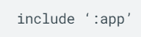

但是，多模块projects需要指定应该进入最终build的每个模块。

##### 2） The top-level build file

The top-level build.gradle file，位于 root project directory，定义了应用到你project中所有模块的build configurations。By default，top-level build file使用buildscript block来定义Gradle repositories和dependencies，这两者are common to all modules in the project。下面的代码样例描述了你能在top-level build.gradle中找到的default settings和DSL elements（在创建一个new project后）。

|  |
| --- |
| /\*\*  \* The buildscript block is where you configure the repositories and  \* dependencies for Gradle itself—meaning, you should not include dependencies  \* for your modules here. For example, this block includes the Android plugin for  \* Gradle as a dependency because it provides the additional instructions Gradle  \* needs to build Android app modules.  \*/  /\*\*buildscript块是你为Gradle配置repositories和dependencies的地方，你不应该将你modules的dependencies放在这。比如，该块包含Android plugin for Gradle as a dependency因为这提供额外的Gradle需要的指令来build Android app modules。\*/  buildscript {      /\*\*      \* The repositories block configures the repositories Gradle uses to      \* search or download the dependencies. Gradle pre-configures support for remote      \* repositories such as JCenter, Maven Central, and Ivy. You can also use local      \* repositories or define your own remote repositories. The code below defines      \* JCenter as the repository Gradle should use to look for its dependencies.      \*      \* New projects created using [Android Studio 3.0](https://developer.android.com/studio/releases#3-0-0) and higher also include      \* [Google's Maven repository](https://developer.android.com/studio/build/dependencies#google-maven).      \*/  /\*\*repositories块配置了Gradle使用的repositories来搜索或下载dependencies。Gradle预配置了一些remote repositories（如JCenter，Maven Central，和Ivy）。你也能使用local repositories或定义你自己的remote repositories。下面的代码定义了JCenter作为Gradle应该使用的repository来寻找相关dependencies。  新的用>= AS3.0创建的projects也包含**[Google's Maven repository](https://developer.android.com/studio/build/dependencies" \l "google-maven)** \*/      repositories {         google()         jcenter()     }      /\*\*      \* The dependencies block configures the dependencies Gradle needs to use      \* to build your project. The following line adds Android plugin for Gradle      \* version 4.0.0 as a classpath dependency.      \*/  /\*\* dependencies块配置Gradle需要用的dependencies来build your project。下面的代码行为Gradle version 4.0.0添加Android plugin作为一个classpath dependency。 \*/      dependencies {         classpath 'com.android.tools.build:gradle:4.0.0'     } }  /\*\*  \* The allprojects block is where you configure the repositories and  \* dependencies used by all modules in your project, such as third-party plugins  \* or libraries. However, you should configure module-specific dependencies in  \* each module-level build.gradle file. For new projects, Android Studio  \* includes JCenter and Google's Maven repository by default, but it does not  \* configure any dependencies (unless you select a template that requires some).  \*/  /\*\* allprojects块是where you configure the repositories and dependencies used by all modules in your project，如third-party plugins or libraries。但是，你应该配置module-specific dependencies in each module-level build.gradle file。对新的project，AS包含JCenter和Google’s Maven repository by default，但不会配置任何dependencies（除非你选择一个需要一些dependencies的template）。 \*/  allprojects {    repositories {        google()        jcenter()    } } |

###### 1》 Configure project-wide properties

对于包含多个modules的Android projects，在project level定义certain properties并在全modules中共享它们可能是有用的。你能通过adding  [extra properties](https://docs.gradle.org/current/userguide/writing_build_scripts.html#sec:extra_properties) to the ext block in the top-level build.gradle file来实现。

|  |
| --- |
| buildscript {...}  allprojects {...}  // This block encapsulates custom properties and makes them available to all // modules in the project.  //该块封装自定义properties并使它们对project中的所有modules都可用。 \*/ ext {     // The following are only a few examples of the types of properties you can define.  //下面are only a few examples of the types of properties you can define.     compileSdkVersion = 28     // You can also create properties to specify versions for dependencies.     // Having consistent versions between modules can avoid conflicts with behavior.  // 在modules间保持一致版本能避免一些冲突。     supportLibVersion = "28.0.0"     ... } ... |

为了在同一个project中从一个module访问这些properties，use the following syntax in the module's build.gradle file (you can learn more about this file in the section below)

|  |
| --- |
| android {   // Use the following syntax to access properties you defined at the project level:   // rootProject.ext.*property\_name*   compileSdkVersion rootProject.ext.compileSdkVersion   ... } ... dependencies {     implementation "com.android.support:appcompat-v7:${rootProject.ext.supportLibVersion}"     ... } |

注：虽然Gradle允许你在module level定义project-wide properties，你应该避免这样做因为这导致共享那些properties的modules形成耦合。 [Module coupling](https://docs.gradle.org/current/userguide/multi_project_builds.html#sec:decoupled_projects) 使得随后导出一个module作为一个stand-alone project变得更困难，同时这很大程度上阻止了Gradle利用[parallel project execution](https://docs.gradle.org/current/userguide/multi_project_builds.html" \l "sec:parallel_execution)来加速multi-module builds。

##### 3） The module-level build file

位于每个**project**/**module**/ directory的module-

level build.gradle file, allows you to configure build settings for the specific module it is located in。Configuring these build settings allows you to provide custom packaging options, such as additional build types and product flavors, 同时能override settings in the main/ app manifest or top-level build.gradle file.

下面的sample Android app module build.gradle file 列出了一些你应该知道的基本的DSL elements以及settings。

|  |
| --- |
| /\*\*  \* The first line in the build configuration applies the Android plugin for  \* Gradle to this build and makes the android block available to specify  \* Android-specific build options.  \*/ /\*\* The first line in the build configuration 为该模块的build应用了Android plugin for Gradle，同时使下面的android块能用来specify Android-specific build options.  \*/  apply plugin: 'com.android.application'  /\*\*  \* The android block is where you configure all your Android-specific  \* build options.  \*/  android {    /\*\*    \* compileSdkVersion specifies the Android API level Gradle should use to    \* compile your app. This means your app can use the API features included in    \* this API level and lower.    \*/    compileSdkVersion 28    /\*\*    \* buildToolsVersion specifies the version of the SDK build tools, command-line    \* utilities, and compiler that Gradle should use to build your app. You need to    \* download the build tools using the SDK Manager.    \*    \* This property is optional because the plugin uses a recommended version of    \* the build tools by default.    \*/    buildToolsVersion "29.0.2"    /\*\*    \* The defaultConfig block encapsulates default settings and entries for all    \* build variants, and can override some attributes in main/AndroidManifest.xml    \* dynamically from the build system. You can configure product flavors to override    \* these values for different versions of your app.    \*/    defaultConfig {      /\*\*      \* applicationId uniquely identifies the package for publishing.      \* However, your source code should still reference the package name      \* defined by the package attribute in the main/AndroidManifest.xml file.      \*/  /\*\* applicationId唯一地标识the package for publishing。但你的源码仍应引用在main/AndroidManifest.xml file中的package属性定义的package name。 \*/      applicationId 'com.example.myapp'      // Defines the minimum API level required to run the app.     minSdkVersion 15      // Specifies the API level used to test the app.     targetSdkVersion 28      // Defines the version number of your app.     versionCode 1      // Defines a user-friendly version name for your app.     versionName "1.0"   }    /\*\*    \* The buildTypes block is where you can configure multiple [build types](https://developer.android.com/studio/build/build-variants#build-types).    \* By default, the build system defines two build types: debug and release. The    \* debug build type is not explicitly shown in the default build configuration,    \* but it includes debugging tools and is signed with the debug key. The release    \* build type applies Proguard settings and is not signed by default.    \*/    buildTypes {      /\*\*      \* By default, Android Studio configures the release build type to enable code      \* shrinking, using minifyEnabled, and specifies the default Proguard rules file.      \*/      release {         minifyEnabled true // Enables code shrinking for the release build type.         proguardFiles getDefaultProguardFile('proguard-android.txt'), 'proguard-rules.pro'     }   }    /\*\*    \* The productFlavors block is where you can configure multiple [product flavors](https://developer.android.com/studio/build/build-variants#product-flavors).    \* This allows you to create different versions of your app that can    \* override the defaultConfig block with their own settings. Product flavors    \* are optional, and the build system does not create them by default.    \*    \* This example creates a free and paid product flavor. Each product flavor    \* then specifies its own application ID, so that they can exist on the Google    \* Play Store, or an Android device, simultaneously.    \*    \* If you declare product flavors, you must also declare flavor dimensions    \* and assign each flavor to a flavor dimension.    \*/    [flavorDimensions](https://google.github.io/android-gradle-dsl/current/com.android.build.gradle.AppExtension.html#com.android.build.gradle.AppExtension:flavorDimensions(java.lang.String[])) "tier"   productFlavors {     free {       dimension "tier"       applicationId 'com.example.myapp.free'     }      paid {       dimension "tier"       applicationId 'com.example.myapp.paid'     }   }    /\*\*    \* The splits block is where you can configure different APK builds that    \* each contain only code and resources for a supported screen density or    \* ABI. You'll also need to configure your build so that each APK has a    \* different versionCode.    \*/  /\*\* splits块能使你配置不同的APK builds，每个build仅包含针对一个supported screen density or ABI的code和resources。你同时需要配置你的build从而每个APK有一个不同的versionCode。 \*/   splits {     // Settings to build multiple APKs based on screen density.     density {        // Enable or disable building multiple APKs.       enable false        // Exclude these densities when building multiple APKs.       exclude "ldpi", "tvdpi", "xxxhdpi", "400dpi", "560dpi"     }   } }  /\*\*  \* The dependencies block in the module-level build configuration file  \* specifies dependencies required to build only the module itself.  \* To learn more, go to [Add build dependencies](https://developer.android.com/studio/build/dependencies).  \*/  dependencies {     implementation project(":lib")     implementation 'com.android.support:appcompat-v7:28.0.0'     implementation fileTree(dir: 'libs', include: ['\*.jar']) } |

##### 4） Gradle properties files

Gradle also includes two properties files, located in your root project directory, that you can use to specify settings for the Gradle build toolkit itself:

###### 1》 gradle.properties

This is where you can configure project-wide Gradle settings, such as the Gradle daemon's maximum heap size. For more information, see [The Build Environment](https://docs.gradle.org/current/userguide/build_environment.html)

###### 2》 local.properties

Configures local environment properties for the build system, including the following:

* ndk.dir - Path to the NDK. This property has been deprecated. Any downloaded versions of the NDK will be installed in the ndk directory within the Android SDK directory.
* sdk.dir - Path to the SDK.
* cmake.dir - Path to CMake.
* ndk.symlinkdir - in Android Studio 3.5+, creates a symlink to the NDK that can be shorter than the installed NDK path.

注：Remap the NDK to a shorter path（Windows only）

The most common issue with Windows long paths is that tools (such as ld.exe) in the installed NDK folder end up with very deep paths, but the tools don't support long paths well.

In local.properties, you can set the property ndk.symlinkdir to request that the Gradle plugin create a symlink to the NDK. The path of that symlink can be shorter than the existing NDK folder. For example, ndk.symlinkdir = C:\ will result in the following symlink: C:\ndk\19.0.5232133

#### 《3》 Syncing project with Gradle files

When you make changes to the build configuration files in your project, Android Studio requires that you sync your project files so that it can import your build configuration changes and run some checks to make sure your configuration won't create build errors.

To sync your project files, click **Sync Now** in the notification bar that appears when you make a change, as shown in figure 3, or click **Sync Project**  from the menu bar.

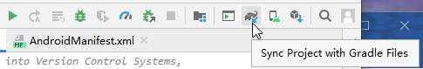

 If Android Studio notices any errors with your configuration, for example, your source code uses API features that are only available in an API level higher than your compileSdkVersion, the **Messages** window appears to describe the issue.

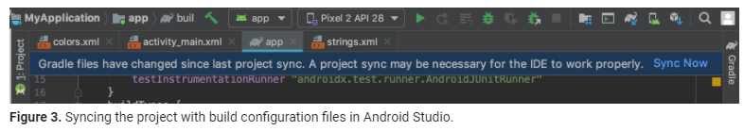

#### 《4》 Source sets

AS逻辑上为每个module将source code和resources分组成*source sets*。一个module的main/ source set包含the code and resources used by all its build variants。Additional source set directories are optional，and Android Studio does not automatically create them for you when you configure new build variants. However, creating source sets, similar to main/,有助于组织只有在build certain versions of your app时才应被Gradle使用的file and resources。

##### 1） Source Sets列表

1》 src/main/

This source set includes code and resources common to（通用的） all build variants.

2》 src/**buildType**/

Create this source set to include code and resources only for a specific build type.

3》 src/**productFlavor**/

Create this source set to include code and resources only for a specific product flavor.

**Note:** If you configure your build to [combine multiple product flavors](https://developer.android.com/studio/build/build-variants#flavor-dimensions), you can create source set directories for each combination of product flavors between the flavor dimensions: **src/productFlavor1ProductFlavor2/**

4》 src/**productFlavorBuildType**/

Create this source set to include code and resources only for a specific build variant.

##### 2） 实例说明

For example, to generate the "fullDebug" version of your app, the build system merges code, settings, and resources from following source sets:

* src/fullDebug/ (the build variant source set)
* src/debug/ (the build type source set)
* src/full/ (the product flavor source set)
* src/main/ (the main source set)

**Note:** When you create a new file or directory in Android Studio, using the **File > New** menu options, you can create it for a specific source set. The source sets you can choose from are based on your build configurations, and Android Studio automatically creates the required directories if they don't already exist.

If different source sets contain different versions of the same file, Gradle uses the following priority order when deciding which file to use (source sets on the left override the files and settings of source sets to the right):

build variant > build type > product flavor > main source set > library dependencies

This allows Gradle to use files that are specific to the build variant you are trying to build while reusing activities, application logic, and resources that are common to other versions of your app. When [merging multiple manifests](https://developer.android.com/studio/build/manifest-merge), Gradle uses the same priority order, so each build variant can define different components or permissions in the final manifest. To learn more about creating custom source sets, go to [Create Source Sets for Build Variants](https://developer.android.com/studio/build/build-variants#sourcesets).

## （2） Configure the app module：配置应用模块

<https://developer.android.com/studio/build/configure-app-module>

This page describes useful app settings in the module-level build.gradle file that you will likely want to toggle：切换.

### 【1】 Set the application ID：设置应用ID

<https://developer.android.com/studio/build/application-id?hl=zh-cn>

todo

## （3） Add build dependencies

## （4） Configure build variants

见 “本文档-8.Configure build variants”

## （5） Gradle tips and recipes

## （6） Migrate to Kotlin script

## （7） Optimize your build speed

## （8） Use the Maven Publish plugin

## （9） Manage manifest files

## （10） Shrink your app

## （11） Enable multidex

## （12） Extend the Android Gradle plugin

# Configure build variants

参考：<https://developer.android.google.cn/studio/build/build-variants>

This page builds on the [Configure your build overview](https://developer.android.google.cn/studio/build) to show you how you can configure build variants to create different versions of your app from a single project , and how to properly manage your dependencies and signing configurations.

Each build variant represents a different version of your app that you can build. For example, you might want to build one version of your app that's free, with a limited set of content, and another paid version that includes more. You can also build different versions of your app that target different devices, based on API level or other device variations. However, if you want to build different versions based on the device ABI or screen density, instead [build multiple APKs](https://developer.android.google.cn/studio/build/configure-apk-splits).

Build variants are the result of Gradle using a [specific set of rules](https://developer.android.google.cn/studio/build/build-variants#sourceset-build) to combine settings, code, and resources configured in your build types and product flavors. Although you do not configure build variants directly, you do configure the build types and product flavors that form them.

For example, a "demo" product flavor can specify different features and device requirements, such as custom source code, resources, and minimum API levels, while the "debug" build type applies different build and packaging settings, such as debug options and signing keys.  The resulting build variant is the "demoDebug" version of your app, and it includes a combination of the configurations and resources included in the "demo" product flavor, "debug" build type, and main/ source set.

## （1） Configure build types

You can create and configure build types in the module-level build.gradle file inside the android block. When you create a new module, Android Studio automatically creates the debug and release build types for you. Although the debug build type doesn't appear in the build configuration file, Android Studio configures it with [debuggable true](https://google.github.io/android-gradle-dsl/current/com.android.build.gradle.internal.dsl.BuildType.html" \l "com.android.build.gradle.internal.dsl.BuildType:debuggable). This allows you to debug the app on secure Android devices and configures APK signing with a generic debug keystore.

You can add the debug build type to your configuration if you want to add or change certain settings. The following sample specifies an [applicationIdSuffix](https://google.github.io/android-gradle-dsl/current/com.android.build.gradle.internal.dsl.BuildType.html#com.android.build.gradle.internal.dsl.BuildType:applicationIdSuffix)  for the debug build type, and configures a "staging" build type that is initialized using settings from the debug build type.

|  |
| --- |
| android {     defaultConfig {         manifestPlaceholders = [hostName:"www.example.com"]         ...     }     buildTypes {         release {             minifyEnabled true             proguardFiles getDefaultProguardFile('proguard-android.txt'), 'proguard-rules.pro'         }          debug {             applicationIdSuffix ".debug"             debuggable true         }          /\*\*          \* The `initWith` property allows you to copy configurations from other build types,          \* then configure only the settings you want to change. This one copies the debug build          \* type, and then changes the [manifest placeholder](https://developer.android.google.cn/studio/build/manifest-build-variables) and [application ID](https://developer.android.google.cn/studio/build/application-id).          \*/         staging {             initWith debug             manifestPlaceholders = [hostName:"internal.example.com"]             applicationIdSuffix ".debugStaging"         }     } } |

**Note:** When you make changes to a build configuration file, Android Studio requires that you sync your project with the new configuration. To sync your project, you can click **Sync Now** in the notification bar that appears as soon as you make a change or **Sync Project**  from the toolbar. If Android Studio notices any errors with your configuration, the **Messages** window appears to describe the issue.

To learn more about all the properties you can configure with build types, read the [build type DSL reference](https://google.github.io/android-gradle-dsl/current/com.android.build.gradle.internal.dsl.BuildType.html).

## （2） Configure product flavors

查了下属于多渠道打包的一种方法。

Creating product flavors is similar to creating build types: add them to the productFlavors block in your build configuration and include the settings you want. The product flavors support the same properties as defaultConfig—this is because defaultConfig actually belongs to the [ProductFlavor](https://google.github.io/android-gradle-dsl/current/com.android.build.gradle.internal.dsl.ProductFlavor.html) class. This means you can provide the base configuration for all flavors in the defaultConfig block, and each flavor can change any of these default values, such as the [applicationId](https://google.github.io/android-gradle-dsl/current/com.android.build.gradle.internal.dsl.ProductFlavor.html" \l "com.android.build.gradle.internal.dsl.ProductFlavor:applicationId). To learn more about the application ID, read [Set the Application ID](https://developer.android.google.cn/studio/build/application-id).

**Note:** You still need to specify a package name using the [**package**](https://developer.android.google.cn/guide/topics/manifest/manifest-element#package) attribute in the **main/** manifest file. You must also use that package name in your source code to refer to the R class, or resolve any relative activity or service registration. This allows you to use **applicationId** to give each product flavor a unique ID for packaging and distribution, without having to change your source code.

All flavors must belong to a named flavor dimension, which is a group of product flavors.  You must assign all flavors to a flavor dimension; otherwise, you will get the build error shown below. If a given module specifies only one flavor dimension, the Android Gradle plugin automatically assigns all of the module's flavors to that dimension.

Error:All flavors must now belong to a named flavor dimension.

The flavor '***flavor\_name***' is not assigned to a flavor dimension.

**Tip:** 这个插件试图匹配你的应用程序的variants和那些本地库的依赖。. Because [variant-aware dependency matching](https://developer.android.google.cn/studio/build/dependencies#variant_aware) relies on how you name flavor dimension,  **name your flavor dimensions carefully**. 这样做可以让您更好地控制本地依赖项中的哪些代码和资源与应用程序的每个版本匹配。

The following code sample creates a flavor dimension named "version" and adds "demo" and "full" product flavors. These flavors provide their own [applicationIdSuffix](https://google.github.io/android-gradle-dsl/current/com.android.build.gradle.internal.dsl.ProductFlavor.html" \l "com.android.build.gradle.internal.dsl.ProductFlavor:applicationIdSuffix) and [versionNameSuffix](https://google.github.io/android-gradle-dsl/current/com.android.build.gradle.internal.dsl.ProductFlavor.html" \l "com.android.build.gradle.internal.dsl.ProductFlavor:versionNameSuffix):

|  |
| --- |
| android {     ...     defaultConfig {...}     buildTypes {         debug{...}         release{...}     }     // Specifies one flavor dimension.     [flavorDimensions](https://google.github.io/android-gradle-dsl/current/com.android.build.gradle.AppExtension.html#com.android.build.gradle.AppExtension:flavorDimensions(java.lang.String[])) "version"     productFlavors {         demo {             // Assigns this product flavor to the "version" flavor dimension.             // If you are using only one dimension, this property is optional,             // and the plugin automatically assigns all the module's flavors to             // that dimension.             dimension "version"             applicationIdSuffix ".demo"             versionNameSuffix "-demo"         }         full {             dimension "version"             applicationIdSuffix ".full"             versionNameSuffix "-full"         }     } } |

下面暂不看，

## （3） Create source sets

By default, Android Studio creates the main/ [source set](https://developer.android.google.cn/studio/build#sourcesets) and directories for everything you want to share between all your build variants. However, you can create new source sets to control exactly what files Gradle compiles and packages for specific build types, product flavors (and combinations of product flavors when [using flavor dimensions](https://developer.android.google.cn/studio/build/build-variants#flavor-dimensions)), and build variants. For example, you can define basic functionality in the main/ source set and use product flavor source sets to change the branding of your app for different clients, or include special permissions and logging functionality only for build variants that use the debug build type.

Gradle expects you to organize source set files and directories a certain way, similar to the main/ source set. For example, Gradle expects Java class files that are specific to your "debug" build type to be located in the src/debug/java/ directory.

The Android plugin for Gradle provides a useful Gradle task that shows you how to organize your files for each of your build types, product flavors, and build variants.  For example, the following sample from the task output describes where Gradle expects to find certain files for the "debug" build type:

|  |
| --- |
| ------------------------------------------------------------  Project :app  ------------------------------------------------------------  ...  debug  ----  Compile configuration: compile  build.gradle name: android.sourceSets.debug  Java sources: [app/src/debug/java]  Manifest file: app/src/debug/AndroidManifest.xml  Android resources: [app/src/debug/res]  Assets: [app/src/debug/assets]  AIDL sources: [app/src/debug/aidl]  RenderScript sources: [app/src/debug/rs]  JNI sources: [app/src/debug/jni]  JNI libraries: [app/src/debug/jniLibs]  Java-style resources: [app/src/debug/resources] |

To view this output, proceed as follows:

# AS中的重要文件

## AndroidManifest.xml

参考：<https://developer.android.com/guide/topics/manifest/manifest-intro>

Every app project must have an AndroidManifest.xml file(确切地就是这个名字) at the root of the [project source set](https://developer.android.com/studio/build#sourcesets). The manifest file describes essential information about your app to the Android build tools, the Android operating system, and Google Play.

Among many other things, the manifest file is required to declare the following:

1. The app's package name, which usually matches your code's namespace. The Android build tools use this to determine the location of code entities when building your project. When packaging the app, the build tools replace this value with the application ID from the Gradle build files, which is used as the unique app identifier on the system and on Google Play.  [Read more about the package name and app ID](https://developer.android.com/guide/topics/manifest/manifest-intro#package-name).
2. The components of the app, which include all activities, services, broadcast receivers, and content providers. Each component must define basic properties such as the name of its Kotlin or Java class. It can also declare capabilities such as which device configurations it can handle, and intent filters that describe how the component can be started.  [Read more about app components](https://developer.android.com/guide/topics/manifest/manifest-intro#components).
3. The permissions that the app needs in order to access protected parts of the system or other apps. It also declares any permissions that other apps must have if they want to access content from this app. [Read more about permissions](https://developer.android.com/guide/topics/manifest/manifest-intro#perms).
4. The hardware and software features the app requires, which affects which devices can install the app from Google Play. [Read more about device compatibility](https://developer.android.com/guide/topics/manifest/manifest-intro#compatibility).

If you're using [Android Studio](https://developer.android.com/studio) to build your app, the manifest file is created for you, and most of the essential manifest elements are added as you build your app (especially when using [code templates](https://developer.android.com/studio/projects/templates)).

### File features

The following sections describe how some of the most important characteristics of your app are reflected in the manifest file.

#### 《1》 Package name and application ID

The manifest file's root element requires an attribute for your app's package name (usually matching your project directory structure—the Java namespace).

For example, the following snippet shows the root [<manifest>](https://developer.android.com/guide/topics/manifest/manifest-element) element with the package name "com.example.myapp":

|  |
| --- |
| <?xml version="1.0" encoding="utf-8"?> <manifest xmlns:android="http://schemas.android.com/apk/res/android"     **package="com.example.myapp"**     android:versionCode="1"     android:versionName="1.0" >     ... </manifest> |

While building your app into the final application package (APK), the Android build tools use the package attribute for two things:

1. It applies this name as the namespace for your app's generated R.java class (used to access your [app resources](https://developer.android.com/guide/topics/resources/overview)).

Example: With the above manifest, the R class is created at com.example.myapp.R.

注：在AS4.0.1中测试，R.java在

project/module/build/generated/source/r/debug/your\_package\_name/R.java

1. It uses this name to resolve any relative class names that are declared in the manifest file.

Example: With the above manifest, an activity declared as <activity android:name=".MainActivity"> is resolved to be com.example.myapp.MainActivity.

这样的话manifest的package属性应该总是和你保存activities以及其他app code所在的project’s base package name一致。当然，你能在你的project中有其他子包，但那些文件必须使用namespace from the package attribute来import the R.java class。

但是，要注意，once the APK is compiled, the package attribute also represents your app's universally unique application ID. After the build tools perform（进行） the above tasks based on the package name, they replace the package value with the value given to the applicationId property in your project's build.gradle file (used in Android Studio projects). This final value for the package attribute must be universally unique because it is the only guaranteed way to identify your app on the system and in Google Play.

The distinction between the package name in the manifest and the applicationId in the build.gradle file can be a bit confusing. But if you keep them same, you have nothing to worry about.

However, if you decide to make your code's namespace (and thus, the package name in the manifest)  something different from the applicationId from the build file, be sure you fully understand the implications of [setting the application ID](https://developer.android.com/studio/build/application-id). That page explains how you can safely adjust the manifest's package name independent of the build file's applicationId, and change the application ID for different build configurations.

#### App components

For each [app component](https://developer.android.com/guide/components/fundamentals#Components) that you create in your app, you must declare a corresponding XML element in the manifest file:

* [<activity>](https://developer.android.com/guide/topics/manifest/activity-element) for each subclass of [Activity](https://developer.android.com/reference/android/app/Activity).
* [<service>](https://developer.android.com/guide/topics/manifest/service-element) for each subclass of [Service](https://developer.android.com/reference/android/app/Service).
* [<receiver>](https://developer.android.com/guide/topics/manifest/receiver-element) for each subclass of [BroadcastReceiver](https://developer.android.com/reference/android/content/BroadcastReceiver).
* [<provider>](https://developer.android.com/guide/topics/manifest/provider-element) for each subclass of [ContentProvider](https://developer.android.com/reference/android/content/ContentProvider).

If you subclass any of these components without declaring it in the manifest file, the system cannot start it.

The name of your subclass must be specified with the name attribute, using the full package designation. For example, an [Activity](https://developer.android.com/reference/android/app/Activity) subclass can be declared as follows:

|  |
| --- |
| <manifest ... >     <application ... >         <activity android:name="com.example.myapp.MainActivity" ... >         </activity>     </application> </manifest> |

但若name value 的第一个字符是一个句点，app的package name（from the [<manifest>](https://developer.android.com/guide/topics/manifest/manifest-element) element's [package](https://developer.android.com/guide/topics/manifest/manifest-element#package) attribute）就作为该name的前缀。For example, the following activity name is resolved to `"com.example.myapp.MainActivity"`:

|  |
| --- |
| <manifest **package="com.example.myapp"** ... >     <application ... >         <activity **android:name=".MainActivity"** ... >             ...         </activity>     </application> </manifest> |

若在子包中有 [app component](https://developer.android.com/guide/components/fundamentals#Components)（such as

in com.example.myapp.purchases）， the name value必须添加这个子包名（such as ".purchases.PayActivity"）或使用完整的包名。

##### 1） Intent filters

App activities, services, and broadcast receivers are activated by *intents*. An intent is a message defined by an [Intent](https://developer.android.com/reference/android/content/Intent) object that describes an action to perform, including the data to be acted upon,  the category of component that should perform the action, and other instructions.

When an app issues an intent to the system, the system locates an app component that can handle the intent based on *intent filter* declarations in each app's manifest file. The system launches an instance of the matching component and passes the [Intent](https://developer.android.com/reference/android/content/Intent) object to that component. If more than one app can handle the intent, then the user can select which app to use.

An app component can have any number of intent filters(defined with the [<intent-filter>](https://developer.android.com/guide/topics/manifest/intent-filter-element) element), each one describing a different capability of that component.

For more information, see the [Intents and Intent Filters](https://developer.android.com/guide/components/intents-filters) document.

##### 2） Icons and labels

A number of manifest elements have icon and label attributes for displaying a small icon and a text label, respectively, to users for the corresponding app component.

In every case, the icon and label that are set in a parent element become the default icon and label value for all child elements. For example, the icon and label that are set in the [<application>](https://developer.android.com/guide/topics/manifest/application-element) element are the default icon and label for each of the app's components (such as all activities).

The icon and label that are set in a component's [<intent-filter>](https://developer.android.com/guide/topics/manifest/intent-filter-element) are shown to the user whenever that component is presented as an option to fulfill an intent. By default, this icon is inherited from whichever icon is declared for the parent component (either the [<activity>](https://developer.android.com/guide/topics/manifest/activity-element) or [<application>](https://developer.android.com/guide/topics/manifest/application-element) element), but you might want to change the icon for an intent filter if it provides a unique action that you'd like to better indicate in the chooser dialog. For more information, see [Allow Other Apps to Start Your Activity](https://developer.android.com/training/basics/intents/filters).

#### 《3》 Permissions

Android apps must request permission to access sensitive user data (such as contacts and SMS) or certain system features(such as the camera and internet access). Each permission is identified by a unique label. For example, an app that needs to send SMS messages must have the following line in the manifest:

|  |
| --- |
| <manifest ... >     <uses-permission android:name="android.permission.SEND\_SMS"/>     ... </manifest> |

Beginning with Android 6.0 (API level 23), the user can approve or reject some app permissions at runtime. But no matter which Android version your app supports,  you must declare all permission requests with a [<uses-permission>](https://developer.android.com/guide/topics/manifest/uses-permission-element) element in the manifest. If the permission is granted, the app is able to use the protected features. If not, its attempts to access those features fail.

Your app can also protect its own components with permissions. It can use any of the permissions that are defined by Android, as listed

in [android.Manifest.permission](https://developer.android.com/reference/android/Manifest.permission), or a permission that's declared in another app. Your app can also define its own permissions. A new permission is declared with the [<permission>](https://developer.android.com/guide/topics/manifest/permission-element) element.

For more information, see the [Permissions Overview](https://developer.android.com/guide/topics/permissions/overview).

#### 《4》 Device compatibility

The manifest file is also where you can declare what types of hardware or software features your app requires, and thus, which types of devices your app is compatible with. Google Play Store does not allow your app to be installed on devices that don't provide the features or system version that your app requires.

There are several manifest tags that define which devices your app is compatible with. The following are just a couple of the most common tags.

1） <uses-feature>

The [<uses-feature>](https://developer.android.com/guide/topics/manifest/uses-feature-element) element allows you to declare hardware and software features your app needs. For example, if your app cannot achieve basic functionality on a device without a compass sensor, you can declare the compass sensor as required with the following manifest tag:

|  |
| --- |
| <manifest ... >     <uses-feature android:name="android.hardware.sensor.compass"                   android:required="true" />     ... </manifest> |

**Note**: If you'd like to make your app available on Chromebooks, there are some important hardware and software feature limitations that you should consider. For more information, see [App Manifest Compatibility for Chromebooks](https://developer.android.com/topic/arc/manifest).

2） <uses-sdk>

Each successive platform version often adds new APIs not available in the previous version. To indicate the minimum version with which your app is compatible, your manifest must include the [<uses-sdk>](https://developer.android.com/guide/topics/manifest/uses-sdk-element) tag and its [minSdkVersion](https://developer.android.com/guide/topics/manifest/uses-sdk-element" \l "min) attribute.

However, beware that attributes in the [<uses-sdk>](https://developer.android.com/guide/topics/manifest/uses-sdk-element) element are overridden by corresponding properties in the [build.gradle](https://developer.android.com/studio/build" \l "build-files) file. So if you're using Android Studio, you must specify the minSdkVersion and targetSdkVersion values there instead:

|  |
| --- |
| android {   defaultConfig {     applicationId 'com.example.myapp'      // Defines the minimum API level required to run the app.     **minSdkVersion 15**      // Specifies the API level used to test the app.     targetSdkVersion 28      ...   } } |

For more information about the build.gradle file, read about [how to configure your build](https://developer.android.com/studio/build)

To learn more about how to declare your app's support for different devices, see the [Device Compatibility Overview](https://developer.android.com/guide/practices/compatibility).

### 【2】 File conventions

This section describes the conventions and rules that generally apply to all elements and attributes in the manifest file.

#### 《1》 Elements

Only the [<manifest>](https://developer.android.com/guide/topics/manifest/manifest-element) and [<application>](https://developer.android.com/guide/topics/manifest/application-element) elements are required. They each must occur only once. Most of the other elements can occur zero or more times. However, some of them must be present to make the manifest file useful.

All of the values are set through attributes, not as character data within an element.

Elements at the same level are generally not ordered.  For example, the [<activity>](https://developer.android.com/guide/topics/manifest/activity-element), [<provider>](https://developer.android.com/guide/topics/manifest/provider-element), and [<service>](https://developer.android.com/guide/topics/manifest/service-element) elements can be placed in any order. There are two key exceptions to this rule:

* An [<activity-alias>](https://developer.android.com/guide/topics/manifest/activity-alias-element) element must follow the [<activity>](https://developer.android.com/guide/topics/manifest/activity-element) for which it is an alias.
* The [<application>](https://developer.android.com/guide/topics/manifest/application-element) element must be the last element inside the [<manifest>](https://developer.android.com/guide/topics/manifest/manifest-element) element.

#### 《2》 Attributes

Technically, all attributes are optional. However, many attributes must be specified so that an element can accomplish its purpose. For truly optional attributes, the [reference documentation](https://developer.android.com/guide/topics/manifest/manifest-intro#reference)indicates the default values.

Except for some attributes of the root [<manifest>](https://developer.android.com/guide/topics/manifest/manifest-element) element, all attribute names begin with an android: prefix. For

example, android:alwaysRetainTaskState. Because the prefix is universal, the documentation generally omits it when referring to attributes by name.

#### 《3》 Multiple values

If more than one value can be specified, the element is almost always repeated, rather than multiple values being listed within a single element. For example, an intent filter can list several actions:

|  |
| --- |
| <intent-filter ... >     <action android:name="android.intent.action.EDIT" />     <action android:name="android.intent.action.INSERT" />     <action android:name="android.intent.action.DELETE" />     ... </intent-filter> |

#### 《4》Resource values

Some attributes have values that are displayed to users, such as the title for an activity or your app icon. The value for these attributes might differ based on the user's language or other device configurations(such as to provide a different icon size based on the device's pixel density), so the values should be set from a resource or theme, instead of hard-coded into the manifest file.  The actual value can then change based on [alternative resources](https://developer.android.com/guide/topics/resources/providing-resources) that you provide for different device configurations.

Resources are expressed as values with the following format:

"@[**package**:]**type**/**name**"

You can omit the **package** name if the resource is provided by your app (including if it is provided by a library dependency, because [library resources are merged into yours](https://developer.android.com/studio/write/add-resources#resource_merging))。The only other valid package name is android, when you want to use a resource from the Android framework.

The **type** is a type of resource, such as [string](https://developer.android.com/guide/topics/resources/string-resource) or [drawable](https://developer.android.com/guide/topics/resources/drawable-resource), and the **name** is the name that identifies the specific resource. Here is an example:

|  |
| --- |
| <activity android:icon="@drawable/smallPic" ... > |

For more information about how to add resources in your project, read [Providing Resources](https://developer.android.com/guide/topics/resources/providing-resources).

To instead apply a value that's defined in a [theme](https://developer.android.com/guide/topics/ui/look-and-feel/themes), the first character must be ? instead of @:

"?[**package**:]**type**/**name**"

#### 《5》 String values

如果attribute value是字符串，则必须用爽反斜杠（\\）来转义字符，如\\n for a newline 或\\uxxxx for a Unicode character.

### 【3】 Manifest elements reference

The following table provides links to reference documents for all valid elements in the AndroidManifest.xml file.

见：[https://developer.android.com/guide/topics/manifest/manifest-intro#reference](https://developer.android.com/guide/topics/manifest/manifest-intro" \l "reference)

#### 《1》 <meta-data>

##### 1） 概述

参考：

<https://developer.android.com/guide/topics/manifest/meta-data-element>

###### 1》 syntax

|  |
| --- |
| <meta-data android:[name](https://developer.android.com/guide/topics/manifest/meta-data-element#nm)="*string*"            android:[resource](https://developer.android.com/guide/topics/manifest/meta-data-element#rsrc)="*resource specification*"            android:[value](https://developer.android.com/guide/topics/manifest/meta-data-element#val)="*string*" /> |

###### 2》 contained in

[<activity>](https://developer.android.com/guide/topics/manifest/activity-element)  
[<activity-alias>](https://developer.android.com/guide/topics/manifest/activity-alias-element)  
[<application>](https://developer.android.com/guide/topics/manifest/application-element)  
[<provider>](https://developer.android.com/guide/topics/manifest/provider-element)  
[<receiver>](https://developer.android.com/guide/topics/manifest/receiver-element)  
[<service>](https://developer.android.com/guide/topics/manifest/service-element)

###### 3》 description

A name-value pair for an item of additional（额外的）, arbitrary（任意的） data that can be supplied to the parent component. A component element can contain any number of <meta-data> subelements. The values from all of them are collected in a single [Bundle](https://developer.android.com/reference/android/os/Bundle) object and made available to the component as the [PackageItemInfo.metaData](https://developer.android.com/reference/android/content/pm/PackageItemInfo" \l "metaData) field.

Ordinary values are specified through the [value](https://developer.android.com/guide/topics/manifest/meta-data-element#value) attribute. However, to assign a resource ID as the value, use the [resource](https://developer.android.com/guide/topics/manifest/meta-data-element#resource) attribute instead. For example, the following code assigns whatever value is stored in the @string/kangaroo resource to the "zoo" name:

|  |
| --- |
| <meta-data android:name="zoo" android:value="@string/kangaroo" /> |

On the other hand, using the resource attribute would assign "zoo" the numeric ID of the resource, not the value stored in the resource:

|  |
| --- |
| <meta-data android:name="zoo" android:resource="@string/kangaroo" /> |

It is highly recommended that you avoid supplying related data as multiple separate <meta-data> entries. Instead, if you have complex data to associate with a component, store it as a resource and use the resource attribute to inform the component of its ID.

###### 4》 attributes

A） android:name

A unique name for the item. To ensure that the name is unique, use a Java-style naming convention — for example,

"com.example.project.activity.fred".

B） android:resource

A reference to a resource. The ID of the resource is the value assigned to the item. The ID can be retrieved from the meta-data Bundle by the [Bundle.getInt()](https://developer.android.com/reference/android/os/BaseBundle" \l "getInt(java.lang.String)) method.

C） android:value

The value assigned to the item. The data types that can be assigned as values and the Bundle methods that components use to retrieve those values are listed in the following table:

|  |  |
| --- | --- |
| **Type** | **Bundle method** |
| String value, using double backslashes (\\) to escape characters — such as "\\n" and "\\uxxxxx" for a Unicode character. | [getString()](https://developer.android.com/reference/android/os/BaseBundle#getString(java.lang.String)) |
| Integer value, such as "100" | [getInt()](https://developer.android.com/reference/android/os/BaseBundle#getInt(java.lang.String)) |
| Boolean value, either "true" or "false" | [getBoolean()](https://developer.android.com/reference/android/os/BaseBundle#getBoolean(java.lang.String)) |
| Color value, in the form "#rgb", "#argb", "#rrggbb", or "#aarrggbb" | [getInt()](https://developer.android.com/reference/android/os/BaseBundle#getInt(java.lang.String)) |
| Float value, such as "1.23" | [getFloat()](https://developer.android.com/reference/android/os/Bundle#getFloat(java.lang.String)) |

##### 2） 使用

参考：<https://www.jianshu.com/p/75e0f4f16471>

###### 1》 前言

在日常的Android开发中，AndroidManifest中总会出现一些<meta-data>标签，或是第三方SDK配置信息，或是系统配置，不禁让人思考<meta-data>到底是什么？有什么用？怎么用？有哪些应用场景？

###### 2》 meta-data简介

A） **<meta-data>**

直译为“元数据”，该标签可为<activity>、<activity-alias>、<application>、<provider>、<receiver>、<service>等组件提供附加数据项。

组件元素可以包含任意数量的<meta-data>子元素。系统将meta-data配置的数据存储于一个Bundle对象中，可以通过PackageItemInfo.metaData字段获取。

B） **语法配置**

|  |
| --- |
| <meta-data android:name="string"  android:resource="resource specification"  android:value="string" /> |

android:name

分配给该标签的键，即唯一名称。为确保名称唯一应使用Java风格命名约定，如“ com.example.project.activity.fred”。

android:resource

对资源的引用，如“@string/app\_name”。该资源ID可以通过该metaData.getInt()方法获取 。

android:value

分配给该标签的值，如String、Boolean等。

###### 3》 meta-data用法

正如前文所说，<meta-data>可用于常见的组件，那么在程序中应该如何配置，并获取这些配置好的外部数据呢？

A） **配置示例**

|  |
| --- |
| *<?***xml version="1.0" encoding="utf-8"***?>* <**manifest xmlns:android="http://schemas.android.com/apk/res/android"  package="com.example.manifesttest"**>   <**application  android:allowBackup="true"  android:icon="@mipmap/ic\_launcher"  android:label="@string/app\_name"  android:roundIcon="@mipmap/ic\_launcher\_round"  android:supportsRtl="true"  android:theme="@style/AppTheme"**>  <**activity android:name=".metadatatest.MainActivity"**>  <**intent-filter**>  <**action android:name="android.intent.action.MAIN"** />  <**category android:name="android.intent.category.LAUNCHER"** />  </**intent-filter**>   <**meta-data  android:name="meta\_act"  android:resource="@string/app\_name"** />  </**activity**>   <**meta-data  android:name="meta\_app"  android:resource="@string/act\_name"  android:value="kkkk"** />  </**application**>  </**manifest**> |

B） **获取配置信息示例**

|  |
| --- |
| **public class** MainActivity **extends** AppCompatActivity {   @Override  **protected void** onCreate(Bundle savedInstanceState) {  **super**.onCreate(savedInstanceState);  setContentView(R.layout.***metadata\_activitymain***);   String appMeta=**"meta\_app"**;  String actMeta=**"meta\_act"**;   Log.*d*(**"ManiTest"**,appMeta+**":"**+**"resource:"**+getMetaDataFromApp(appMeta,**"res"**));  Log.*d*(**"ManiTest"**,appMeta+**":"**+**"value:"**+getMetaDataFromApp(appMeta,**"value"**));  Log.*d*(**"ManiTest"**,actMeta+**":"**+**"resource:"**+getMetaDataFromAct(actMeta,**"res"**));  Log.*d*(**"ManiTest"**,actMeta+**":"**+**"value:"**+getMetaDataFromAct(actMeta,**"value"**));  }   *//获取app的meta-data* **private** String getMetaDataFromApp(String metaKey,String metaType) {  String rtn = **""**;  **try** {  ApplicationInfo appInfo = getPackageManager().getApplicationInfo(getPackageName(),  PackageManager.***GET\_META\_DATA***);  **switch**(metaType){  **case "res"**:{  rtn= Integer.*toString*(appInfo.**metaData**.getInt(metaKey));  **break**;  }  **case "value"**:{  rtn=appInfo.**metaData**.getString(metaKey);  **break**;  }  }  } **catch** (PackageManager.NameNotFoundException e) {  e.printStackTrace();  }  **return** rtn;  }   *//获取act的meta-data* **private** String getMetaDataFromAct(String metaKey,String metaType) {  String rtn= **""**;  **try** {  ActivityInfo activityInfo = getPackageManager().getActivityInfo(getComponentName(),  PackageManager.***GET\_META\_DATA***);  **switch**(metaType){  **case "res"**:{  rtn= Integer.*toString*(activityInfo.**metaData**.getInt(metaKey));  **break**;  }  **case "value"**:{  rtn=activityInfo.**metaData**.getString(metaKey);  **break**;  }  }  } **catch** (PackageManager.NameNotFoundException e) {  e.printStackTrace();  }  **return** rtn;  } } |

结果：

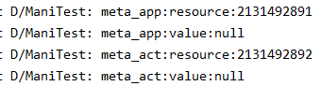

然后把

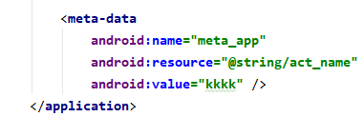的resource去掉，得

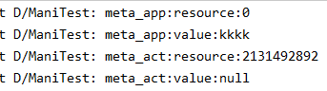

说明resource和value不能同时存在。如果同时存在，一方会将另一方置为空。

下面看下metadata源码（从activityInfo/appInfo.metaData进去）

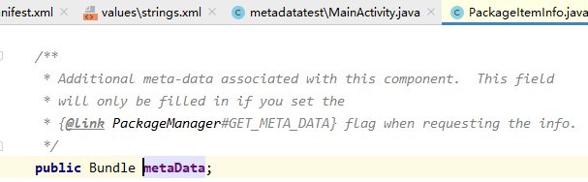

就是个Bundle。

###### 4》 应用场景

<meta-data>这个标签我们经常是在接入第三方SDK时见到，那么它的应用场景肯定跟SDK开发有关！并且在系统属性配置上也有应用，比如配置屏幕支持比例，配置SearchableActivity等等。来看几个示例：

**示例一：某分享**

|  |
| --- |
| <meta-data  android:name="UMENG\_APPKEY"  android:value="oooooooooooooxxxxxxxxxxxx" /> |

**示例二：桌面快捷方式**

|  |
| --- |
| <meta-data  android:name="android.app.shortcuts"  android:resource="@xml/shortcuts" /> |

**示例三：18:9屏幕适配**

|  |
| --- |
| <meta-data  android:name="android.max\_aspect"  android:value="2.1" /> |

**示例四：某地图**

|  |
| --- |
| <meta-data  android:name="com.amap.api.v2.apikey"  android:value="oooooooooooooxxxxxxxxxxxx" /> |

我们接入某分享、某地图、其他私有第三方SDK时，一般都要先申请一个账号，用于接入配置。SDK则会在内部代码中读取这些数据，通过这些key标记来源的信息，分辨接入方，进行访问控制、数据统计等。

其实不知不觉之中，开发者接入了这些SDK，App运营中产生的一些数据也就分享给SDK开发商了，包括使用频率、用户画像等等。

我们在开发自己的SDK过程中，也可以使用这种方法控制访问。通过分配账号的方式要求接入方配置相关信息，并在SDK中读取配置好的<meta-data>信息，用于对比鉴权，若无相关匹配账号，则直接抛异常或者返回相关返回码。当然了，账号分配这一步也可以放到后台做，然而并不是所有的SDK接入都需要后台接入，比如分享SDK。

### 【4】 Example manifest file

The XML below is a simple example AndroidManifest.xml that declares two activities for the app.

|  |
| --- |
| <?xml version="1.0" encoding="utf-8"?> <manifest     xmlns:android="http://schemas.android.com/apk/res/android"     android:versionCode="1"     android:versionName="1.0"     package="com.example.myapp">      <!-- Beware that these values are overridden by the build.gradle file -->     <uses-sdk android:minSdkVersion="15" android:targetSdkVersion="26" />      <application         android:allowBackup="true"         android:icon="@mipmap/ic\_launcher"         android:roundIcon="@mipmap/ic\_launcher\_round"         android:label="@string/app\_name"         android:supportsRtl="true"         android:theme="@style/AppTheme">          <!-- This name is resolved to com.example.myapp.MainActivity              based upon the package attribute -->         <activity android:name=".MainActivity">             <intent-filter>                 <action android:name="android.intent.action.MAIN" />                 <category android:name="android.intent.category.LAUNCHER" />             </intent-filter>         </activity>          <activity             android:name=".DisplayMessageActivity"             android:parentActivityName=".MainActivity" />     </application> </manifest> |

## gradle存储位置

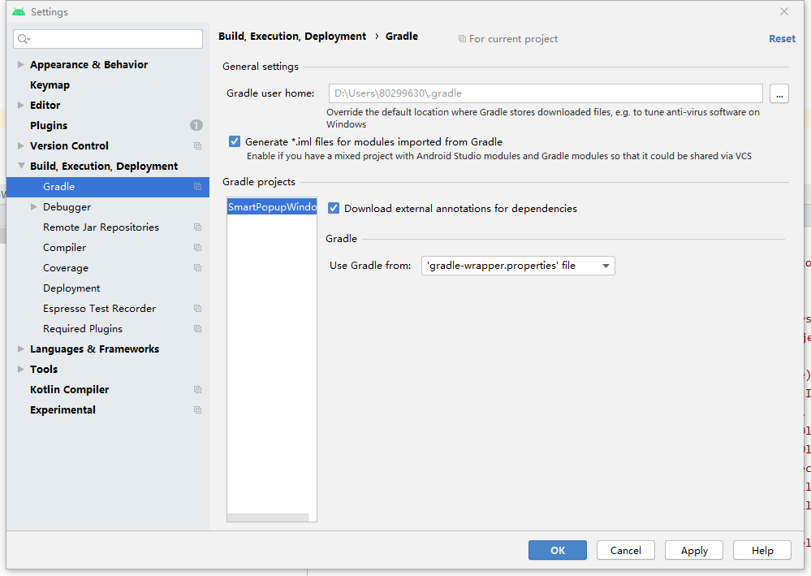

具体gradle文件：

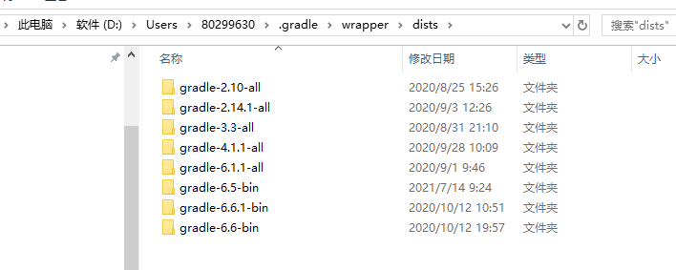

# Android Gradle(版本一: plugin release notes）

参考：<https://developer.android.com/studio/releases/gradle-plugin>

注：用AS简称Android Studio

The Android Studio build system is based on Gradle, and the Android Gradle plugin adds several features that are specific to building Android apps. 虽然Android plugin通常和AS同步更新，该plugin（and the rest of the Gradle system）can run independent of Android Studio and be updated separately.

This page explains how to keep your Gradle tools up to date and what's in the recent updates.

For details about how to configure your Android builds with Gradle, see the following pages:

* [Configure Your Build](https://developer.android.com/studio/build)
* [Android Plugin DSL Reference](https://google.github.io/android-gradle-dsl/current/)
* [Gradle DSL Reference](https://docs.gradle.org/current/dsl/)

For more information about the Gradle build system, see the [Gradle user guide](https://docs.gradle.org/current/userguide/userguide.html).

## Update the Android Gradle plugin

When you update Android Studio, you may receive a prompt to automatically update the Android Gradle plugin to the latest available version.  You can choose to accept the update or manually specify a version based on your project's build requirements.

You can specify the plugin version in either the **File** > **Project Structure** > **Project** menu in Android Studio，

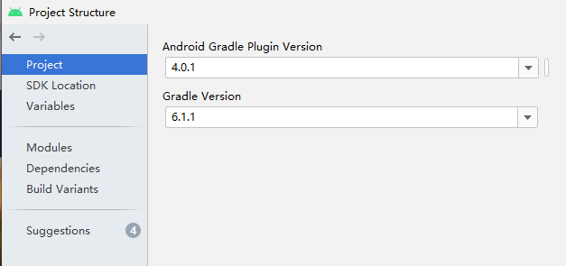

or the top-level build.gradle file

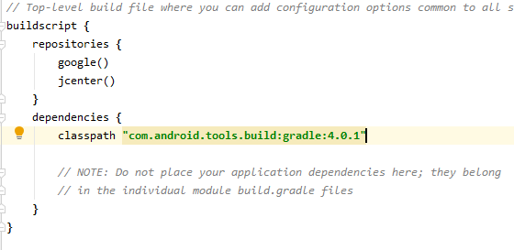

The plugin version applies to all modules built in that Android Studio project. The following example sets the plugin to version 4.0.0 from the build.gradle file:

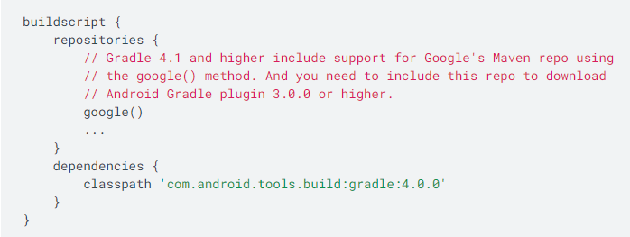

**Caution:** You should not use dynamic dependencies in version numbers, such as **'com.android.tools.build:gradle:2.+'**. Using this feature can cause unexpected version updates and difficulty resolving version differences.

If the specified plugin version has not been downloaded, Gradle downloads it the next time you build your project or click **Sync Project with Gradle Files** from the Android Studio menu bar.

## Update Gradle

When you update Android Studio, you may receive a prompt to also update Gradle to the latest available version. You can choose to accept the update or manually specify a version based on your project's build requirements.

The following table lists which version of Gradle is required for each version of the Android Gradle plugin. For the best performance, you should use the latest possible version of both Gradle and the plugin.

|  |  |
| --- | --- |
| **Plugin version** | **Required Gradle version** |
| 1.0.0 - 1.1.3 | 2.2.1 - 2.3 |
| 1.2.0 - 1.3.1 | 2.2.1 - 2.9 |
| 1.5.0 | 2.2.1 - 2.13 |
| 2.0.0 - 2.1.2 | 2.10 - 2.13 |
| 2.1.3 - 2.2.3 | 2.14.1+ |
| 2.3.0+ | 3.3+ |
| 3.0.0+ | 4.1+ |
| 3.1.0+ | 4.4+ |
| 3.2.0 - 3.2.1 | 4.6+ |
| 3.3.0 - 3.3.3 | 4.10.1+ |
| 3.4.0 - 3.4.3 | 5.1.1+ |
| 3.5.0 - 3.5.4 | 5.4.1+ |
| 3.6.0 - 3.6.4 | 5.6.4+ |
| 4.0.0+ | 6.1.1+ |

You can specify the Gradle version in either the **File** > **Project Structure** > **Project** menu in Android Studio

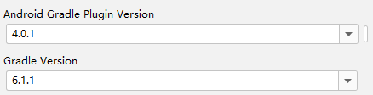

or by editing the Gradle distribution reference in the gradle/wrapper/gradle-wrapper.properties file.

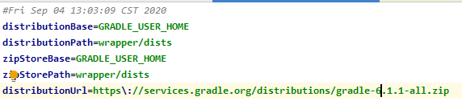

The following example sets the Gradle version to 6.1.1 in the gradle-wrapper.properties file.



下面是Android Gradle plugin和Gradle版本更新关系。

## 实例

* 1. 例1

<https://github.com/PopFisher/SmartPopupWindow>

放到AS4.0.1中报错

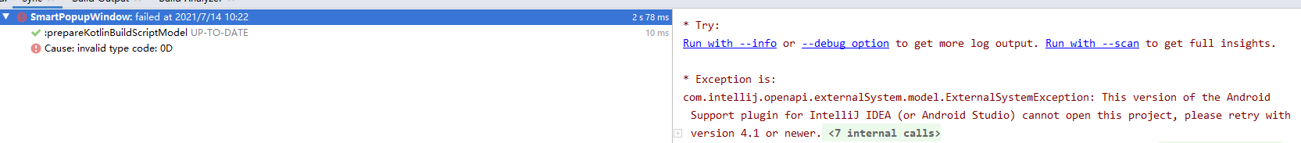

参照：

<https://stackoverflow.com/questions/62678785/android-support-plugin-for-intellij-idea-or-android-studio-cannot-open-this-pr>

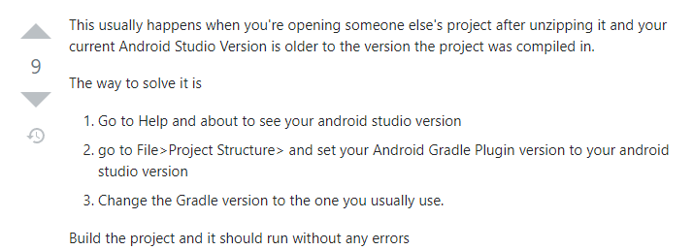

但plugin改成4.0.2也行。

# Android Gradle(版本二: Gradle tips and recipes)

参考：<https://developer.android.com/studio/build/gradle-tips>

# Android Gradle(版本三:操作)

## exclude

见“各种语言.docx”中Gradle的排除依赖

# Android Gradle(版本四:总结)

## （1） gradle和android gradle plugin设置位置

### 【1】 gradle

#### 《1》 法1

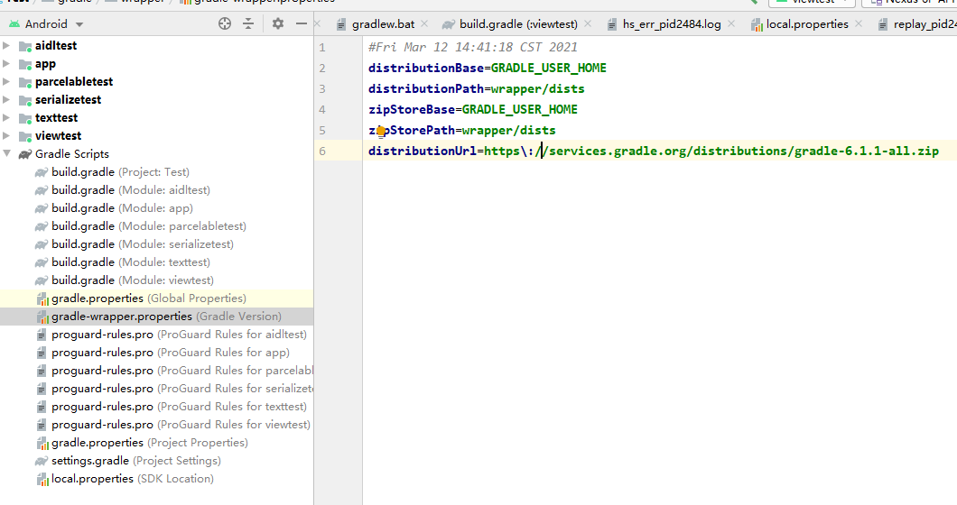

这是从网上下载，若要用本地的

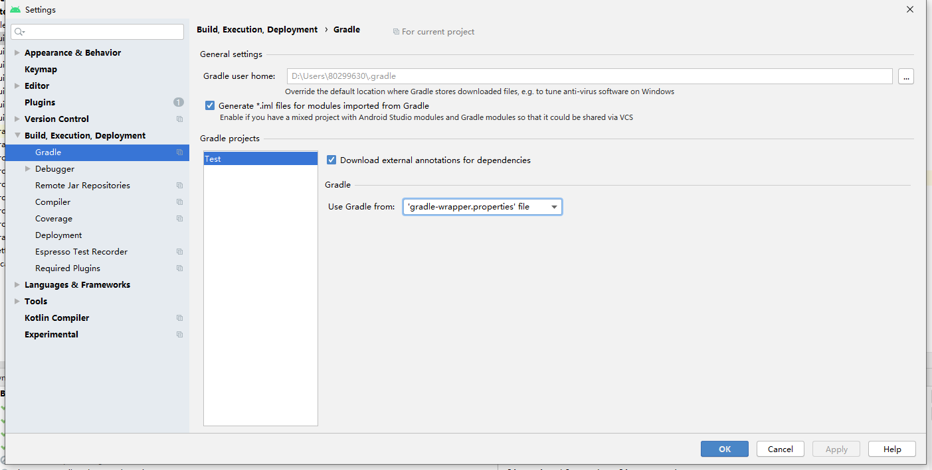

Use gradle from改成：

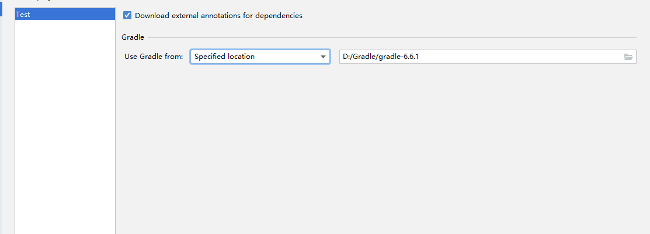

#### 《2》 法2

File-》Project Structure

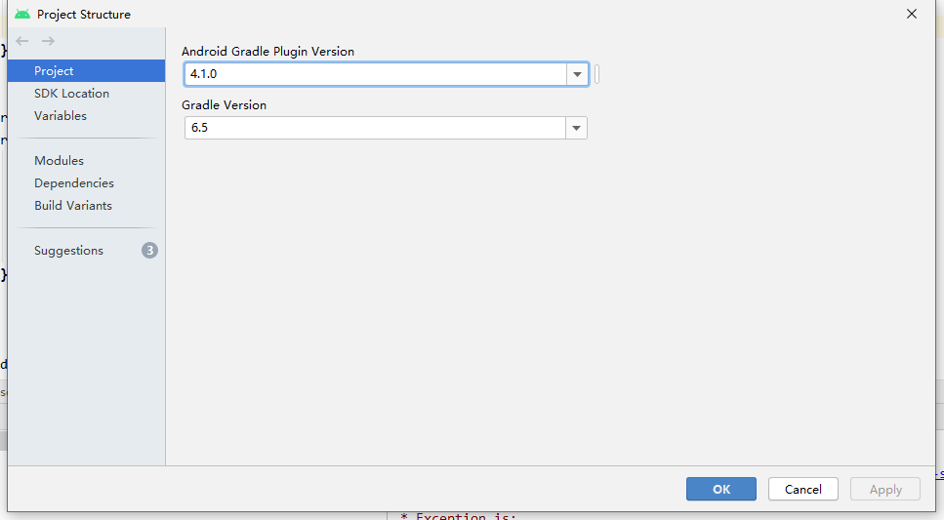

### 【2】 android gradle plugin

#### 《1》 法1

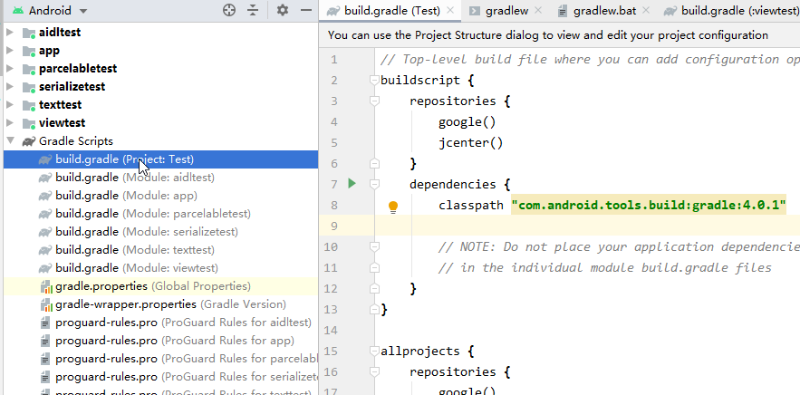

#### 《2》 法2

File-》Project Structure



### 注意：

【1】和【2】中的法1和法2都是相互关联的，即 法1改《=》法2改

## （2） gradle和android gradle plugin对应版本

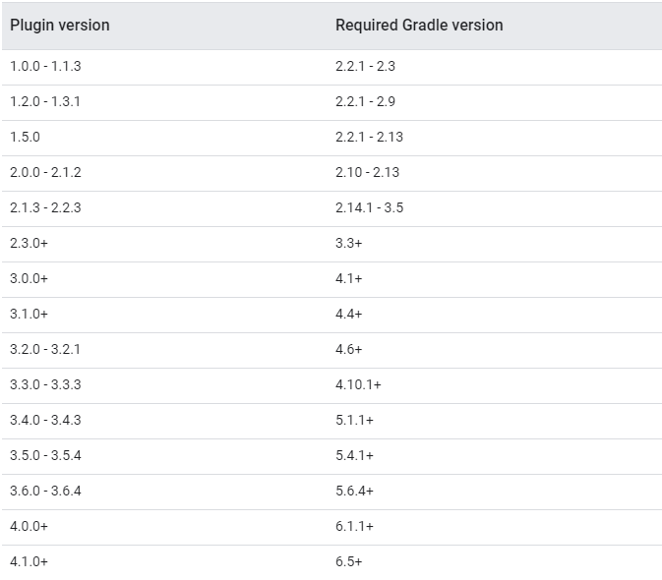

实例：将

<https://github.com/PopFisher/SmartPopupWindow>

用AS打开

## （3） gradle和android gradle plugin更新

进行AS自动提示的更新

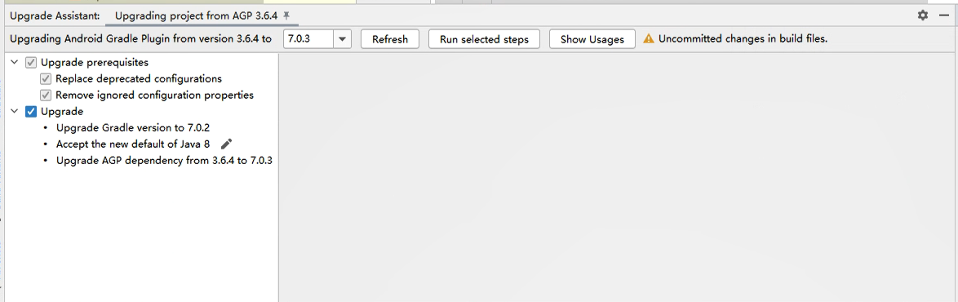

## （4） gradle删除依赖

<https://blog.csdn.net/qq_37077360/article/details/80655974>

<https://www.cxyzjd.com/article/ccc20134/85783367>

<https://blog.csdn.net/zjb12316/article/details/77713950>

<https://www.bbsmax.com/A/Vx5M6ArpdN/>

# 快捷键

参考：<https://developer.android.com/studio/intro/keyboard-shortcuts>

## （1） 查找文本

【1】 init shortcut：ctrl+shift+f

【2】 作用

《1》 查找文本；

《2》 搜中文；

【3】 界面

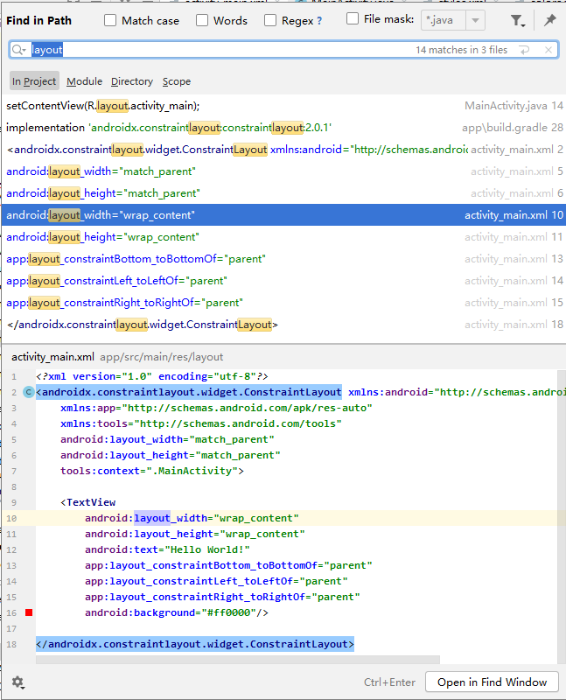

## （2） 搜索任意内容

【1】 init shortcut：shift+shift

【2】 作用

【3】 界面

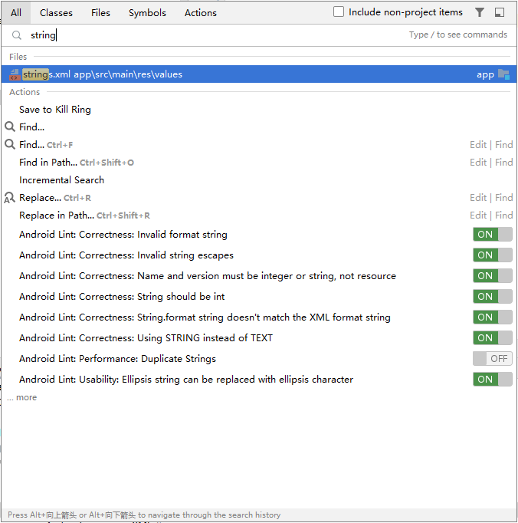

Classes：类名中包含输入的

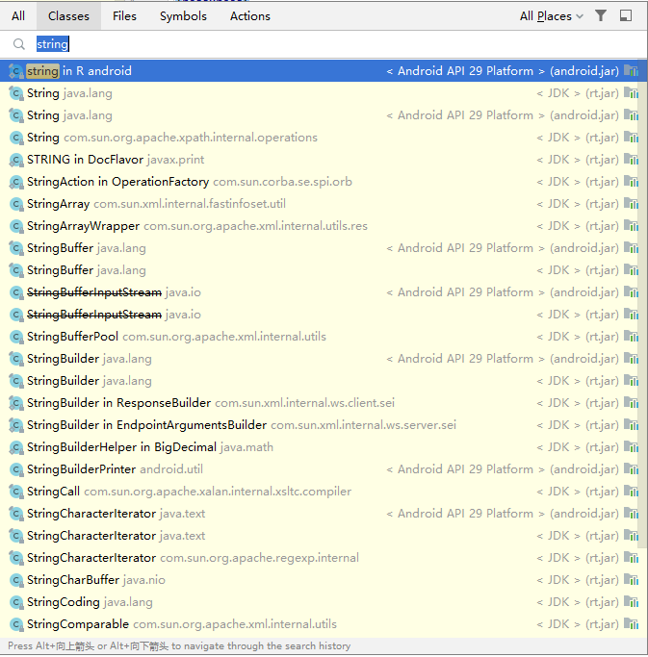

Files：文件名中包含输入的

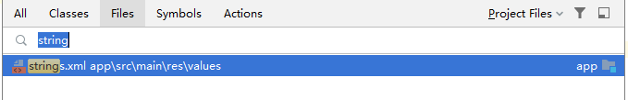

Symbols：

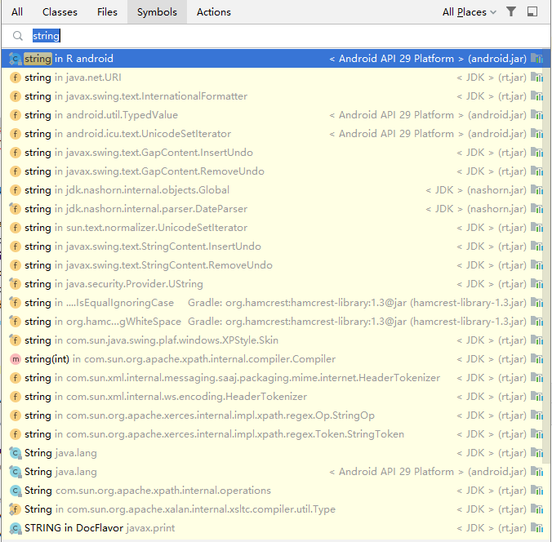

Actions：

进行一些操作，如find usage

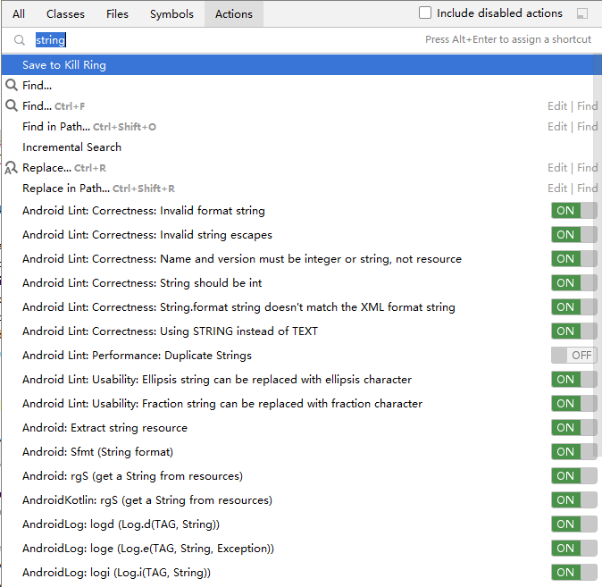

## （3） Find usages

* 1. 两个除了所在类不同其余完全相同的函数，其中一个被find usages，另一个是否也会被查找？

测试code：

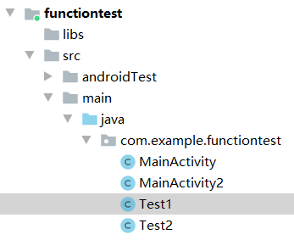

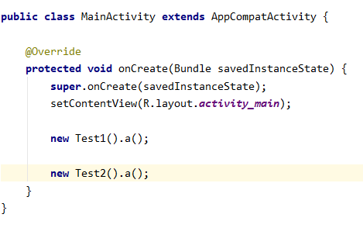

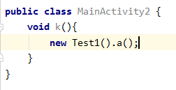

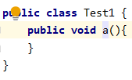

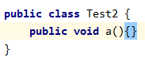

在Test1.a（）上find usages

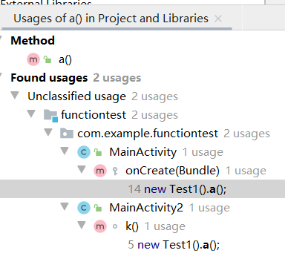

可见只会find指定类的函数。

## （4） Go to implementation（s）

# Test your app

参考：<https://developer.android.com/studio/test>

包含run with coverage

# AAR文件相关

[版本一：概述（官网](#_Android_Library)）

[版本二：生成和引入aar及相关注意点](#_生成和引入AAR（SDK）)

[版本三：aar和jar的关联](#_aar和jar的关联)

# 生成和引入AAR（SDK）及相关注意点

## （1） 生成和引入AAR

参考：<https://www.cnblogs.com/androidxiaoyang/p/5473916.html>

### 【1】 生成aar包

《1》 用android studio打开一个工程，然后新建一个Module，新建Module时候选择Android Library,后面按新建普通工程操作，成功后如下：



1. 在新建的Module中编写完代码后，接下来编译该Module后就会自动生成aar包：选中自己创建好的Module，点击菜单栏 Build里面的Make Module ‘xxx’，如下图

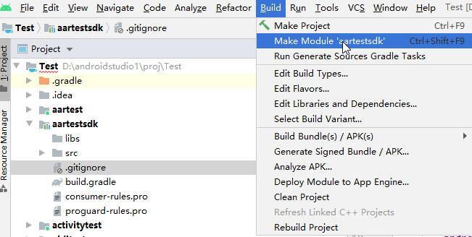

编译完成之后会在Module的build-->outputs-->aar-->xxxxx.aar，如图

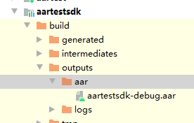

### 【2】 其他androidstudio工程引用aar包

《1》 将aar包复制到libs目录下 如下图：

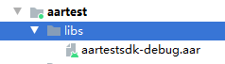

《2》 配置module/build.gradle文件

加入：

|  |
| --- |
| repositories **{** flatDir **{** dirs **'libs'  } }**  compile(**name**: **'aartestsdk-debug'**, **ext**: **'aar'**) |

name后面是自己的aar的名字

完整的配置文件：

|  |
| --- |
| apply **plugin**: **'com.android.application'** android **{** compileSdkVersion 30  buildToolsVersion **"30.0.3"** defaultConfig **{** applicationId **"com.example.aartest"** minSdkVersion 17  targetSdkVersion 30  versionCode 1  versionName **"1.0"** testInstrumentationRunner **"androidx.test.runner.AndroidJUnitRunner"  }** buildTypes **{** release **{** minifyEnabled **false** proguardFiles getDefaultProguardFile(**'proguard-android-optimize.txt'**), **'proguard-rules.pro'  }  } }** repositories **{** flatDir **{** dirs **'libs'  } }** dependencies **{** implementation fileTree(**dir**: **"libs"**, **include**: [**"\*.jar"**])  implementation **'androidx.appcompat:appcompat:1.3.0'** implementation **'androidx.constraintlayout:constraintlayout:2.0.4'** testImplementation **'junit:junit:4.12'** androidTestImplementation **'androidx.test.ext:junit:1.1.3'** androidTestImplementation **'androidx.test.espresso:espresso-core:3.4.0'** compile(**name**: **'aartestsdk-debug'**, **ext**: **'aar'**) **}** |

《3》 sync project

### 注意点

《1》 在修改library module（即生成aar的工程）后，重新编译好后，替换引入aar项目中的原有文件，需要重新sync

以下待看

1. 要尽量避免定义内部接口

这其实是一个编程习惯, 接口interface最好是独立定义, 避免定义在类的内部.

因为当你发布aar时, 内部的接口在混淆后会独立成一个外部的接口Outer$InnerInterface.

然后麻烦来了, 别人在实现这个类的时候必须也写成XXX implement Outer$InnerInterface{}的形式. 否则是找不到这个类的.

想写成XXX implement Outer.InnerInterface{}是不行的, 因为在Outer里没有这个InnerInterface的定义, 在混淆后, 所有的内部类都被改写成了形如Outer$Inner的外部类了. 包括interface, enum, 等等.

更糟糕的是, 你很可能只是发布项目的一部分代码作为aar, 那你的项目内已经引用的Outer.Inner的类或接口都必须写成Outer$Inner的形式, 否则编译不过, 否则运行时找不到类. 所以, 为了以后不必要的麻烦, 尽量避免使用内部类, 内部接口,

除非你确认不会混淆代码, 或者会将所有定义和调用都参与混淆.

2. 使用maven发布需要将所有依赖都发布到maven上

如果你发布多个aar, 每个aar互相依赖, 那么你需要将这些依赖都以maven的形式定义, 否则会在编译时, maven解析某个aar的pom时会报空指针异常.

maven的形式定义:

apply plugin: 'maven'  
compile 'com.nineoldandroids:library:2.4.0+'

3. res内定义的属性或者名称, 都应当加上前缀

你的aar里定义资源文件是很正常的事, 资源文件很有可能和别人的资源重名, 而悲剧的是, 别人很有可能是引用了另外一个aar导致与你重名. 他无法修改那个aar的资源名, 就像他不能修改你的aar资源名一样. 为了避免这种尴尬, 最好在定义的资源程前加上一个前缀, 比如你的模块简写,商标简写等等. 避免冲突, 还能打个广告, 何乐而不为.

## 修改已有aar并重新引入

主：<https://blog.csdn.net/Maiduoudo/article/details/93197074>

辅：<https://www.jianshu.com/p/f0a267551493>

### 测试环境

AS arctic fox 2020.3.1 patch 3

### 步骤

## （x） AAR注意点

### 【1】 打包时的文件替换问题

#### 《1》 是什么

1） Apk打包优先打和aar中同名的工程中的资源文件，即aar中的同名文件会被覆盖

#### 《2》 实例

##### 1) 基础准备

1》 aar工程

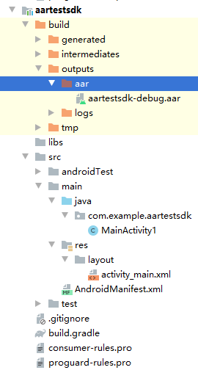

A） MainActivity1

|  |
| --- |
| **public class** MainActivity1 **extends** AppCompatActivity {   @Override  **protected void** onCreate(Bundle savedInstanceState) {  **super**.onCreate(savedInstanceState);  setContentView(R.layout.*activity\_main*);  } } |

B） activity\_main.xml

|  |
| --- |
| *<?***xml version="1.0" encoding="utf-8"***?>* <**androidx.constraintlayout.widget.ConstraintLayout xmlns:android="http://schemas.android.com/apk/res/android"  xmlns:app="http://schemas.android.com/apk/res-auto"  xmlns:tools="http://schemas.android.com/tools"  android:layout\_width="match\_parent"  android:layout\_height="match\_parent"  tools:context=".MainActivity"**>   <**TextView  android:layout\_width="wrap\_content"  android:layout\_height="wrap\_content"  android:text="Hello World!"  app:layout\_constraintBottom\_toBottomOf="parent"  app:layout\_constraintLeft\_toLeftOf="parent"  app:layout\_constraintRight\_toRightOf="parent"  app:layout\_constraintTop\_toTopOf="parent"** />  </**androidx.constraintlayout.widget.ConstraintLayout**> |

C） AndroidManifest.xml

|  |
| --- |
| <**manifest xmlns:android="http://schemas.android.com/apk/res/android"  package="com.example.aartestsdk"**>   <**application**>  <**activity  android:label="aartestsdk"  android:name=".MainActivity1"** />  </**application**> </**manifest**> |

2》 引入aar的工程

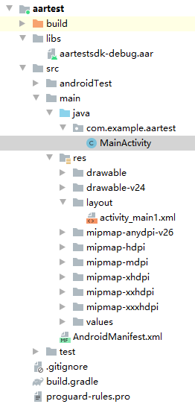

A） MainActivity

|  |
| --- |
| **public class** MainActivity **extends** AppCompatActivity {   @Override  **protected void** onCreate(Bundle savedInstanceState) {  **super**.onCreate(savedInstanceState);  setContentView(R.layout.***activity\_main***);  }   **public void** ButtonOnClick(View view) {  startActivity(**new** Intent(**this**, MainActivity1.**class**));  } } |

B） activity\_main1.xml

|  |
| --- |
| *<?***xml version="1.0" encoding="utf-8"***?>* <**LinearLayout xmlns:android="http://schemas.android.com/apk/res/android"  xmlns:app="http://schemas.android.com/apk/res-auto"  xmlns:tools="http://schemas.android.com/tools"  android:layout\_width="match\_parent"  android:layout\_height="match\_parent"  tools:context=".MainActivity"**>   <**TextView  android:layout\_width="wrap\_content"  android:layout\_height="wrap\_content"  android:text="覆盖Hello World!"** />   <**Button  android:layout\_width="wrap\_content"  android:layout\_height="wrap\_content"  android:text="Button"  android:onClick="ButtonOnClick"**/>  </**LinearLayout**> |

C） AndroidManifest.xml

|  |
| --- |
| *<?***xml version="1.0" encoding="utf-8"***?>* <**manifest xmlns:android="http://schemas.android.com/apk/res/android"  package="com.example.aartest"**>   <**application  android:allowBackup="true"  android:icon="@mipmap/ic\_launcher"  android:label="@string/app\_name"  android:roundIcon="@mipmap/ic\_launcher\_round"  android:supportsRtl="true"  android:theme="@style/AppTheme"**>  <**activity android:name=".MainActivity"**>  <**intent-filter**>  <**action android:name="android.intent.action.MAIN"** />   <**category android:name="android.intent.category.LAUNCHER"** />  </**intent-filter**>  </**activity**>  </**application**>  </**manifest**> |

module/build.gradle:

|  |
| --- |
| apply **plugin**: **'com.android.application'** android **{** compileSdkVersion 30  buildToolsVersion **"30.0.3"** defaultConfig **{** applicationId **"com.example.aartest"** minSdkVersion 17  targetSdkVersion 30  versionCode 1  versionName **"1.0"** testInstrumentationRunner **"androidx.test.runner.AndroidJUnitRunner"  }** buildTypes **{** release **{** minifyEnabled **false** proguardFiles getDefaultProguardFile(**'proguard-android-optimize.txt'**), **'proguard-rules.pro'  }  } }** repositories **{** flatDir **{** dirs **'libs'  } }** dependencies **{** implementation fileTree(**dir**: **"libs"**, **include**: [**"\*.jar"**])  implementation **'androidx.appcompat:appcompat:1.3.0'** implementation **'androidx.constraintlayout:constraintlayout:2.0.4'** testImplementation **'junit:junit:4.12'** androidTestImplementation **'androidx.test.ext:junit:1.1.3'** androidTestImplementation **'androidx.test.espresso:espresso-core:3.4.0'** compile(**name**: **'aartestsdk-debug'**, **ext**: **'aar'**) **}** |

##### 2) 运行效果



##### 3) 文件修改

把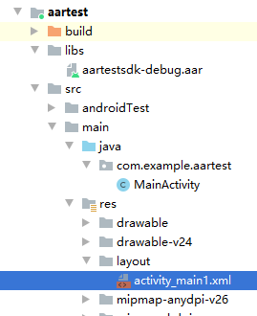改成

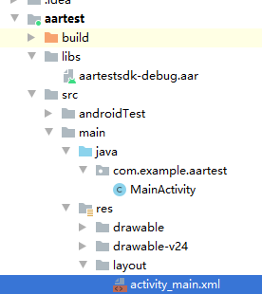

##### 4) 新效果



# aar和jar的关联

<https://blog.csdn.net/shusheng0007/article/details/79666505>

<https://blog.csdn.net/zxw136511485/article/details/52777286>

1. aar是什么？

aar是Android Archive的缩写，而我们熟悉的jar则是Java Archive的缩写。说白了“aar就是一种类似于Jar的打包格式”。

1. aar与jar有什么异同？

aar与jar非常类似，基本上都可以理解为一个压缩文件（ zip-file ）。jar中包含了编译后的class文件以及一些包含元数据的文本文件。而aar比jar多了些Android特有的一些文件，例如layout文件，drawable文件以及manifest文件。说白了，一个aar在Android中就是一个完整的Library Module。

Jar是被广大java世界的成员所熟知的，但是Aar除了Android Studio认识它，其他人根本不屌它，因为压根不认识这货。

# Logcat【old，待整合进new】

## 是什么

参考：<https://developer.android.com/studio/command-line/logcat>

Logcat is a command-line tool that dumps a log of system messages, including stack traces when the device throws an error and messages that you have written from your app with the [Log](https://developer.android.com/reference/android/util/Log) class.

## Logging system overview

参考：https://developer.android.com/studio/command-line/logcat#Overview

## Logcat command-line相关

### Command-line syntax

https://developer.android.com/studio/command-line/logcat#Syntax

### Filtering log output

https://developer.android.com/studio/command-line/logcat#filteringOutput

### Control log output format

https://developer.android.com/studio/command-line/logcat#outputFormat

### Format modifiers

https://developer.android.com/studio/command-line/logcat#formatmodify

### View alternative log buffers

https://developer.android.com/studio/command-line/logcat#alternativeBuffers

## Logcat Window相关

### 是什么

参考：<https://developer.android.com/studio/debug/am-logcat>

The **Logcat** window in Android Studio displays system messages, such

as when a garbage collection occurs, and messages that you added to your app with the [Log](https://developer.android.com/reference/android/util/Log) class.

To display just the information of interest, you can create filters, modify how much information is displayed in messages, set priority levels, display messages produced by app code only, and search the log. By default, logcat shows the log output related to the most recently run app only.

When an app throws an exception, logcat shows a message followed by the associated stack trace containing links to the line of code.

As of Android Studio 2.2, the **Run** window also displays log messages for the current running app. Note that you can configure the logcat output display, but not the **Run** window.

### Log Message

#### Write Log Messages

##### 最常用methods

The [Log](https://developer.android.com/reference/android/util/Log) class allows you to create log messages that appear in logcat. Generally, you should use the following log methods, listed in order from the highest to lowest priority (or, least to most verbose):

* [Log.e(String, String)](https://developer.android.com/reference/android/util/Log#e(java.lang.String,%20java.lang.String)) (error)
* [Log.w(String, String)](https://developer.android.com/reference/android/util/Log#w(java.lang.String,%20java.lang.String)) (warning)
* [Log.i(String, String)](https://developer.android.com/reference/android/util/Log#i(java.lang.String,%20java.lang.String)) (information)
* [Log.d(String, String)](https://developer.android.com/reference/android/util/Log#d(java.lang.String,%20java.lang.String)) (debug)
* [Log.v(String, String)](https://developer.android.com/reference/android/util/Log#v(java.lang.String,%20java.lang.String)) (verbose)

See the [Log](https://developer.android.com/reference/android/util/Log) class description for a more complete list of options.

##### 用法

1》 不同method使用时机

You should never compile verbose logs into your app, except during development. Debug logs are compiled in but stripped（删除） at runtime, while error, warning, and info logs are always kept.

2》 tag和message

For each log method, the first parameter should be a unique tag and the second parameter is the message.

**系统日志信息的tag：**The tag of a system log message is a short string indicating the system component from which the message originates (for example, [ActivityManager](https://developer.android.com/reference/android/app/ActivityManager)).

Your tag can be any string that you find helpful, such as the name of the current class.

**推荐用法：**A good convention is to declare a TAG constant in your class to use in the first parameter. For example, you might create an information log message as follows:

|  |
| --- |
| private static final String TAG = "MyActivity"; ... Log.i(TAG, "MyClass.getView() — get item number " + position); |

**Note:** Tag names greater than 23 characters are truncated（截断） in the logcat output.

#### 《2》 Logcat中message的格式

Every Android log message has a tag and a priority associated with it. You define it in a Log method call, for example:

|  |
| --- |
| Log.d(tag, message); |

The priority is one of the following values:

* **V:** Verbose (lowest priority)
* **D:** Debug
* **I:** Info
* **W:** Warning
* **E:** Error
* **A:** Assert

格式：The log message format is:

|  |
| --- |
| **date** **time** **PID**-**TID**/**package** **priority**/**tag**: **message** |

For example, the following log message has a priority of V and a tag of AuthZen:

|  |
| --- |
| 12-10 13:02:50.071 1901-4229/com.google.android.gms V/AuthZen: Handling delegate intent. |

PID stands for process identifier and TID is thread identifier; they can be the same if there’s only one thread.

#### 《3》 Read garbage collection messages

##### 1） Dalvik log messages

##### 2） ART log messages

### View your app logs（Logcat窗体结构）

To display the log messages for an app:

1. [Build and run your app](https://developer.android.com/studio/run#RunningApp) on a device.
2. Click **View > Tool Windows > Logcat** (or click **Logcat**  in the tool window bar).

如下图所示：

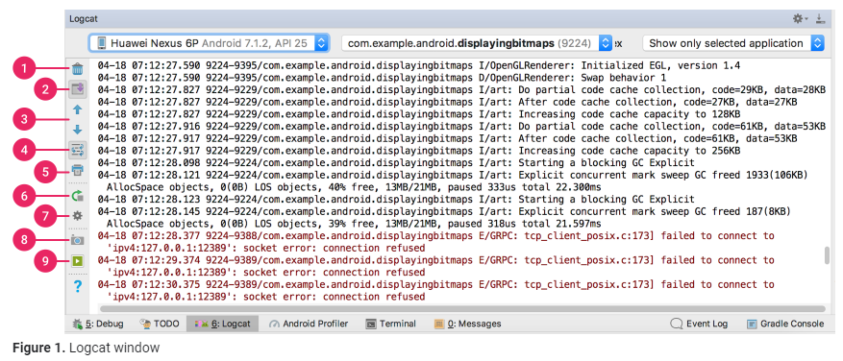

#### 《1》 上图9个红圈

##### 1） Clear logcat

Click to clear the visible log.

##### 2） Scroll to the end

Click to jump to the bottom of the log and see the latest log messages. If you then click a line in the log, the view pauses scrolling at that point.

解释：选中后光标一直在底部

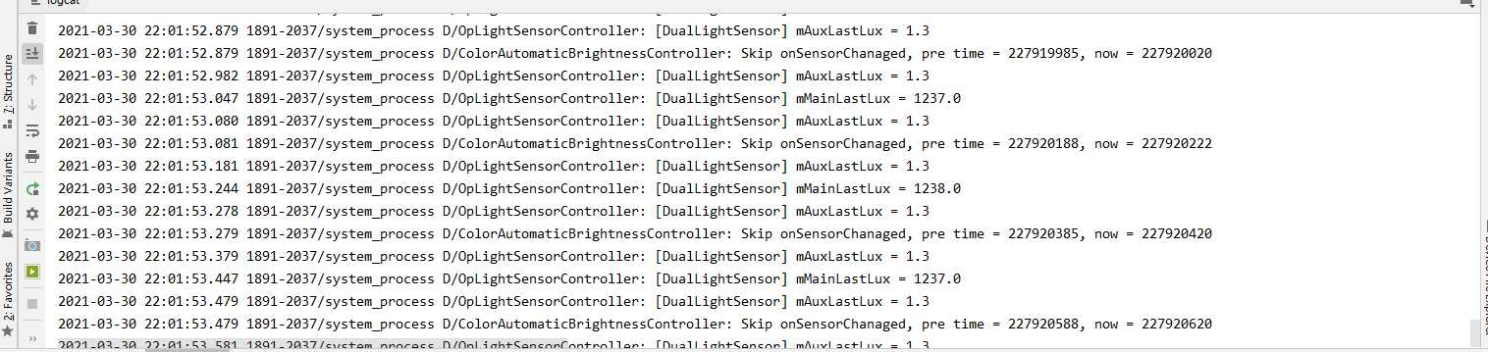

不选中后滚条会一直上升

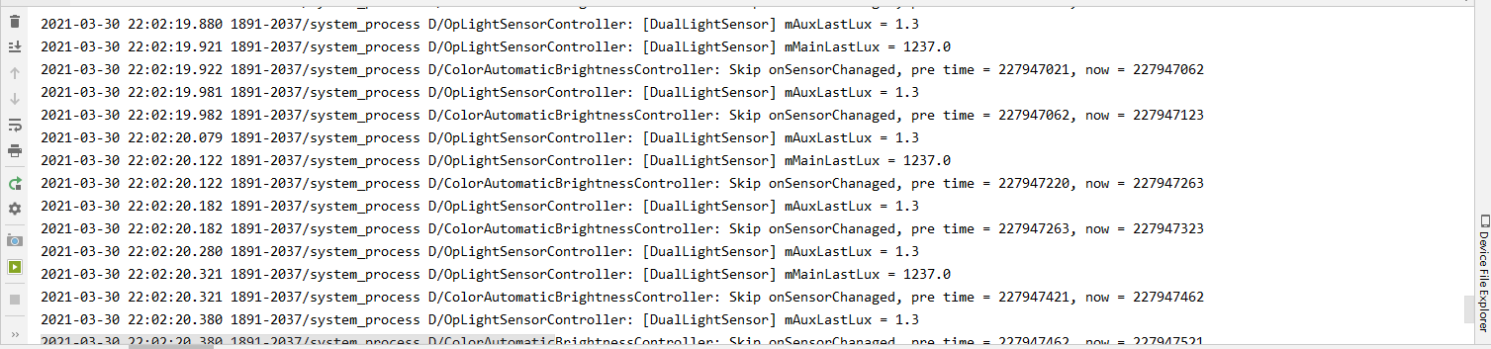

##### Up the stack trace and Down the stack trace

Click to navigate up and down the stack traces in the log, selecting the subsequent filenames (and viewing the correspnding line numbers in the editor) that appear in the printed exceptions. This is the same behavior as when you click on a filename in the log.

解释：点上或下会向上/下选中stack traces中相应的类名，并在代码窗口中显示对应行

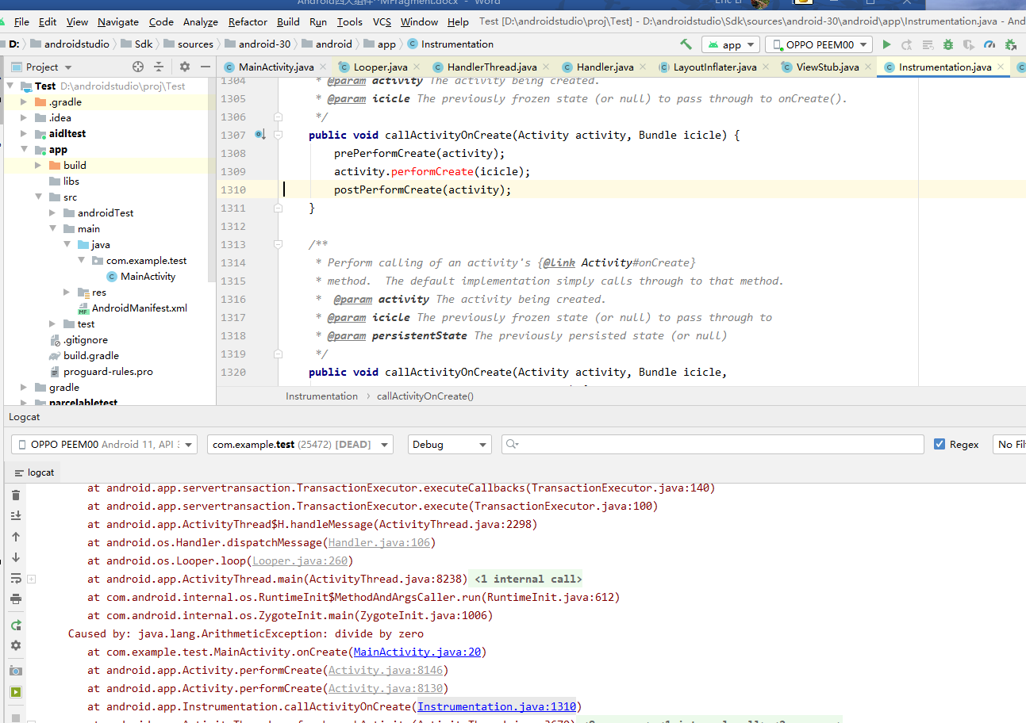

点上

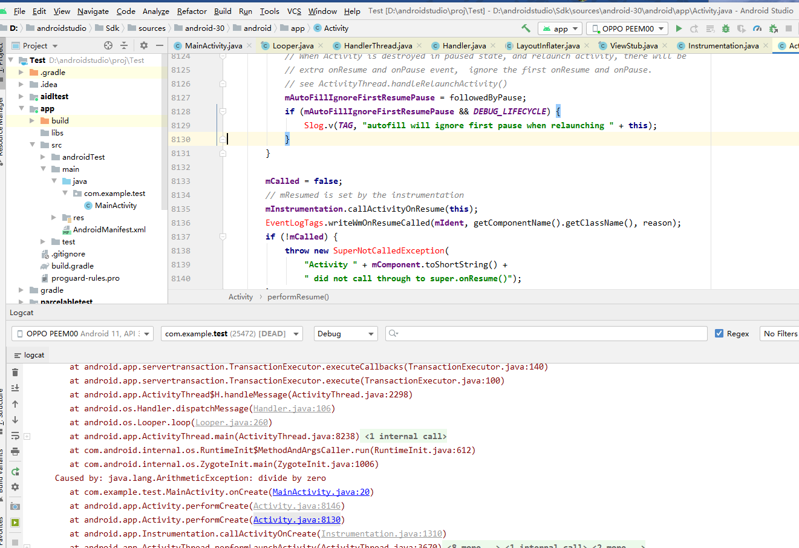

点上

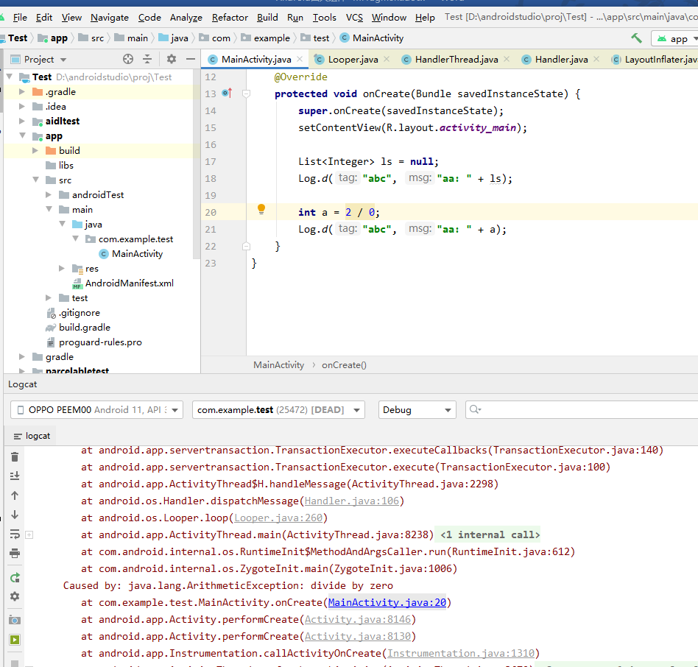

##### Use soft wraps

Click to enable line wrapping and prevent horizontal scrolling (though any unbreakable strings will still require horizontal scrolling).

解释：点击来允许换行并阻止水平滚动（虽然任何不可分割的字符串仍需要水平滚动）。如图，可选中

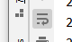

##### 5） Print

Click to print the logcat messages. After selecting your print preferences in the dialog that appears, you can also choose to save to a PDF.

解释：点击后

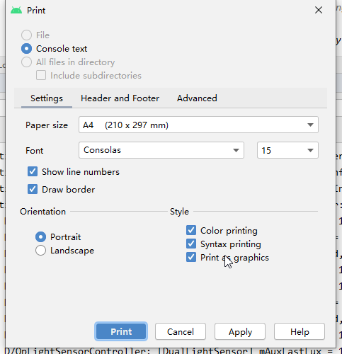

点print后

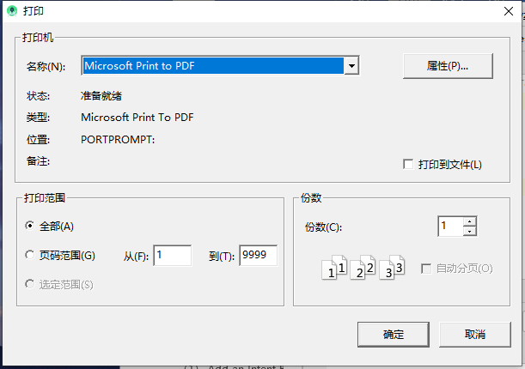

##### 6） Restart

Click to clear the log and restart logcat. Unlike the **Clear logcat** button, this recovers and displays previous log messages, so is most useful if Logcat becomes unresponsive and you don't want to lose your log messages.

##### 7） Logcat header

Click to open the **Configure Logcat Header** dialog, where you can customize the appearance of each logcat message, such as whether to show the date and time.

解释：

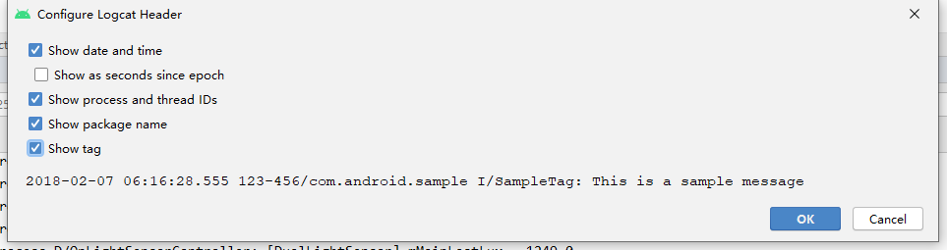

##### 8） Screen capture

Click to [capture a screenshot](https://developer.android.com/studio/debug/am-screenshot).

解释：点击后

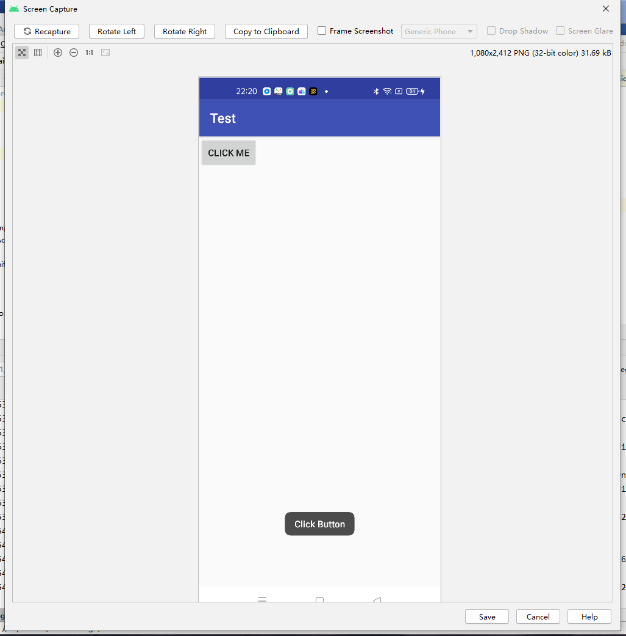

##### 9） Screen record

Click to [record a video](https://developer.android.com/studio/debug/am-video) of the device (for a maximum of 3 minutes).

解释：点击后

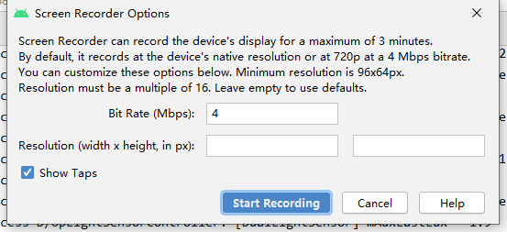

点start

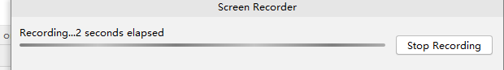

#### 《2》 设置log level

You can control how many messages appear in logcat by setting the log level. You can display all messages, or just the messages indicating the most severe conditions.

注：Remember that logcat continues to collect all messages regardless of the log level setting. The setting just determines what logcat displays.

In the Log level menu, select one of the following values:

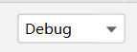

* **Verbose:** Show all log messages (the default).
* **Debug:** Show debug log messages that are useful during development only, as well as the message levels lower in this list.
* **Info:** Show expected log messages for regular usage, as well as the message levels lower in this list.
* **Warn:** Show possible issues that are not yet errors, as well as the message levels lower in this list.
* **Error:** Show issues that have caused errors, as well as the message level lower in this list.
* **Assert:** Show issues that the developer expects should never happen.

#### 过滤Logcat messages



One way to reduce the log output to a manageable level is to restrict it by using a filter.

**Note:** The filter applies to your full logcat history, not just those messages currently displayed in logcat. Make sure your other display options are set appropriately so you can see the filter output you want to examine.

过滤器种类：

##### Show only selected application

Display the messages produced by the app code only (the default). Logcat filters the log messages using the PID of the active app.

##### No Filters

Apply no filters. Logcat displays all log messages from the device, regardless of which process you selected.

##### Firebase

##### Edit Filter Configuration

Create or modify a custom filter. For example, you could create a filter to view log messages from two apps at the same time.

解释：

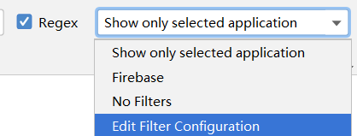

到

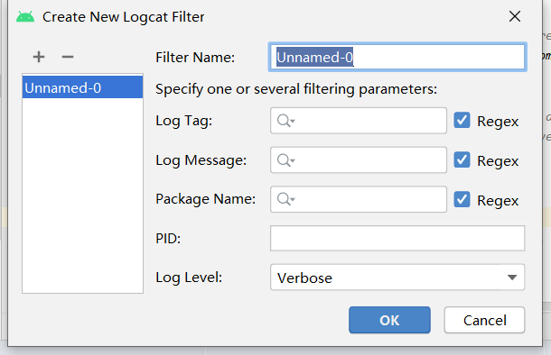

* 1. Filter Name

Type the name of a filter you want to define, or select it in the left pane to modify an existing filter. The name can contain lowercase characters, underscores, and digits only.

* 1. Log Tag

Optionally specify a tag. For more information, see [logcat Message Format](https://developer.android.com/studio/debug/am-logcat#format).

* 1. Log Message

Optionally specify log message text. For more information, see [logcat Message Format](https://developer.android.com/studio/debug/am-logcat#format).

* 1. Package Name

Optionally specify a package name. For more information, see [logcat Message Format](https://developer.android.com/studio/debug/am-logcat#format).

* 1. PID

Optionally specify a process ID. For more information, see [logcat Message Format](https://developer.android.com/studio/debug/am-logcat#format).

* 1. Log Level

Optionally select a log level. For more information, see [Set the Log Level](https://developer.android.com/studio/debug/am-logcat#level).

##### 注意点：

If you don't think you see the log messages you want, try selecting **No filters** and [searching](https://developer.android.com/studio/debug/am-logcat#searching) for particular log messages.

#### 《4》 搜索logcat message

To search the messages currently displayed in logcat:



1. Optionally select **Regex** if you want to use a regular expression search pattern.
2. Type a character sequence in the search field .

The logcat output display changes accordingly.

## 其他待整理资料

<https://developer.android.com/reference/android/util/Log>

<https://www.cnblogs.com/andy-songwei/p/9676823.html>

<https://stackoverflow.com/questions/25457858/android-log-levels>

<https://medium.com/shipbook/android-log-levels-c0313055fdb9>

<https://www.jianshu.com/p/a88508358006>

<https://segmentfault.com/a/1190000038631522>

<https://www.huaweicloud.com/articles/a8fb2c6140bc9e21058c5d344a5cac28.html>

<https://www.ithome.com/html/android/318639.htm>

<https://www.jianshu.com/p/bc5645e4e69b>

<https://www.cnblogs.com/aqyl/p/6605103.html>  
<https://www.cnblogs.com/tsingke/p/9200462.html>

<https://medium.com/android-dev-hacks/android-studio-tips-tricks-part-3-debugging-107d34b40220>

<https://heartbeat.fritz.ai/tips-tricks-for-debugging-in-android-studio-c36a96173d7b>

<https://www.xda-developers.com/how-to-take-logs-in-android/>

<https://www.dev2qa.com/android-logcat-and-logging-best-practice/>

<https://stackoverflow.com/questions/24949311/what-is-the-best-practice-using-android-logger>

<https://code.tutsplus.com/tutorials/android-essentials-application-logging--mobile-4578>

## 待搞清问题

【1】 log的各个级别分别什么场景用？

# Logcat【new】

<https://developer.android.com/studio/debug/am-logcat>

## （1） 是什么

## （2） Logging system overview

## （3） 使用

### 【1】 Logcat command-line

<https://developer.android.com/studio/command-line/logcat#Syntax>

#### 《1》 oppo资料

<https://hio.oppo.com/app/module/detail?tkh_id=2326360&itm_id=35&mod_id=262>

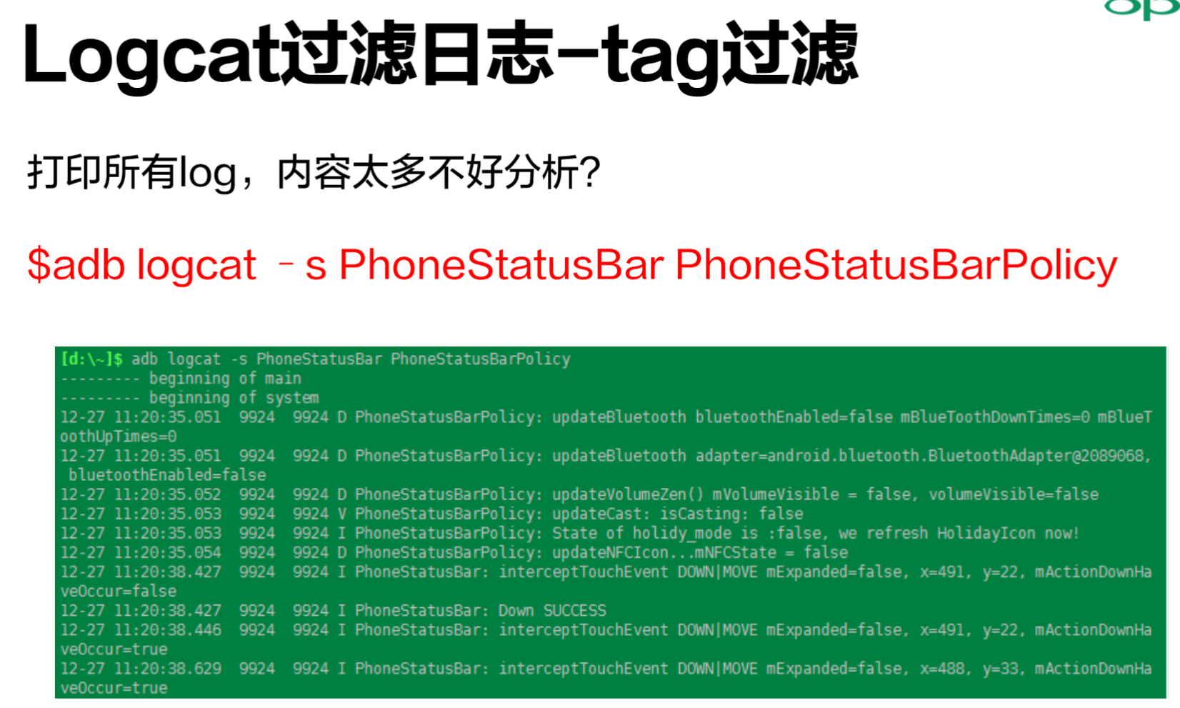

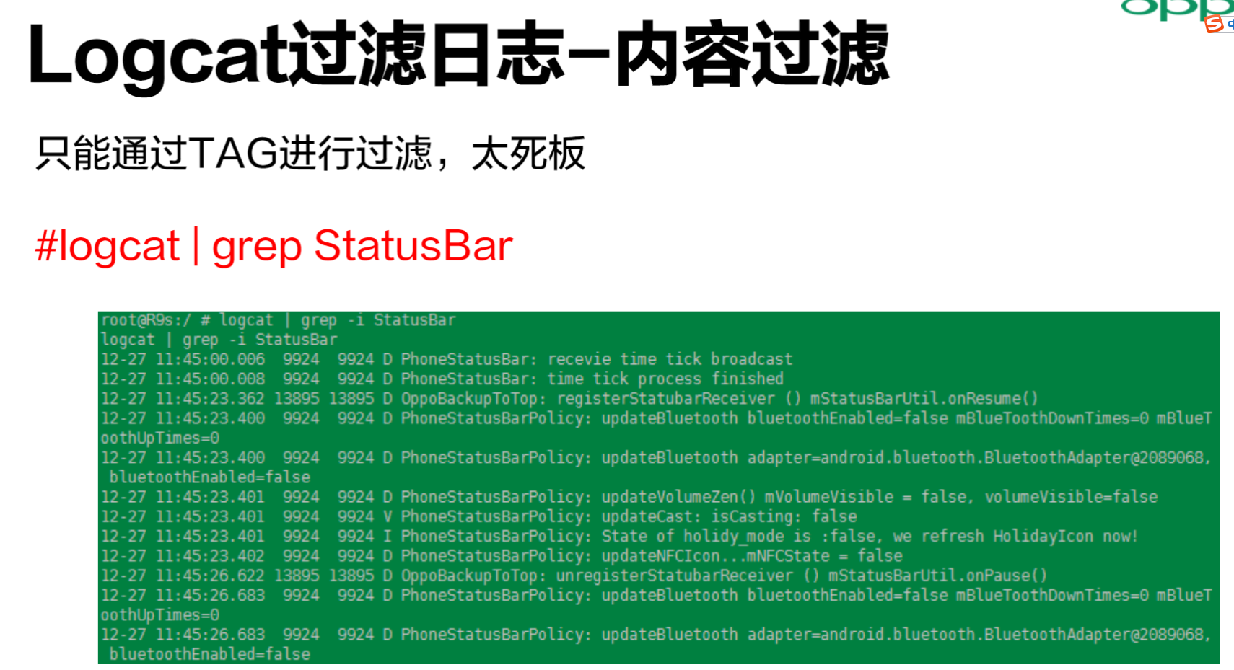

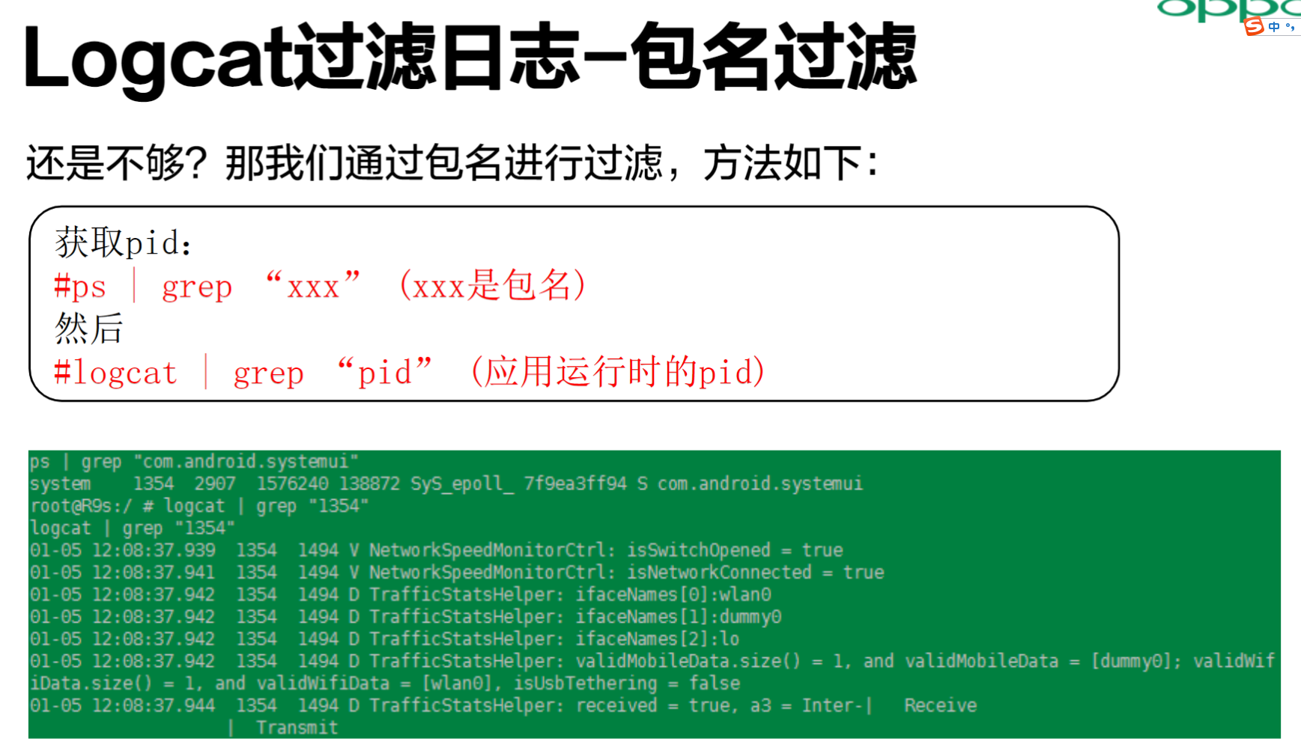

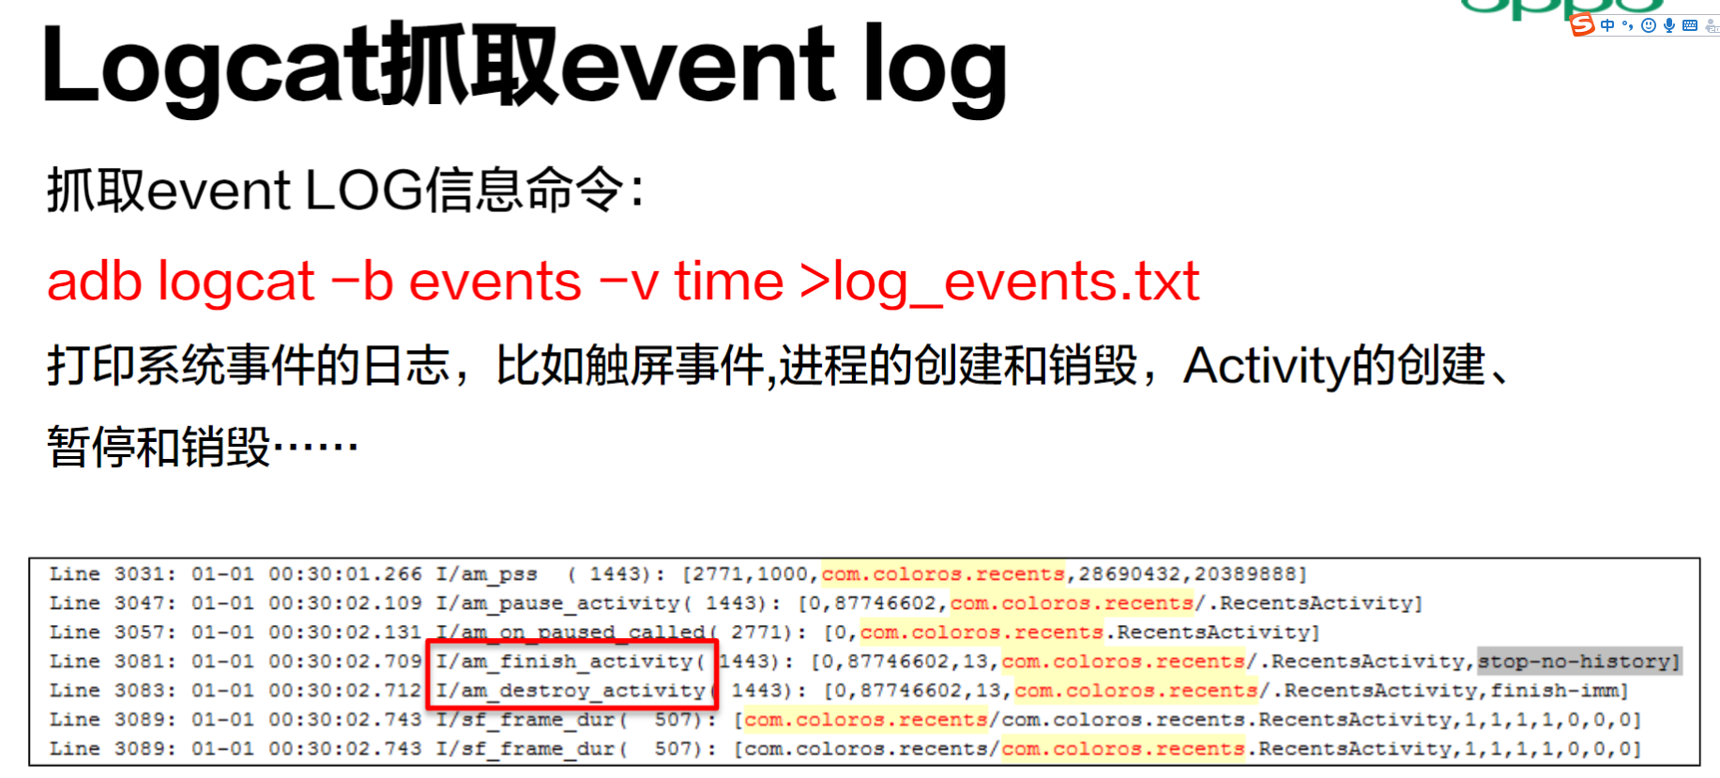

### 【2】 Logcat Window

<https://developer.android.com/studio/debug/am-logcat>

## 一些归纳：

### 【1】 logcat和系统log的关系

<https://developer.android.com/studio/debug/am-logcat>

<https://developer.android.google.cn/studio/command-line/logcat>

android是用一个日志系统:logging system来管理整个android系统的日志的，该日志系统是由系统进程logd维护的。

Logcat是一个命令行工具，在AS中它表现为logcat窗口。Logcat用于显示系统消息日志:a log of system messages【即整个android系统的日志】。系统消息（日志）包括：

* android系统自己的消息

比如：设备抛出错误时的堆栈轨迹:stack traces、在进行垃圾回收时显示的消息

* app中通过Log类打印的消息

<https://developer.android.google.cn/studio/command-line/logcat#logClass>

# AS使用git

参考：

1. 主：<https://www.jianshu.com/p/885786074e96>

<https://blog.csdn.net/gao_chun/article/details/49817229>

## 安装与配置

### 安装配置git

#### 安装

<https://git-scm.com/downloads>

安装流程：

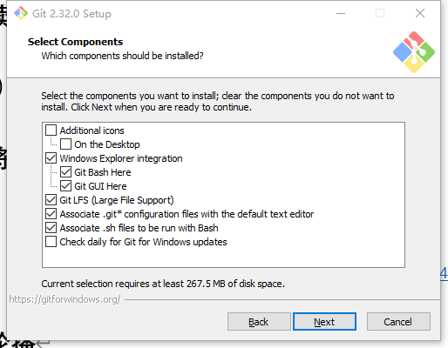

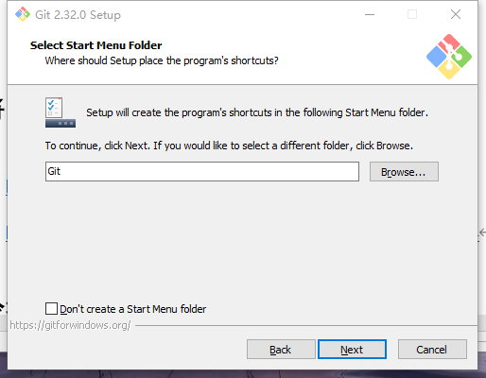

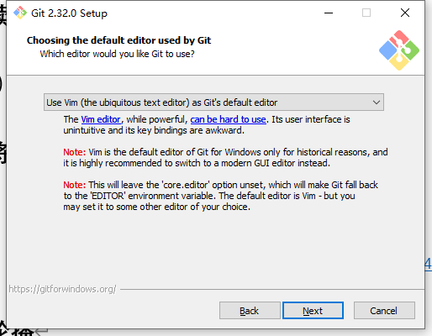

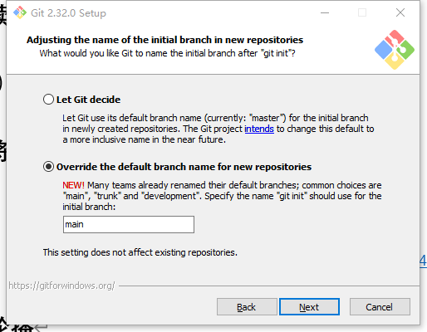

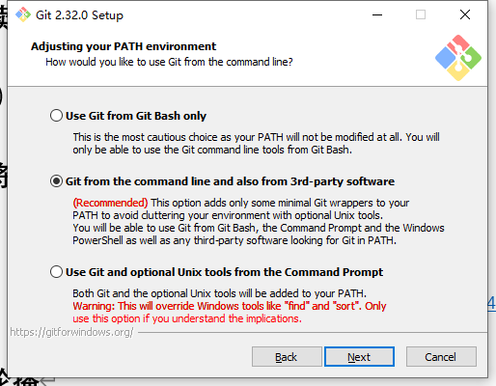

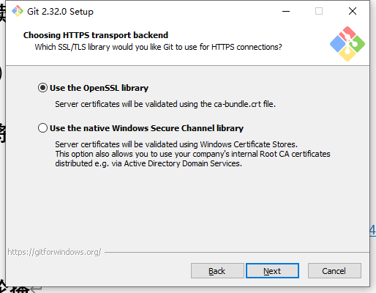

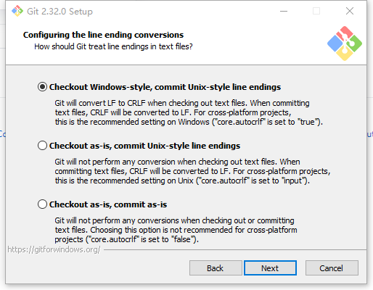

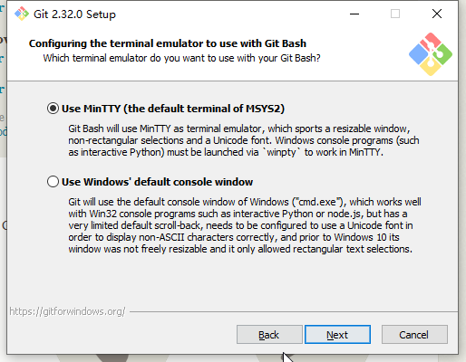

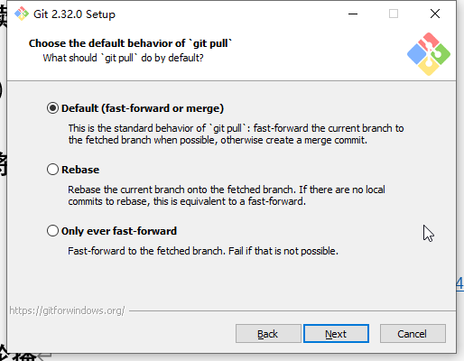

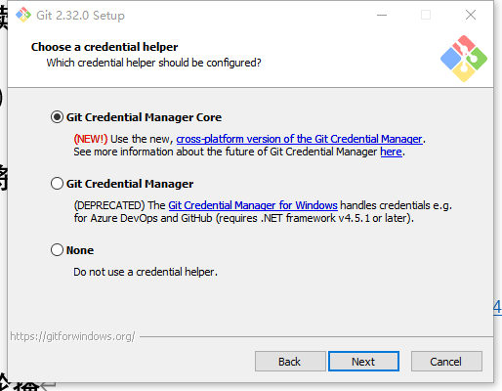

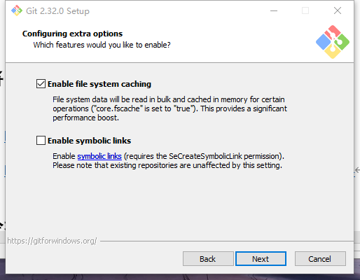

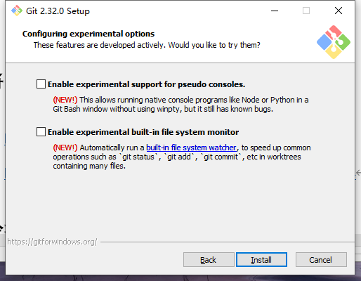

完成

#### 验证

在start menu和右键有如下，

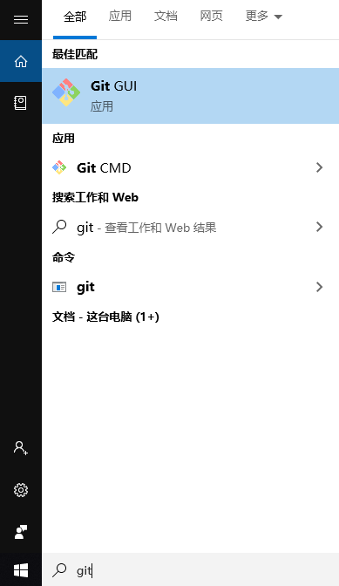

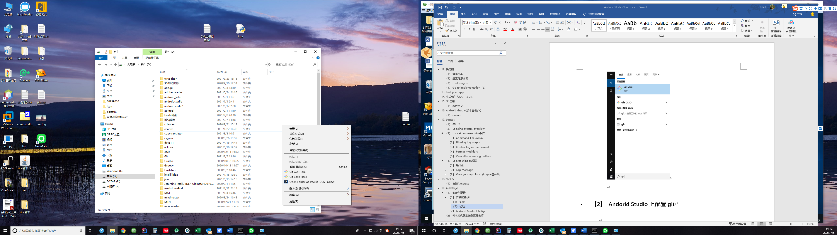

查看环境变量，

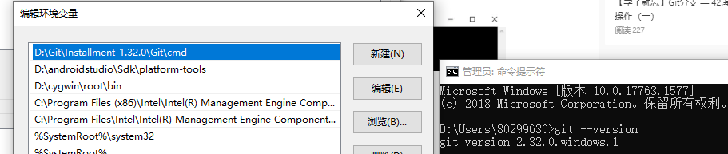

#### 配置git

1. 配置姓名和邮箱

|  |
| --- |
| git config --global [user.name](http://user.name/) "姓名" git config --global user.email "邮箱" |

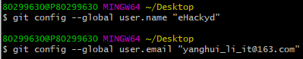

参考：https://www.yiibai.com/git/git\_config.html

git config 命令的 --global参数，表示你这台机器上所有的 Git仓库都会使用这个配置。

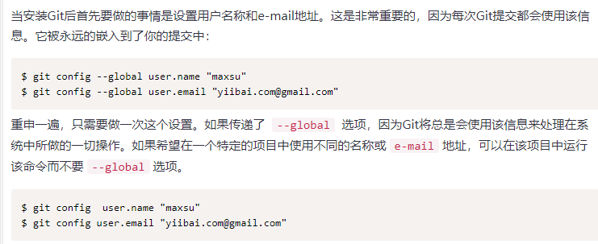

### Git代码托管平台创建仓库

参考：<https://cloud.tencent.com/developer/article/1414120>

#### Github

##### 流程

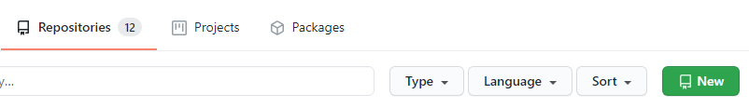到

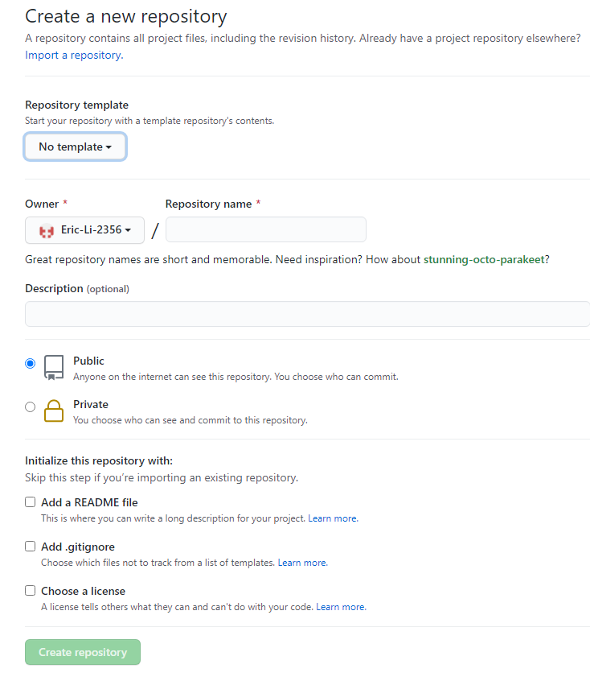

相关项解释

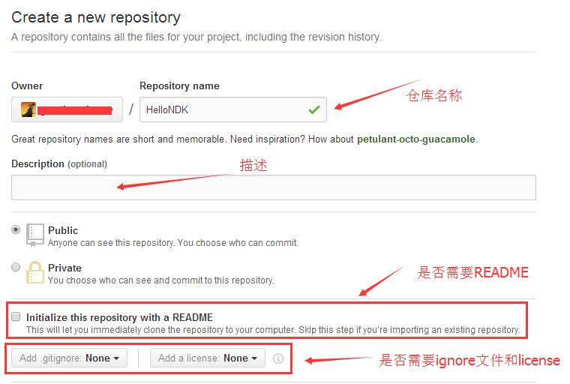

[关于.gitignore见](#_.gitignore文件)

##### .gitignore文件

参考：

1】 <https://docs.github.com/en/get-started/getting-started-with-git/ignoring-files>

2】 <https://git-scm.com/docs/gitignore>

3】 https://www.jianshu.com/p/a09a9b40ad20

4】 https://www.cnblogs.com/techflow/p/13801136.html

###### 1》 是什么

A） You can configure Git to ignore files you don't want to check in to GitHub.

B） gitignore - Specifies intentionally untracked files to ignore.

C) A gitignore file specifies intentionally untracked files that Git should ignore. Files already tracked by Git are not affected; see the NOTES below for details.

D） 当你使用git add .的时候有没有遇到把你不想提交的文件也添加到了缓存中去？比如项目的本地配置信息，如果你上传到Git中去其他人pull下来的时候就会和他本地的配置有冲突，所以这样的个性化配置文件我们一般不把它推送到git服务器中，但是又为了偷懒每次添加缓存的时候都想用git add .而不是手动一个一个文件添加，该怎么办呢？很简单，git为我们提供了一个.gitignore文件只要在这个文件中申明哪些文件你不希望添加到git中去，这样当你使用git add .的时候这些文件就会被自动忽略掉。

###### 2》 为什么

看到这里你可能很疑惑，git创造出来就是为了管理代码和文件的，为什么还要禁止一些文件提交呢？

其实也很简单，举个很简单的例子。比如当我们写一些编译型语言的时候，比如C、C++、Java、go。我们在运行之前往往需要编译一下将它们编译成可执行的二进制文件，也称为binary文件。编译之后的binary文件其实是比较大的，要比源码大很多。经常一个几十行的代码编译出来好几百KB甚至1MB这都是很正常的，像是这些二进制文件我们就完全没有必要上传。

因为**不论是谁拿到源代码编译一下就可以获得一样的结果**，完全没有上传可执行文件的必要。相反它还会在git仓库当中占据大量的空间，以后不论项目经过多少次迭代，它都会一直停留在git仓库当中，占据磁盘资源。

像是这样没有必要上传的文件还有很多，比如Java编译出来的class文件，一些中间结果、配置文件等等。我们往往图方便都是会喜欢在使用git add提交文件的时候使用git add .也就是提交全部的命令来提交。但是如果我们目录下有这些我们不希望提交的内容的话，也一样会全部提交上去，所以我们希望可以在一个地方进行设置，这样当我们使用git add .的时候可以避开一些我们不希望提交上的文件。

这个用来设置的地方就是gitignore文件。

###### 3》 忽略文件的原则

• 忽略操作系统自动生成的文件，比如缩略图等；

• 忽略编译生成的中间文件、可执行文件等，也就是如果一个文件是通过另一个文件自动生成的，那自动生成的文件就没必要放进版本库，比如Java编译产生的.class文件；

• 忽略你自己的带有敏感信息的配置文件，比如存放口令的配置文件。

###### 4》 怎么用

gitignore的使用方法非常简单，我们在git目录下创建一个.gitignore文件，然后在这个文件当中列举出我们不希望提交的文件即可。

凡是列在这个文件当中的名称，当我们在使用git add的时候都会替我们忽略掉。我们也没有必要从头开始编写这个gitignore文件，因为git当中已经替我们写好了很多模板，我们可以直接拿过来参考。

模板的地址：<https://github.com/github/gitignore>

我们打开之后会看到各种ignore文件，这些都是为各个语言定制的gitignore文件。

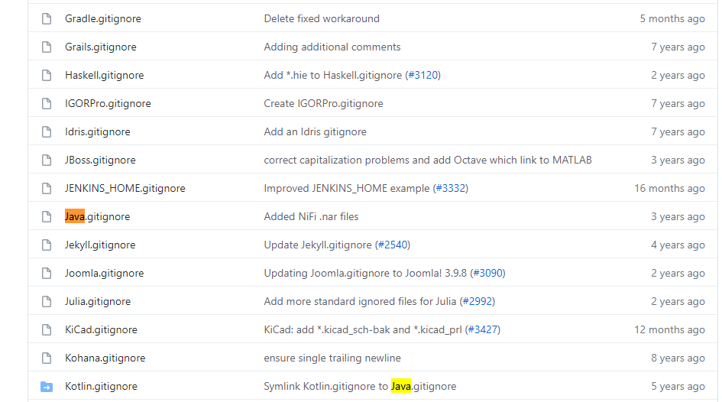

我们随便打开一个看看。比如打开一个Java.gitignore的：

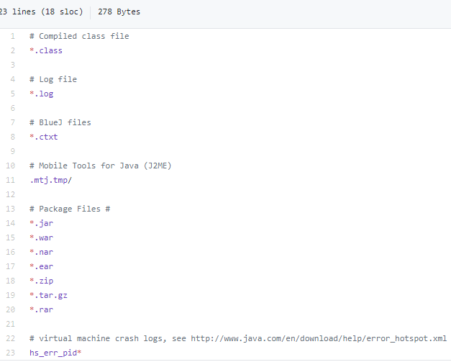

###### 5》 语法

###### 6》 实例

比如你的项目是java项目，.java文件编译后会生成.class文件，这些文件多数情况下是不想被传到仓库中的文件。这时候你可以直接适用github的.gitignore文件模板：

<https://github.com/github/gitignore/blob/master/Java.gitignore> 将这些忽略文件信息复制到你的.gitignore文件中去，这里就选两项：

|  |
| --- |
| # Compiled class file  \*.class  # Log file  \*.log |

git init后文件结构

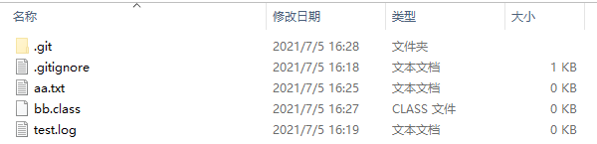

git add .后git status

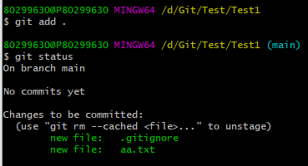

但原文有untracked files（https://www.jianshu.com/p/a09a9b40ad20）

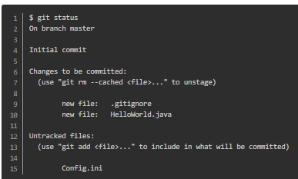

如果有些文件已经被你忽略了，当你使用git add时是无法添加的，比如我忽略了\*.class，现在我想把bb.class添加到git中去：

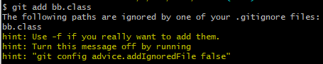  
git会提示我们这个文件已经被我们忽略了，需要加上-f参数才能强制添加到git中去：

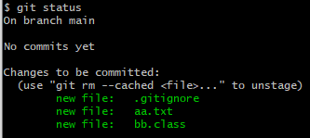

如果我们意外的将想要忽略的文件添加到暂存区中去了，我们可以使用rm命令将其从中移除：

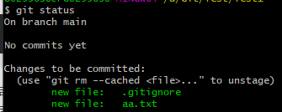

如果你已经把不想上传的文件上传到了git仓库，那么你必须先从远程仓库删了它，我们可以从远程仓库直接删除然后pull代码到本地仓库这些文件就会本删除，或者从本地删除这些文件并且在.gitignore文件中添加这些你想忽略的文件，然后再push到远程仓库。

### Andorid Studio上配置git

#### 配置git路径

快捷键ctrl+shift+a打开settings，点击version control -》 Git在Path To Git Executable 上输入 Git.exe 的存放位置，如下图：

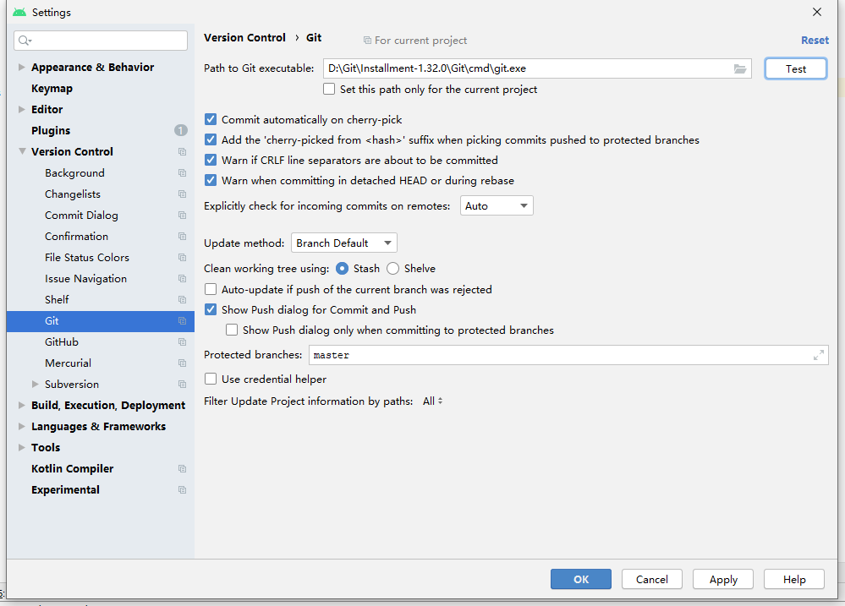

之后点击旁边的Test按钮，如果出现如下的成功提示，说明Git配置成功。

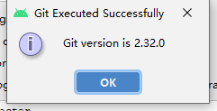

## （x） 将本地代码推送到远程仓库

忽略文件

## （x） 从远程仓库下拉到本地代码

## （x） git操作（分支管理，回退等）

### 【1】 看一个文件历史commit

右键文件任何位置，按如下

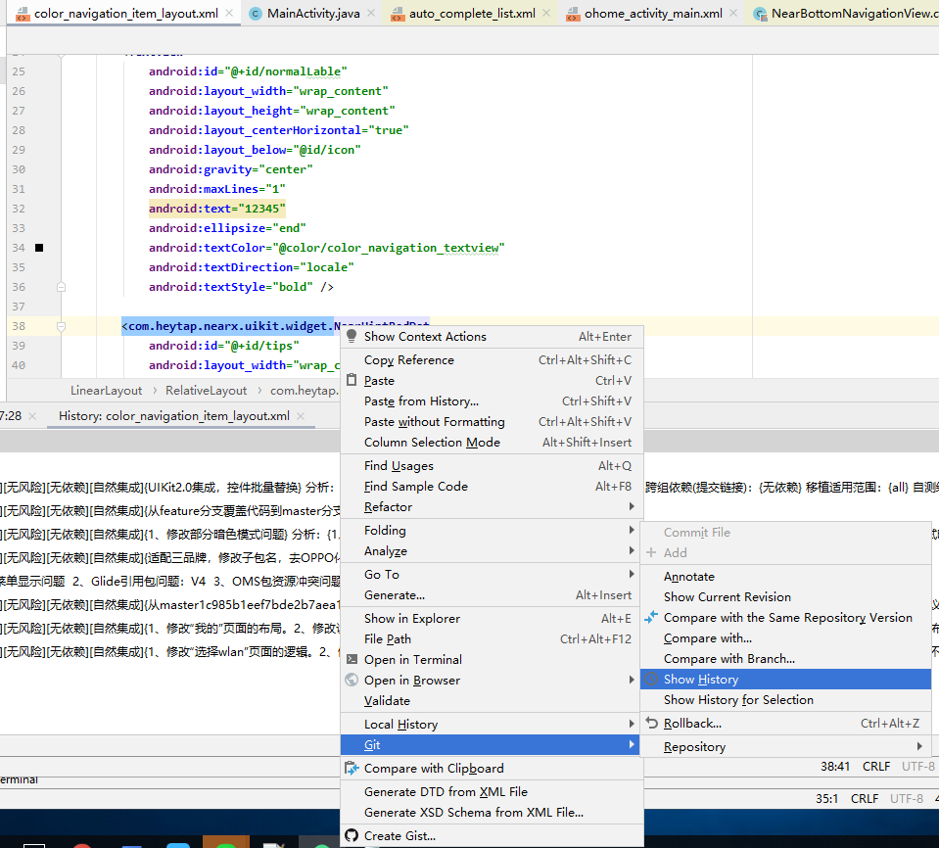

即可。

### 【2】 看某行最近的commit

在行号右边右键Annotate

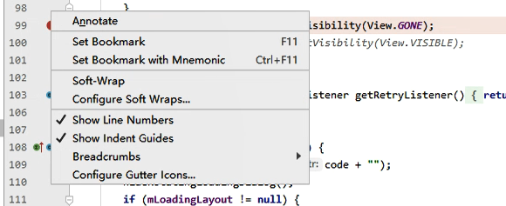

可看到当前代码提交git

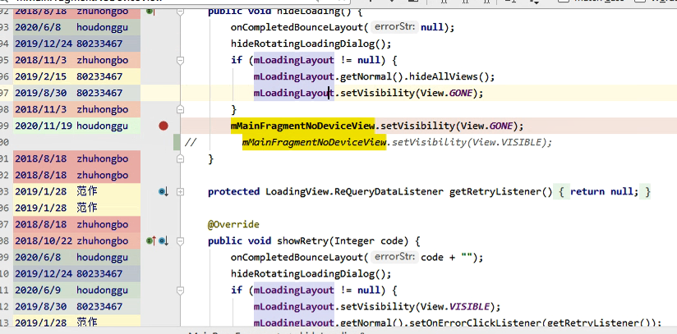

鼠标上去看到commit

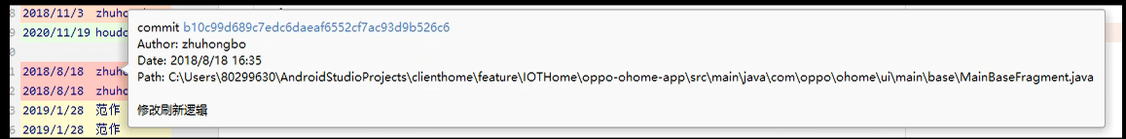

左键进去看到commit对应更改

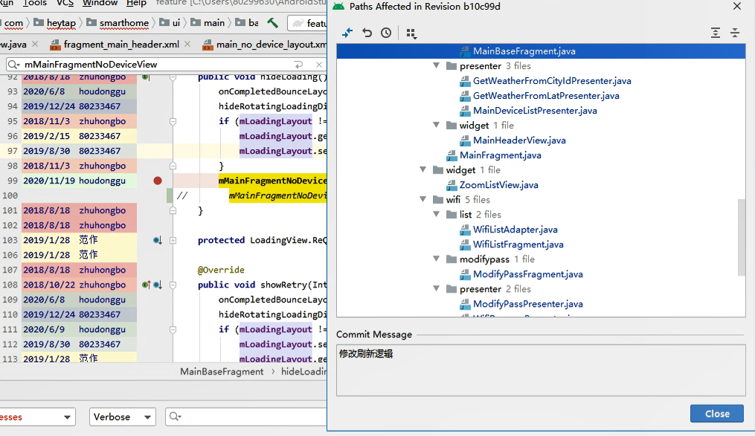

双击或点show diff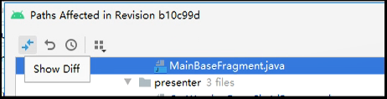显示具体commit信息，

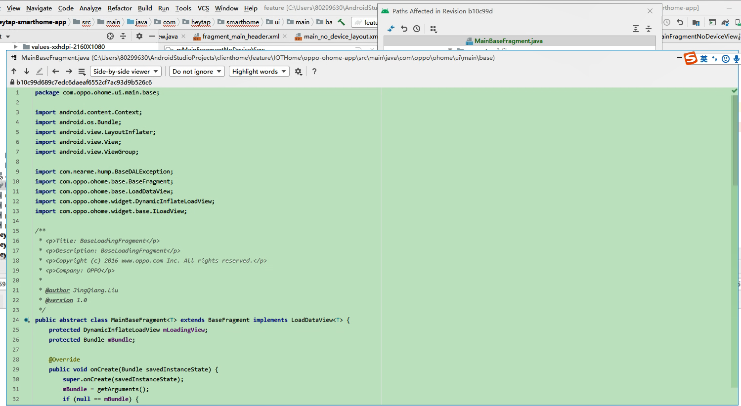

## （x） 颜色意义

1. 左侧绿色：表删除





1. 左侧浅蓝：表修改

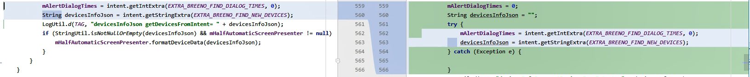

右侧浅蓝：表未修改

右侧绿色：表新增

## （x） 注意点

### 【1】 AS的commit bug

经常资源文件

# 添加构建依赖：Add build dependencies

参考：[https://developer.android.com/studio/build/dependencies#groovy](https://developer.android.com/studio/build/dependencies" \l "groovy)

## （1） 概述

## （2） 依赖类型

### 【1】 Local library module dependency

#### 语法

|  |
| --- |
| implementation project(':mylibrary') |

This declares a dependency on an [Android library module](https://developer.android.com/studio/projects/android-library) named "mylibrary" (this name must match the library name defined with an include: in your [settings.gradle](https://docs.gradle.org/current/dsl/org.gradle.api.initialization.Settings.html) file). When you build your app, the build system compiles the library module and packages the resulting compiled contents in the app.

#### 实例

### 【2】 Local binary dependency

### 【3】 Remote binary dependency

# minsdkversion，compilesdkversion，targetsdkversion

参考：

1. 主：<http://mouxuejie.com/blog/2018-08-04/android-compilesdkversion-minsdkversion-targetsdkversion/>
2. 辅：

<https://developer.android.com/guide/topics/manifest/uses-sdk-element>

<https://stackoverflow.com/questions/24510219/what-is-the-difference-between-min-sdk-version-target-sdk-version-vs-compile-sd>

<https://developer.android.com/studio/releases/build-tools?hl=zh-cn>

<https://stackoverflow.com/questions/24521017/android-gradle-buildtoolsversion-vs-compilesdkversion>

<https://blog.csdn.net/gaolh89/article/details/79809034>

## （1） sdkversion配置概述

<http://mouxuejie.com/blog/2018-08-04/android-compilesdkversion-minsdkversion-targetsdkversion/>

|  |
| --- |
| #build.gradle android **{** compileSdkVersion 23  buildToolsVersion "23.0.1"   defaultConfig **{** applicationId "com.mouxuejie.xxx"  minSdkVersion 7  targetSdkVersion 23  versionCode 1  versionName "1.0"  **} }** #AndroidManifest.xml  <uses-sdk android:targetSdkVersion="23" android:minSdkVersion="7" /> |

sdkversion可以在主module的build.gradle或主module的AndroidManifest.xml文件中配置。

但是gradle构建时，build.gradle会覆盖AndroidManifest.xml中的配置。

## （2） 不同sdkversion

### 【1】 compileSdkVersion+buildToolsVersion

#### 《1》 compileSdkVersion

##### 1） 是什么

<http://mouxuejie.com/blog/2018-08-04/android-compilesdkversion-minsdkversion-targetsdkversion/>

1、告诉Gradle用哪个Android SDK版本编译你的应用。使用任何新版本的API时就需要使用对应Level的Android SDK。  
2、只影响编译时的行为，不影响运行时的行为。

##### 2） 使用

<http://mouxuejie.com/blog/2018-08-04/android-compilesdkversion-minsdkversion-targetsdkversion/>

Android SDK的版本升级了的话，会出现一些新的API，某些老的API会deprecated。如果我想使用新的API，则可以将compileSdkVersion升级到对应Level。然后编译的时候，可能会出现编译警告或编译错误。

##### 3） 建议

<http://mouxuejie.com/blog/2018-08-04/android-compilesdkversion-minsdkversion-targetsdkversion/>

建议compileSdkVersion使用最新的API Level编译。

##### 4） 关于support library

<http://mouxuejie.com/blog/2018-08-04/android-compilesdkversion-minsdkversion-targetsdkversion/>

如果使用 Support Library ，那么使用最新发布的 Support Library 就需要使用最新的 SDK 编译。例如要使用 23.1.1 版本的 Support Library ，compileSdkVersion 就必需至少是 23 （大版本号要一致！）

##### 5） 实例

当前build.gradle

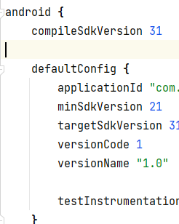

点

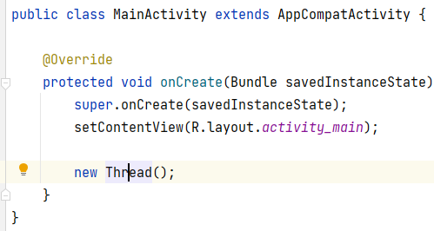

的Thread，显示api31

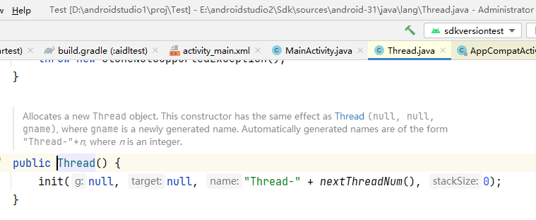

然后build.gradle改成：

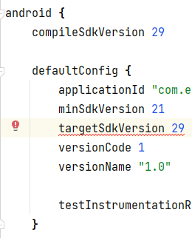

再点Thread变成：

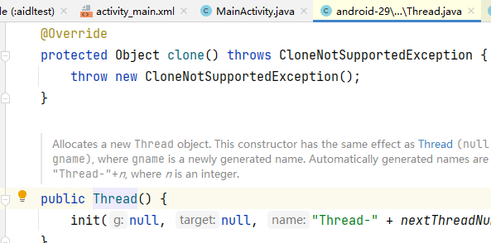

###### 总结：

写代码时用的api级别就是编译时sdk的级别，两者都由compileSdkVersion控制。

#### 《2》 buildToolsVersion

##### 1） 是什么

###### 参1：

<http://mouxuejie.com/blog/2018-08-04/android-compilesdkversion-minsdkversion-targetsdkversion/>

buildToolsVersion 编译工具集的版本号。

###### 参2：<https://developer.android.com/studio/releases/build-tools>

Android SDK Build-Tools is a component of the Android SDK required for building Android apps. It's installed in the <sdk>/build-tools/ directory.

You should always keep your Build Tools component updated by downloading the latest version using the [Android SDK Manager](https://developer.android.com/studio/intro/update). If you're using [Android plugin for Gradle 3.0.0](https://developer.android.com/studio/releases/gradle-plugin#3-0-0) or higher, your project automatically uses a default version of the build tools that the plugin specifies. To use a different version of the build tools, specify it using [buildToolsVersion](https://google.github.io/android-gradle-dsl/current/com.android.build.gradle.AppExtension.html" \l "com.android.build.gradle.AppExtension:buildToolsVersion) in your module's build.gradle, as follows:

|  |
| --- |
| android {     buildToolsVersion "30.0.2"     ... } |

##### 2） 和compileSdkVersion的关系

<https://stackoverflow.com/questions/24521017/android-gradle-buildtoolsversion-vs-compilesdkversion>

compileSdkVersion is the API version of Android that you compile against.

buildToolsVersion is the version of the compilers (aapt, dx, renderscript compiler, etc...) that you want to use. For each API level (starting with 18), there is a matching .0.0 version.

At IO 2014, we release API 20 and build-tools 20.0.0 to go with it.

Between Android releases we will release updates of the compilers, and so we'll release version .0.1, .0.2, etc... Because we don't want to silently update these version under you, it's up to you to move to the new version when it's convenient for you.

You can use a higher version of the build-tools than your compileSdkVersion, in order to pick up new/better compiler while not changing what you build your app against.

#### 《3》 设置位置

* 1. module的build.gradle中；
  2. 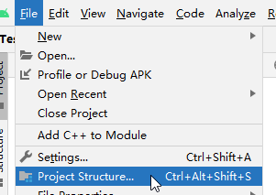到

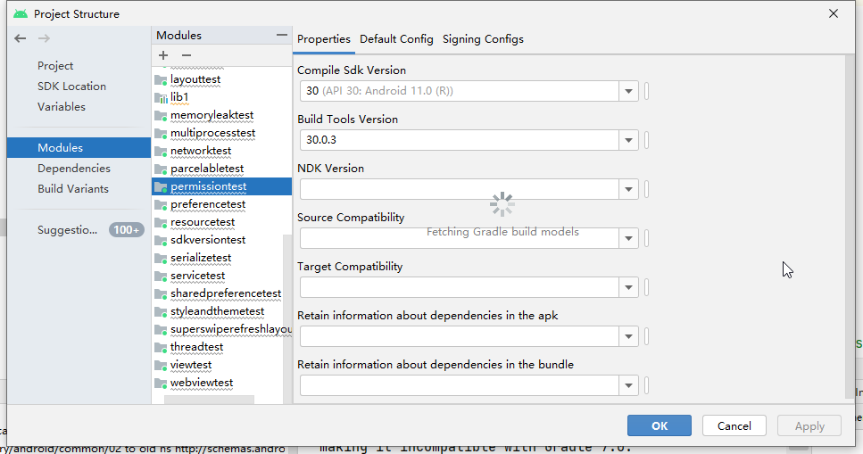

在AS Bumblebee 2021.1.1上测两者不同步，有bug。

### 【2】 minSdkVersion+maxSdkVersion

#### 《1》 是什么

<http://mouxuejie.com/blog/2018-08-04/android-compilesdkversion-minsdkversion-targetsdkversion/>

我理解的是，minSdkVersion和maxSdkVersion决定了APP可运行的Android SDK版本的下限和上限，即可以安装在哪个范围API Level的手机系统上。

minSdkVersion是应用可以运行的Android SDK的最低版本。Google Play 商店用来判断用户设备是否可以安装某个应用的标志之一。

APP使用的Library如果有自己的minSdkVersion，则APP本身设置的minSdkVersion必需大于等于这些库的 minSdkVersion。

maxSdkVersion是应用可以运行的Android SDK的最高版本。一般不指定，因为系统升级时如果超过maxSdkVersion可能会出现APP被移除的问题。

#### 《2》 实例

##### 例1：

###### 前提：

Smarthome app，android6手机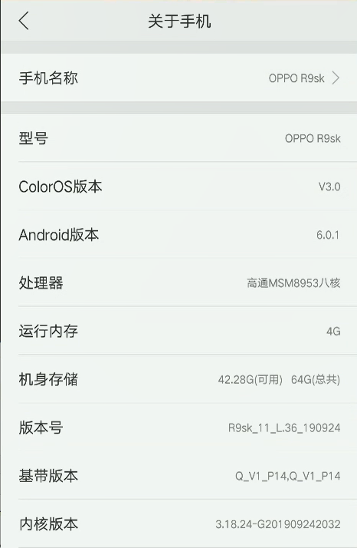

###### 1） 最新app版本

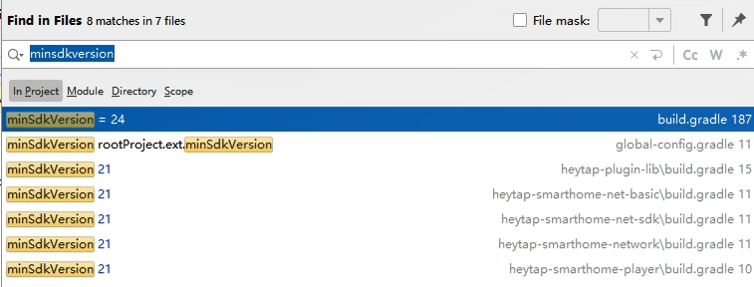

<https://developer.android.com/studio/releases/platforms?hl=zh-cn>

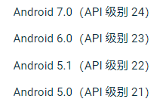

其中project的build.gradle如下：

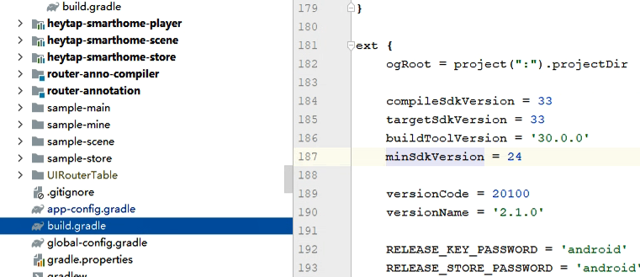

打debug包装在android6手机上，报错：

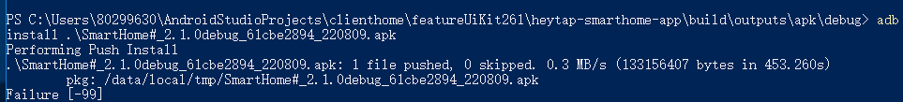

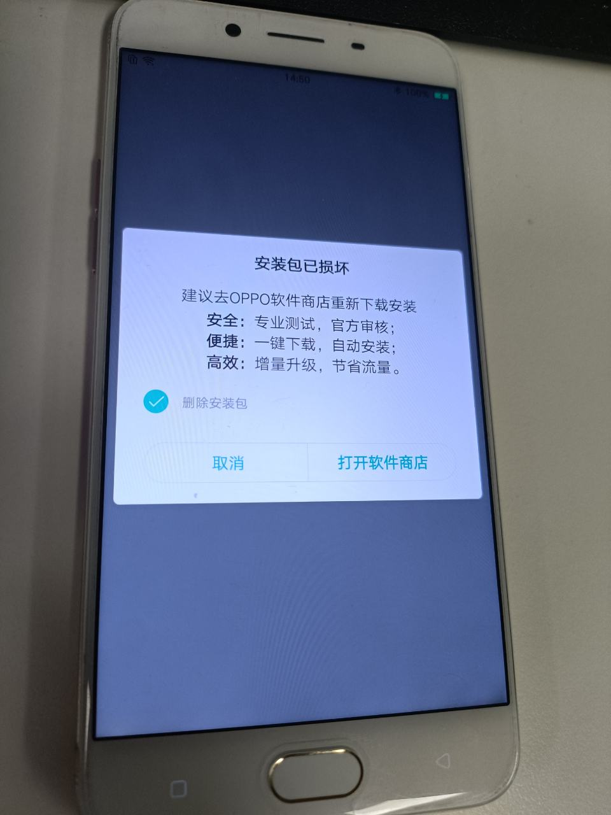

###### 2） 回退到之前app版本

退到

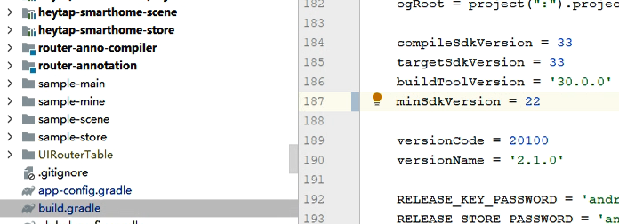

再编debug包，能安装成功

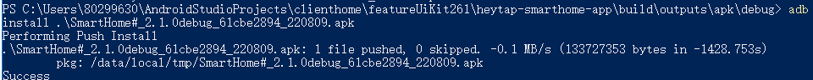

### 【3】 targetSdkVersion

#### 《1》 是什么

<http://mouxuejie.com/blog/2018-08-04/android-compilesdkversion-minsdkversion-targetsdkversion/>

最重要的就是targetSdkVersion，targetSdkVersion 是 Android 提供向前兼容的主要依据。在应用的 targetSdkVersion 没有更新之前系统不会应用最新的行为变化。

比如系统升级到Android 4.4(API 19)之后，AlarmManager API设置时间的精确度行为发生了变化，由精确变成了非精确。假设APP的targetSdkVersion是17，那么还是会保持原来的精确行为，当targetSdkVersion>=19时才会使用新特性：

|  |
| --- |
| #AlarmManager  AlarmManager(IAlarmManager service, Context ctx) {  mService = service;   mContext = ctx;  mPackageName = ctx.getPackageName();  mTargetSdkVersion = ctx.getApplicationInfo().targetSdkVersion;  mAlwaysExact = (mTargetSdkVersion < Build.VERSION\_CODES.*KITKAT*);  mMainThreadHandler = new Handler(ctx.getMainLooper()); } |

#### 《2》 情景

<http://mouxuejie.com/blog/2018-08-04/android-compilesdkversion-minsdkversion-targetsdkversion/>

假设手机系统升级到某个新版本newVersion，可能发生的变化：（1）有新的API，老的API有可能deprecated；（2）API外观没有变化，但是内部特性发生变化。

##### 情景1：有新的API

|  |
| --- |
| #Android Oreo之前 public abstract ComponentName startService(Intent service);  #Android Oreo之后，API层面新增了startForegroundService public abstract ComponentName startService(Intent service); public abstract ComponentName startForegroundService(Intent service); |

所以我的APP如果想使用前台服务，需要如下写：

|  |
| --- |
| if (Build.VERSION.SDK\_INT >= Build.VERSION\_CODES.O) {  startForegroundService(intent);*//因为只有Android Oreo后系统才有这个API，不然编译和运行都不通过* } else {  startService(intent);  *//然后在Service里startForeground(...)* } |

##### 情景2：API内部特性发生变化

targetSDKVersion的版本大小可以决定是否采用新的特性还是维持老的特性。因为在手机系统升级之后，Android SDK在提供新特性的同时会兼容一下老特性，会根据APP targetSDKVersion的版本号来选择使用哪个特性。只要targetSDKVersion没有变化，即使手机系统升级了，还是采用老特性。上面AlarmManager就是一个典型的例子。

|  |
| --- |
| #Android SDK中的代码形如 if (ctx.getApplicationInfo().targetSdkVersion > Build.VERSION\_CODES.KITKAT) {  *//新特性* } else {  *//老特性* } |

##### 情景3：

假设APP的targetSDKVersion是API 26（对应Android 8.0系统）,然后运行的手机系统是Android 6.0，由于Android 6.0相对8.0来说比较老，API和特性都是老的，即使APP targetSDKVersion指定了高版本，APP在低版本的手机上还是老特性。

#### 《3》 实例

##### 例1：

<https://hio.oppo.com/app/module/detail?tkh_id=2326369&itm_id=9311&mod_id=226434&record=true>

<https://android-developers.googleblog.com/2013/03/native-rtl-support-in-android-42.html>

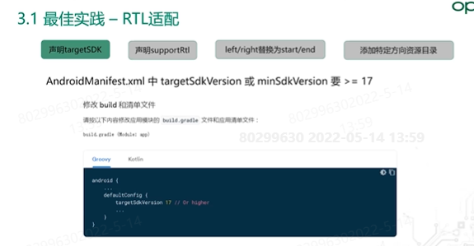

### 总结：

#### 《1》 不同sdkversion的作用

<http://mouxuejie.com/blog/2018-08-04/android-compilesdkversion-minsdkversion-targetsdkversion/>

所以compileSdkVersion决定了编译期间能否使用新版本的API。targetSDKVersion决定了运行期间使用哪种特性。

用较低的minSdkVersion来覆盖最大的人群，用最新的compileSdkVersion和targetSDKVersion来获得最好的外观和行为。

#### 《2》 不同sdkversion的数值关系

<http://mouxuejie.com/blog/2018-08-04/android-compilesdkversion-minsdkversion-targetsdkversion/>

maxSdkVersion >= buildToolsVersion >= compileSdkVersion>= targetSdkVersion >= minSdkVersion

# AS版本更新

## AS arctic fox

### 符号显示

看源码时

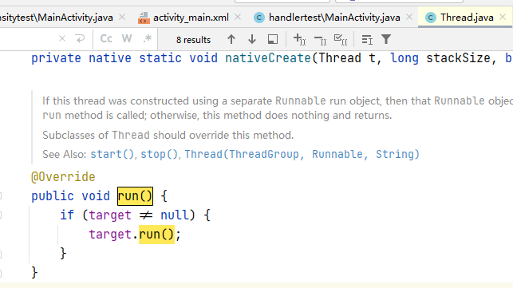

不等号不是java语法，需复制到自己的.java中

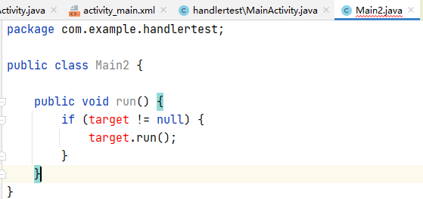

即变成java语法

# 代码检查机制

## 是什么

见“IDE相关.docx”-代码检查：code inspections

## 实例

### Handler黄色警告

# 14. Shrink：缩减，obfuscate：混淆处理，and optimize：优化 your app（版本一）

参考：

1. <https://developer.android.com/studio/build/shrink-code>
2. <https://medium.com/androiddevelopers/practical-proguard-rules-examples-5640a3907dc9>

## 概述

To make your app as small as possible, you should enable shrinking in your release build to remove unused code and resources. When enabling **shrinking**, you also benefit from **obfuscation**, which shortens the names of your app’s classes and members, and **optimization**, which applies more aggressive strategies to further reduce the size of your app. This page describes how R8 performs these compile-time tasks for your project and how you can customize them.

When you build your project using [Android Gradle plugin 3.4.0](https://developer.android.com/studio/releases/gradle-plugin#3-4-0) or higher, the plugin no longer uses ProGuard to perform compile-time code optimization. Instead, the plugin works with the R8 compiler to handle the following compile-time tasks:

* **Code shrinking (or tree-shaking):** detects and safely removes unused classes, fields, methods, and attributes from your app and its library dependencies (making it a valuable tool for working around the [64k reference limit](https://developer.android.com/studio/build/multidex)). For example, if you use only a few APIs of a library dependency, shrinking can identify library code that your app is not using and remove only that code from your app. To learn more, go to the section about how to [shrink your code](https://developer.android.com/studio/build/shrink-code#shrink-code).
* **Resource shrinking:** removes unused resources from your packaged app, including unused resources in your app’s library dependencies. It works in conjunction with code shrinking such that once unused code has been removed, any resources no longer referenced can be safely removed as well. To learn more, go to the section about how to [shrink your resources](https://developer.android.com/studio/build/shrink-code#shrink-resources).
* **Obfuscation:** shortens the name of classes and members, which results in reduced DEX file sizes. To learn more, go to the section about how to [obfuscate your code](https://developer.android.com/studio/build/shrink-code#obfuscate).
* **Optimization:** inspects and rewrites your code to further reduce the size of your app’s DEX files. For example, if R8 detects that the else {} branch for a given if/else statement is never taken, R8 removes the code for the else {} branch. To learn more, go to the section about [code optimization](https://developer.android.com/studio/build/shrink-code#optimization).

## Enable shrinking，obfuscation，and optimization

When you use Android Studio 3.4 or Android Gradle plugin 3.4.0 and higher, R8 is the default compiler that converts your project’s Java bytecode into the DEX format that runs on the Android platform. However, when you create a new project using Android Studio, shrinking, obfuscation, and code optimization is not enabled by default. That’s because these compile-time optimizations increase the build time of your project and might introduce bugs if you do not sufficiently [customize which code to keep](https://developer.android.com/studio/build/shrink-code#keep-code).

So, it’s best to enable these compile-time tasks when building the final version of your app that you test prior to publishing. To enable shrinking, obfuscation, and optimization, include the following in your project-level build.gradle file.

|  |
| --- |
| android {     buildTypes {         release {             // Enables code shrinking, obfuscation, and optimization for only             // your project's release build type.【是关于代码的3项】             minifyEnabled true              // Enables resource shrinking, which is performed by the             // Android Gradle plugin.【是关于资源的1项】             shrinkResources true              // Includes the default ProGuard rules files that are packaged with             // the Android Gradle plugin. To learn more, go to the section about             // R8 configuration files.             proguardFiles getDefaultProguardFile(                     'proguard-android-optimize.txt'),                     'proguard-rules.pro'         }     }     ... } |

## R8 configuration files

## Shrink your code

### 【1】 概述

### 【2】 Customize which code to keep

#### 《1》 引出

For most situations, the default ProGuard rules file (proguard-android- optimize.txt) is sufficient for R8 to remove only the unused code. However, some situations are difficult for R8 to analyze correctly and it might remove code your app actually needs. Some examples of when it might incorrectly remove code include:

* When your app calls a method from the Java Native Interface (JNI)
* When your app looks up code at runtime (such as with reflection)

Testing your app should reveal any errors caused by inappropriately removed code, but you can also inspect what code was removed by [generating a report of removed code](https://developer.android.com/studio/build/shrink-code#usage).

#### 《2》 keep certain code

##### 1） 2种方式

To fix errors and force R8 to keep certain code,

###### 1》 法1

add a [-keep](https://www.guardsquare.com/en/products/proguard/manual/usage#keepoptions) line in the ProGuard rules file. For example:

|  |
| --- |
| -keep public class MyClass |

###### 2》 法2

Alternatively, you can add the [@Keep](https://developer.android.com/reference/androidx/annotation/Keep) annotation to the code you want to keep. Adding @Keep on a class keeps the entire class as-is. Adding it on a method or field will keep the method/field (and its name) as well as the class name intact. Note that this annotation is available only when using the [AndroidX Annotations Library](https://developer.android.com/reference/androidx/annotation/package-summary) and when you include the ProGuard rules file that is packaged with the Android Gradle plugin, as described in the section about how to [enable shrinking](https://developer.android.com/studio/build/shrink-code#enable).

##### 2） 详细规则查阅

There are many considerations you should make when using the -keep option; for more information about customizing your rules file, read the [ProGuard Manual](https://www.guardsquare.com/en/products/proguard/manual/usage). The [Troubleshooting](https://www.guardsquare.com/en/products/proguard/manual/troubleshooting) section outlines other common problems you might encounter when your code gets stripped away.

##### 3） 关于“-keep”的总结

###### 1》 定义

<https://www.guardsquare.com/manual/configuration/usage>

-keep [[,modifier](https://www.guardsquare.com/manual/configuration/usage#keepoptionmodifiers),...] [class\_specification](https://www.guardsquare.com/manual/configuration/usage" \l "classspecification)

Specifies classes and class members (fields and methods) to be preserved as entry points to your code. For example, in order to [keep an application](https://www.guardsquare.com/manual/configuration/examples#application), you can specify the main class along with its main method. In order to [process a library](https://www.guardsquare.com/manual/configuration/examples#library), you should specify all publicly accessible elements.

###### 2》 和相关proguard/R8功能的关系

<https://www.guardsquare.com/manual/home>

In order to determine which code has to be preserved and which code can be discarded or obfuscated, you have to specify one or more **entry points** to your code. These entry points are typically classes with main methods, applets, midlets, activities, etc.

* In the **shrinking step**, ProGuard starts from these seeds and recursively determines which classes and class members are used. All other classes and class members are discarded.
* In the **optimization step**, ProGuard further optimizes the code. Among other optimizations, classes and methods that are not entry points can be made private, static, or final, unused parameters can be removed, and some methods may be inlined.
* In the **obfuscation step**, ProGuard renames classes and class members that are not entry points. In this entire process, keeping the entry points ensures that they can still be accessed by their original names.
* The **preverification step** is the only step that doesn't have to know the entry points.

The [Usage section](https://www.guardsquare.com/manual/configuration/usage) of this manual describes the necessary [-keep options](https://www.guardsquare.com/manual/configuration/usage#keepoptions) and the [Examples section](https://www.guardsquare.com/manual/configuration/examples) provides plenty of examples.

即“-keep“是用于**shrinking step，optimization step，obfuscation step这3个功能的，被-keep修饰的代码不会被这3个功能处理。**

## Strip native libraries

## Shrink your resources

## Obfuscate your code

### 是什么

The purpose of obfuscation is to reduce your app size by shortening the names of your app’s classes, methods, and fields.

### 【2】 示例

The following is an example of obfuscation using R8:

|  |
| --- |
| androidx.appcompat.app.ActionBarDrawerToggle$DelegateProvider -> a.a.a.b:  androidx.appcompat.app.AlertController -> androidx.appcompat.app.AlertController:  android.content.Context mContext -> a  int mListItemLayout -> O  int mViewSpacingRight -> l  android.widget.Button mButtonNeutral -> w  int mMultiChoiceItemLayout -> M  boolean mShowTitle -> P  int mViewSpacingLeft -> j  int mButtonPanelSideLayout -> K |

### 【3】 Decode an obfuscated stack trace

#### 《1》 概述

While obfuscation does not remove code from your app, significant size savings can be seen in apps with DEX files that index many classes, methods, and fields. However, as obfuscation renames different parts of your code, certain tasks, such as inspecting stack traces, require additional tools. To understand your stacktrace after obfuscation, read the next section about how to [decode an obfuscated stack trace](https://developer.android.com/studio/build/shrink-code#decode-stack-trace).

#### 《2》 细节【关于mapping.txt】

After R8 obfuscates your code, understanding a stack trace is difficult (if not impossible) because names of classes and methods might have been changed. Besides renaming, R8 can also change the line numbers present in the stack traces to achieve additional size savings when writing the DEX files. Fortunately, R8 creates a **mapping.txt** file each time it runs, which contains the obfuscated class, method, and field names mapped to the original names. This mapping file also contains information to map the line numbers back to the original source file line numbers. R8 saves the file in the <module-name>/build/outputs/mapping/<build-type>/ directory.

。。。。。。

### 【4】 customize which code to keep

#### 《1》 概述

Additionally, if your code relies on predictable naming for your app’s methods and classes—when using reflection, for example, you should treat those signatures as entry points and specify keep rules for them, as described in the section about how to [customize which code to keep](https://developer.android.com/studio/build/shrink-code#keep-code). Those keep rules tell R8 to not only keep that code in your app’s final DEX but also retain its original naming.

#### 《2》 细节

见（4）【2】

## Code optimization

## Troubleshoot with R8

## 补充知识：

### ProGuard

<https://www.guardsquare.com/manual/home>

### R8

<https://www.guardsquare.com/blog/comparison-proguard-vs-r8-october-2019-edition>